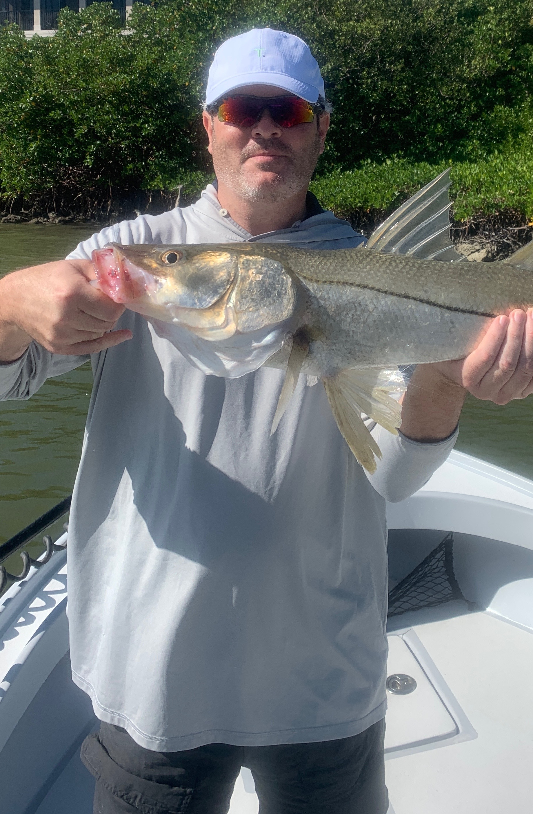

First day back at it
Pic: Ryan had a non stop trip catching snook and redfish with Capt Matt Mitchell this week.
After a few weather related days off you are never quiet sure exactly what you will return to. A 5 to 10 degree drop in water temperature can completely rearrange what was so good just a few days prior. My day starts at 5am as I open the shrimp tank and take a hundred shrimp just in case. I head out the canal to be greeted with a brisk north east wind and temperatures in the low 60’s. This noticeable change brought the realisation the season has changed.

Chumming for twenty minutes at a favourite bait spot in the dark I was not hearing any shiners or bait fish flipping. As it gradually begun to get light that first throw of the cast net had flashes of at lest a few shiners in it. Its always a big relief knowing that the bait had not moved out of the bay with the passing of our strong cold front. Bait as expected does prove a little tougher than pre front and requires a half dozen throws before I’m comfortable I have enough for my morning trip.

After washing the grass off the boat I take off the rain gear. Idling out from the shallow grass flat. I re-rig a few rods and make sure to shorten up and re-tie any chaffed leaders. By 7am its go time as I pull some floating grass out of my livewell hopping the boat up on plane and heading back to the south to pick up my clients for the day. During this ride I’m looking at the tide phase and deciding on the first fishing spot

Starting off in a mangrove channel close to home after chumming a few different spots down the shoreline its looking like the first stop was the wrong move. Pushing further down the bank to the deep dead end corner the first scoop of live shiners I chum gets a instant reaction. This puts a smile on my face as we begin to catch small snook. A few more casts and my client catches a few decent redfish. The sun is slowly warming the waters bringing the fish to life. After 20 minutes of good action this bite slowly grinds to a halt and its time to move on.

Crossing the sound the conditions had picked up and it was a little sloppy. I headed to the pass hoping that during the last few hours of falling tide the fish will fire up. With very few boats out I power poled down in the fast moving current setting us up to fish a favorite rocky edge. One scoop of shiners was a sure sign that this was the right call. Hungry snook chased shiners up to the surface making loud pops as they ate freely. For the next hour we sat and caught snook after snook on almost ever cast.

