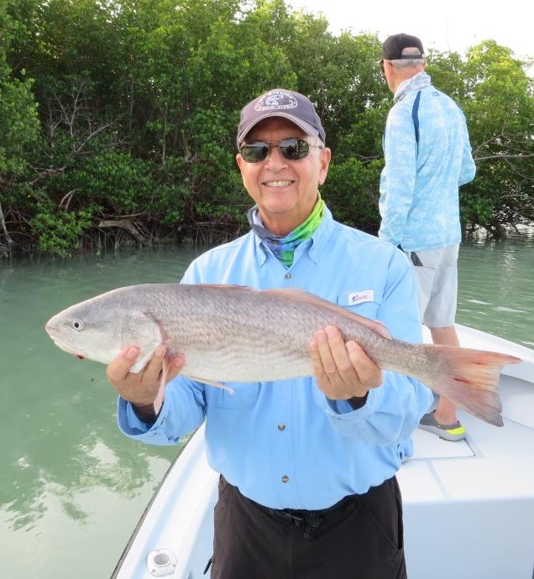

Finally a warming trend

Pic: Ray Bucaria from Lexington with a redfish caught and released with Capt Matt Mitchell this week.

A warming trend between Christmas and New Years was much welcomed after what so far has been a colder than usual start to our winter. What started out as a week with cold and windy mornings and super low tides rebounded to spring like warm and humid conditions.

Shrimp fishing all week was great for catching lots of fish along with one or two big fish trip makers each time out. Sheepshead remained the goto species with some days being much better than others. Along with keeper sized sheepshead in the box we caught lots of rat redfish an occasional bigger redfish and Black drum ranging in size from 14-24 inches.

Area’s around the passes remain the best places to get on these sheepshead with the cleaner clearer outgoing tide being the better bite. Water coming in from the Gulf side is still really stirred up after some crazy windy days and looks like milk during the incoming tide.
Mangrove fishing on the other hand has been the better bite during the incoming tide with creeks in the sound having the cleaner water.

As conditions continue to warm its now time to venture out and start looking for shiners again. Water temperatures are now approaching that magic 70 degree mark and Snook are getting active again. With very few bait fish appearing on the bridges or on the beaches yet I think its going to require chumming out on the flats to catch pilchards.

Tripletail fishing out on the beaches has been productive on the calmer days for those that are willing to put in the time and burn the fuel looking. With very few stone crab pots out on the gulf side its a matter of running until you find what depth these fish are hanging in. New regulations on tripletail this year: minimum size is now 18 inches and you are allowed 2 per person. Tripletail are possibly the best eating fish in our waters.

