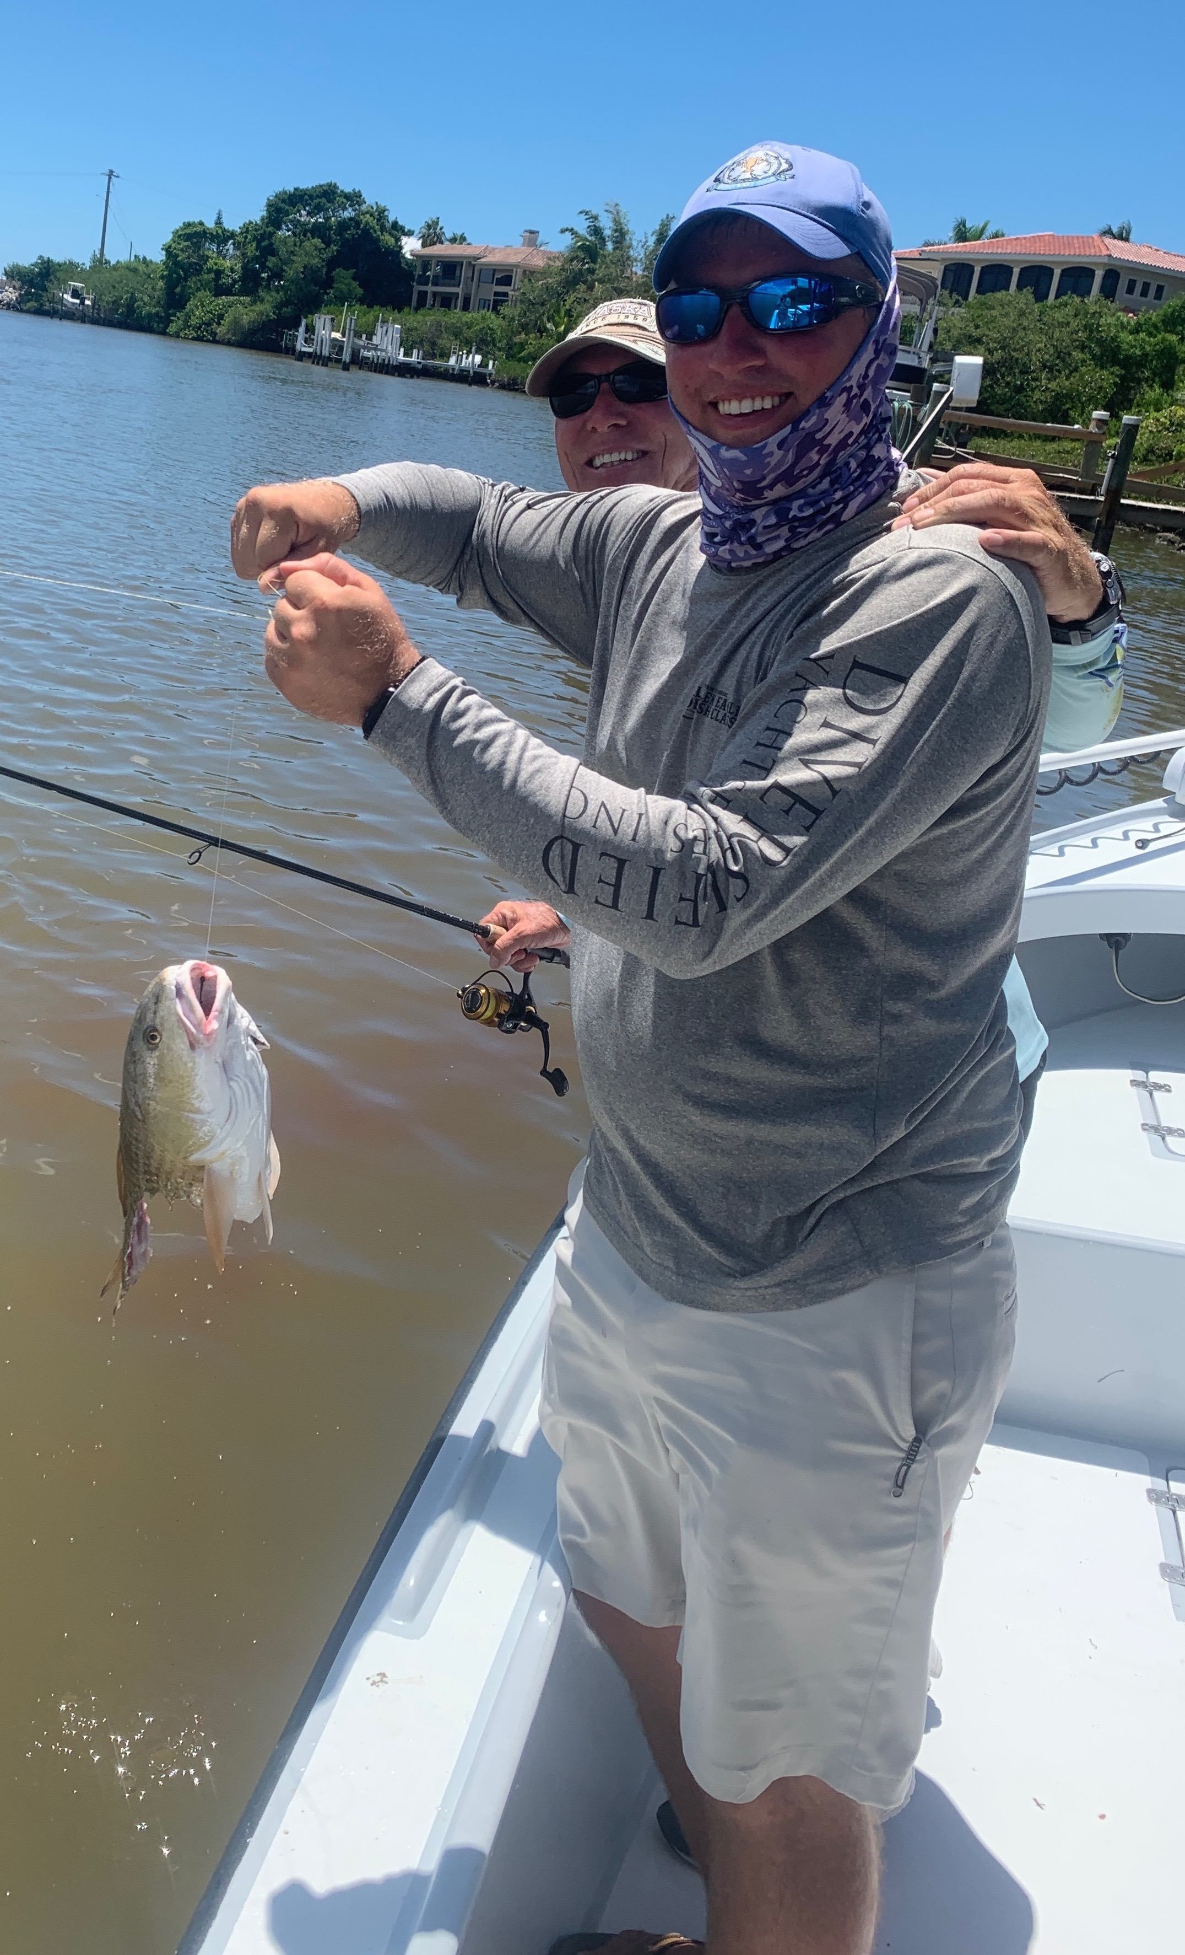

Pic: Craig from Miami had his best ever red taken away boat side this week while fishing with Capt Matt Mitchell.

Fall like fishing has arrived

As August comes to a close what a difference a year makes. Last year this place was a ghost town due to the worst ride tide we have ever seen. This August the bay has not only been full of life there are lots of people around and business has been record breaking. Getting out and experiencing this rebound has to be seen to be believed.

Bait has been one of the major factors in what is making our fishing so great. Anywhere in the sound you look you see feeding birds and when you look a little closer there are fish breaking the surface right under them. The variety is awesome with trout, ladyfish, snapper, mackerel, jacks and bluefish all part of the mix. Watching these fish blitz is exciting then at times throw in a few rolling tarpon and some sharks and its like fall. Usually all this bait does not show up in our water for another month but no one is complaining.

Redfish action keeps getting better too with the rain stained water being the perfect set up to catch lots of them. These reds have ranged anywhere from 20 inches up into the mid 30-inch range. I’ve been targeting these fish under the mangroves during the higher periods then moving to the passes during the lower water. Small silver dollar sized pinfish have been my bait of choice either tail hooked and free lined under the mangroves or weighted with a split shot when in the passes.

While fishing the passes for redfish over the weekend we lost count of how many redfish we caught. At one point we had a large Bull shark came up and eat a big redfish in two right next to the boat. In the stained water you never knew the shark was there until it was too late. Having a shark cut a big redfish in two like a warm stick of butter is impressive and scary as I was reaching over the side grabbing these fish by hand.

Snook fishing for me has been best during the last few hours of the falling tide. Deeper mangrove points with good tide flow have held lots of mid 20 inch sized snook. Our big snook of the week came while targeting redfish on the high tide under the mangroves and measured right around 30 inches. Falling tide fishing in the passes has been a little hit or miss as it seems these fish have started making there way back across the bay a little early this year. Though its not feeling like fall it sure looks like fall with the way our water have come to life.
places in the sound. Find the bait and you will find the tarpon. better yet they generally feed much better now than they did pre spawn in the spring.

