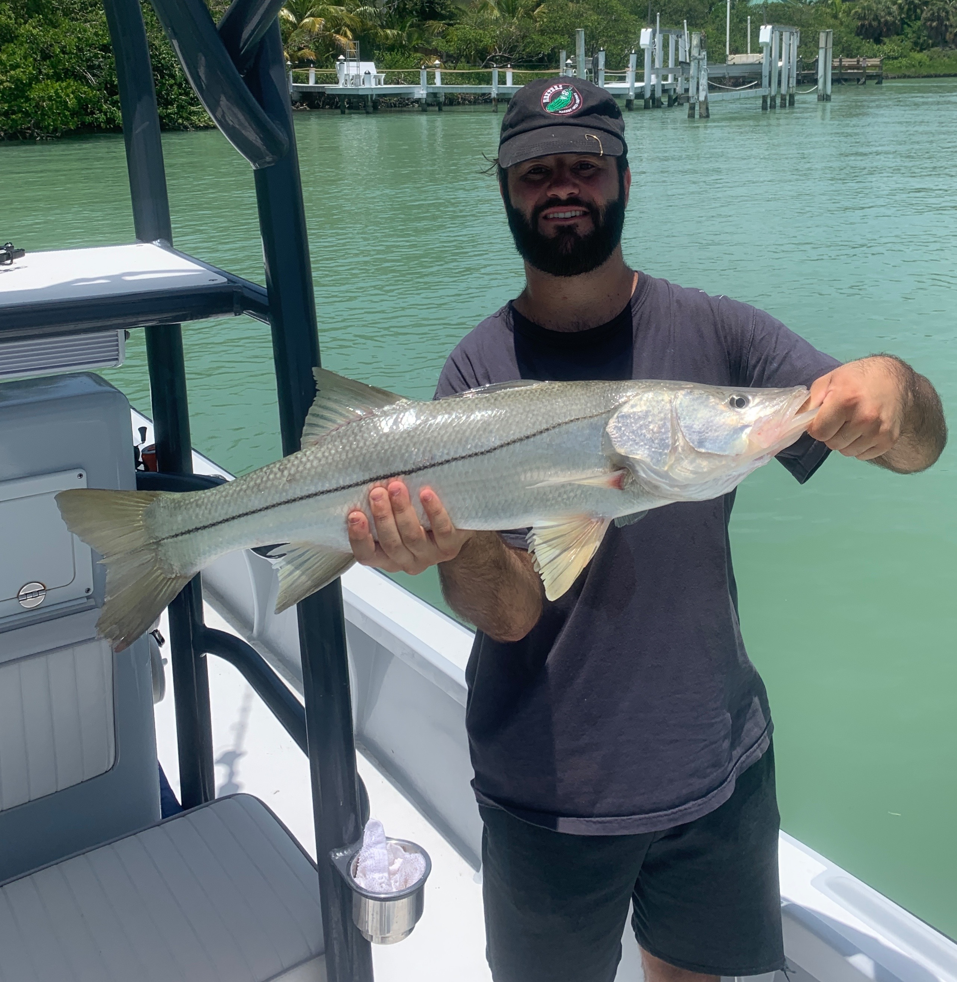

Pic: Spencer Nowell with a big snook caught while drifting the passes with Capt Matt Mitchell this week

Don’t pass on the passes

Fishing the passes has remained the best bite in town as the prevailing onshore west wind made getting out on the beaches just too sloppy. Which of our passes and on which phase of the tide this bite would happen seems to change from day to day. When I did find these fish my clients would get a hour of wide open action that made the whole trip. Drifting while dragging live baits on the bottom worked best to catch snook, redfish and even a few big trout. Working out this pass pattern was often a little frustrating with no two days being alike.

Mangrove Snapper action has begun to pick up as it does all summer long. When clients are looking for fillets to take home these have been our fish of choice. Drop weighted small baits to the bottom in the deeper passes along with docks in these same areas. Tying on a little longer and lighter leader has helped as these fish are really leader shy in clear water. Often I will downsize to 6-10ft of 12# fluorocarbon and a #1 hook. Small shiners and live shrimp had these fish fired up. Fishing some favorite docks in the northern sound we had these fish up on the surface giving us a crazy sight fishing bite.

Many of the shallower humps inside the passes have been good action on the incoming tide. St James hump and a few of the shallower spots at the south end of Matlacha Pass lit up with a variety of species including trout, ladyfish, mackerel and jacks. Small shiners fished under a float and allowed to float on the tide made bending the rods easy. This bite has only happened on the incoming tide as I think the water is just too hot on the outgoing tide.

The westerly wind pattern we have had all week gave us both high humidity and a disturbed weather pattern bringing coastal storms at almost any time of day.. Four days in a row this week I just could not dodge this weather and got soaked. Coming back from Captiva to St James early in the week I got wacked by a micro burst just a mile from home. Thinking I could make it around the small fast moving storm I was caught by blinding rain and wind gusts I’d estimate at 40mph plus. Keeping your eyes on the sky doesn’t always work this time of year.

