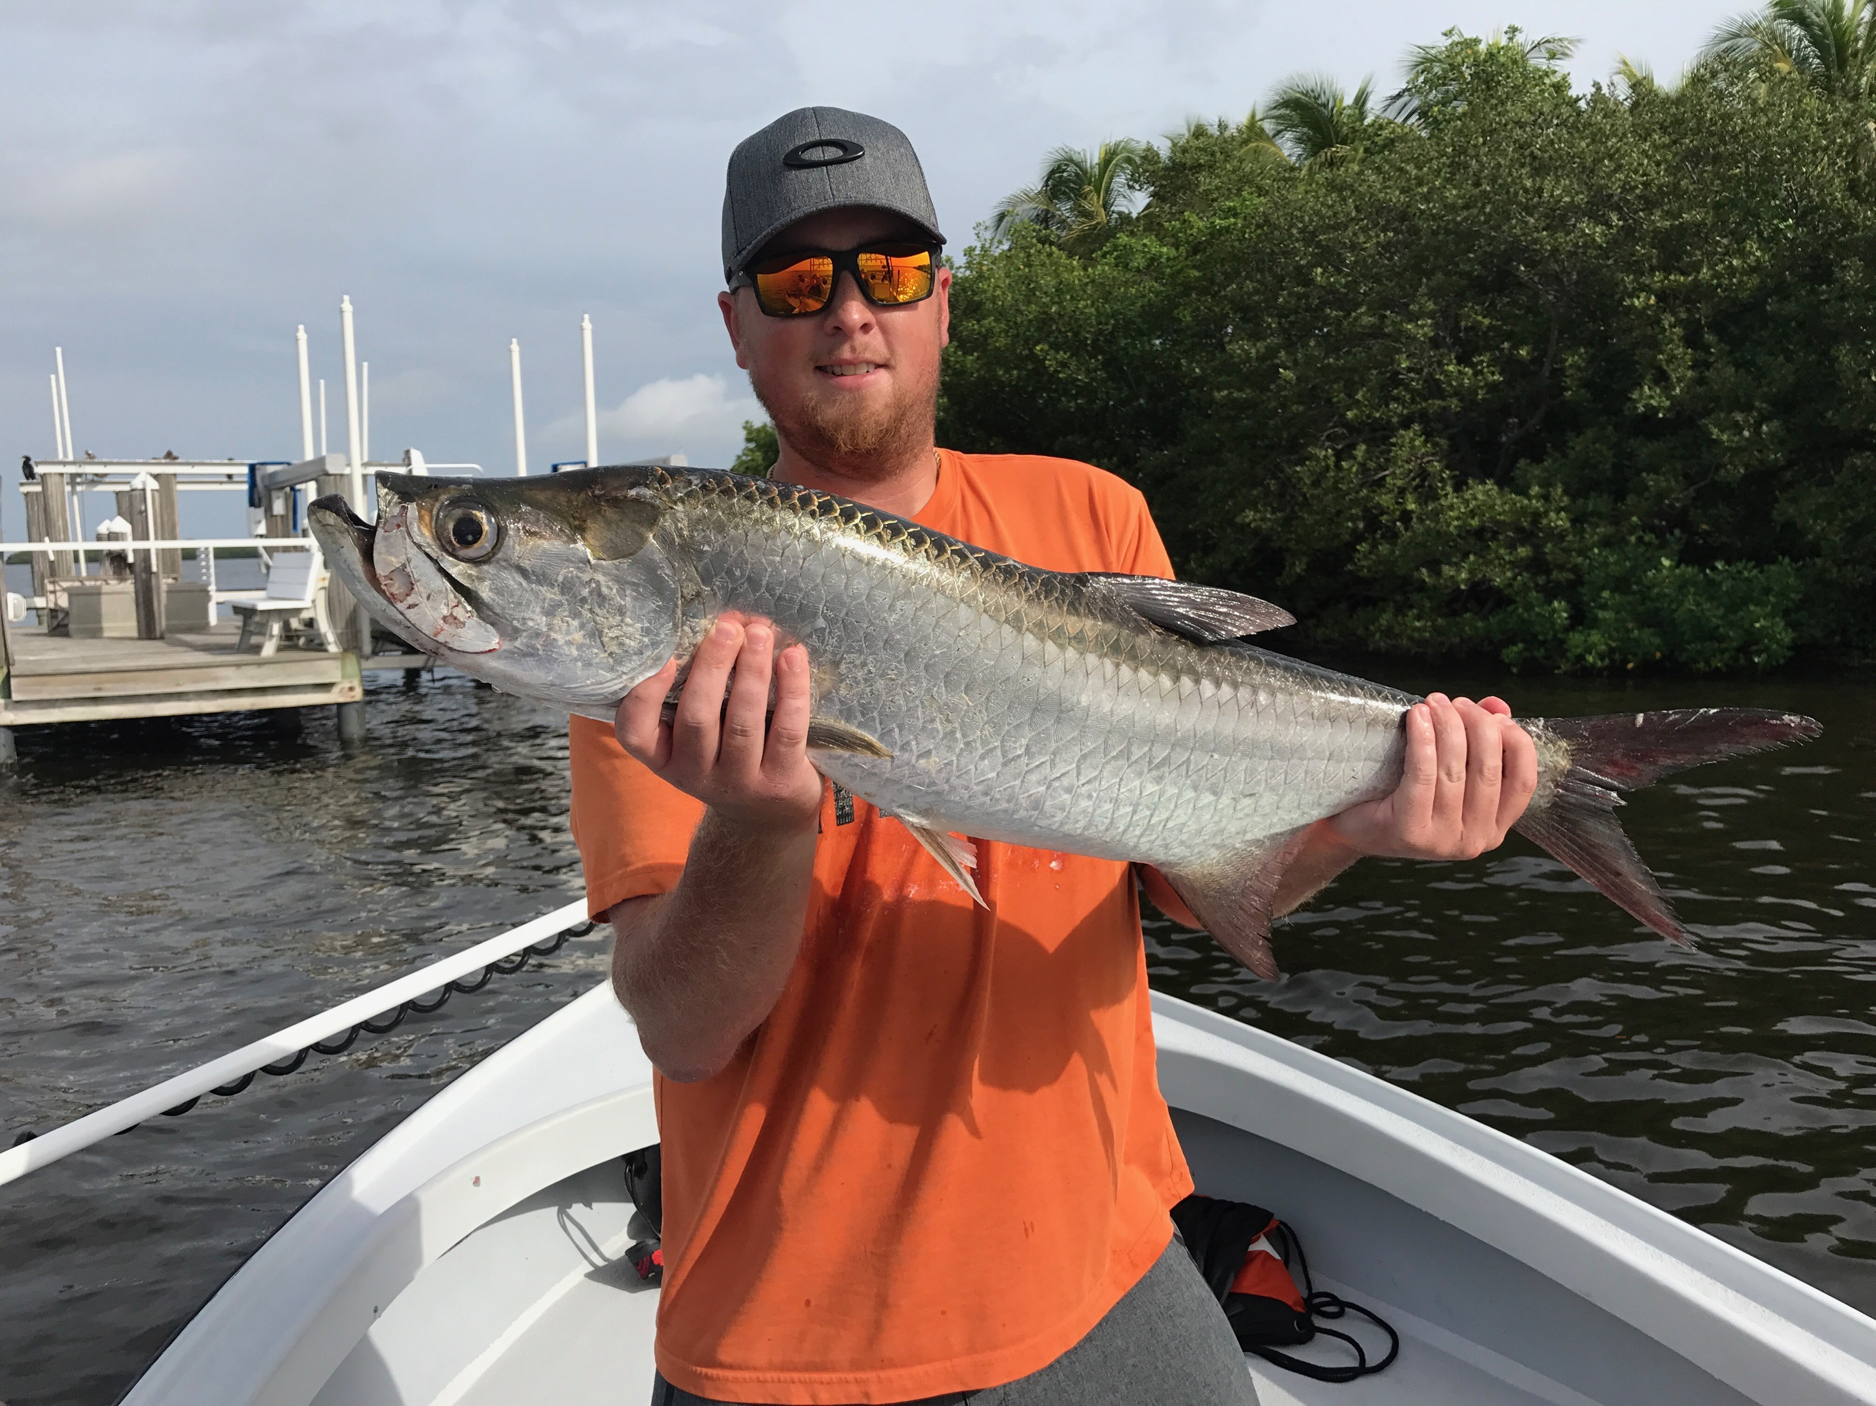

Picture: Joe Scott from Kentucky with his first tarpon caught while fishing with Capt Matt Mitchell this week.

Dodging morning coastal showers.

A summertime pattern with light westerly steering winds gave us morning showers which developed out in the Gulf and moved slowly into the coast all week. Trying to dodge these often slow moving storms was challenging as this rain often had no movement and could develop right on top of you. I don’t have a single trip this week that we did not get rained on at least briefly. Some days attempting to avoid the rain meant fishing in the northern sound while other days staying south was the better choice.

Mangrove snapper fishing was by far the best action again this week with the average size of these snapper just getting bigger and bigger. Mangrove Snapper are very structure oriented and can be found in schools often on docks, piers, mangroves, channel edges and submerged structure. When around structure they will stage up facing into the current while waiting for a meal. Free line small live baits so the bait looks as natural as possible. Once you get them in a feeding frenzy they can even catch them on small artificial’s. Good numbers of keeper sized snapper are being caught from the mouth of the river all the way up to the northern passes.

Catch and release Snook fishing in the passes was also good action this week but only on the outgoing tide. During the incoming tide the water is so clear you can see hundreds of Snook all over but they just don’t want to eat. This lack of action on the incoming tide could change if we have a big rain event to dirty the water up but for now the majority of my success on Snook in the passes is coming on the outgoing tide. Once the water gets it dirtiest about half way through the falling tide it’s all about big baits and big tackle. Drifting while dragging a big bait along the bottom or even anchored up while pinning a big bait down close to the structure will give you your best chance of catching a trophy sized snook.

This weeks fishing was often more about what species of fish the weather would let you target than what you wanted to target. Staying close to home some days meant catching snook and mangrove snapper in deeper canal mouths and mangrove islands while watching rain slide by us. Airing on the side of caution is always safest as some of these storms have had scary lightening in them. Lightening while your out on the water is no joke and should not be taken lightly. No matter how good the fishing is if lightening is close its time to go!!

