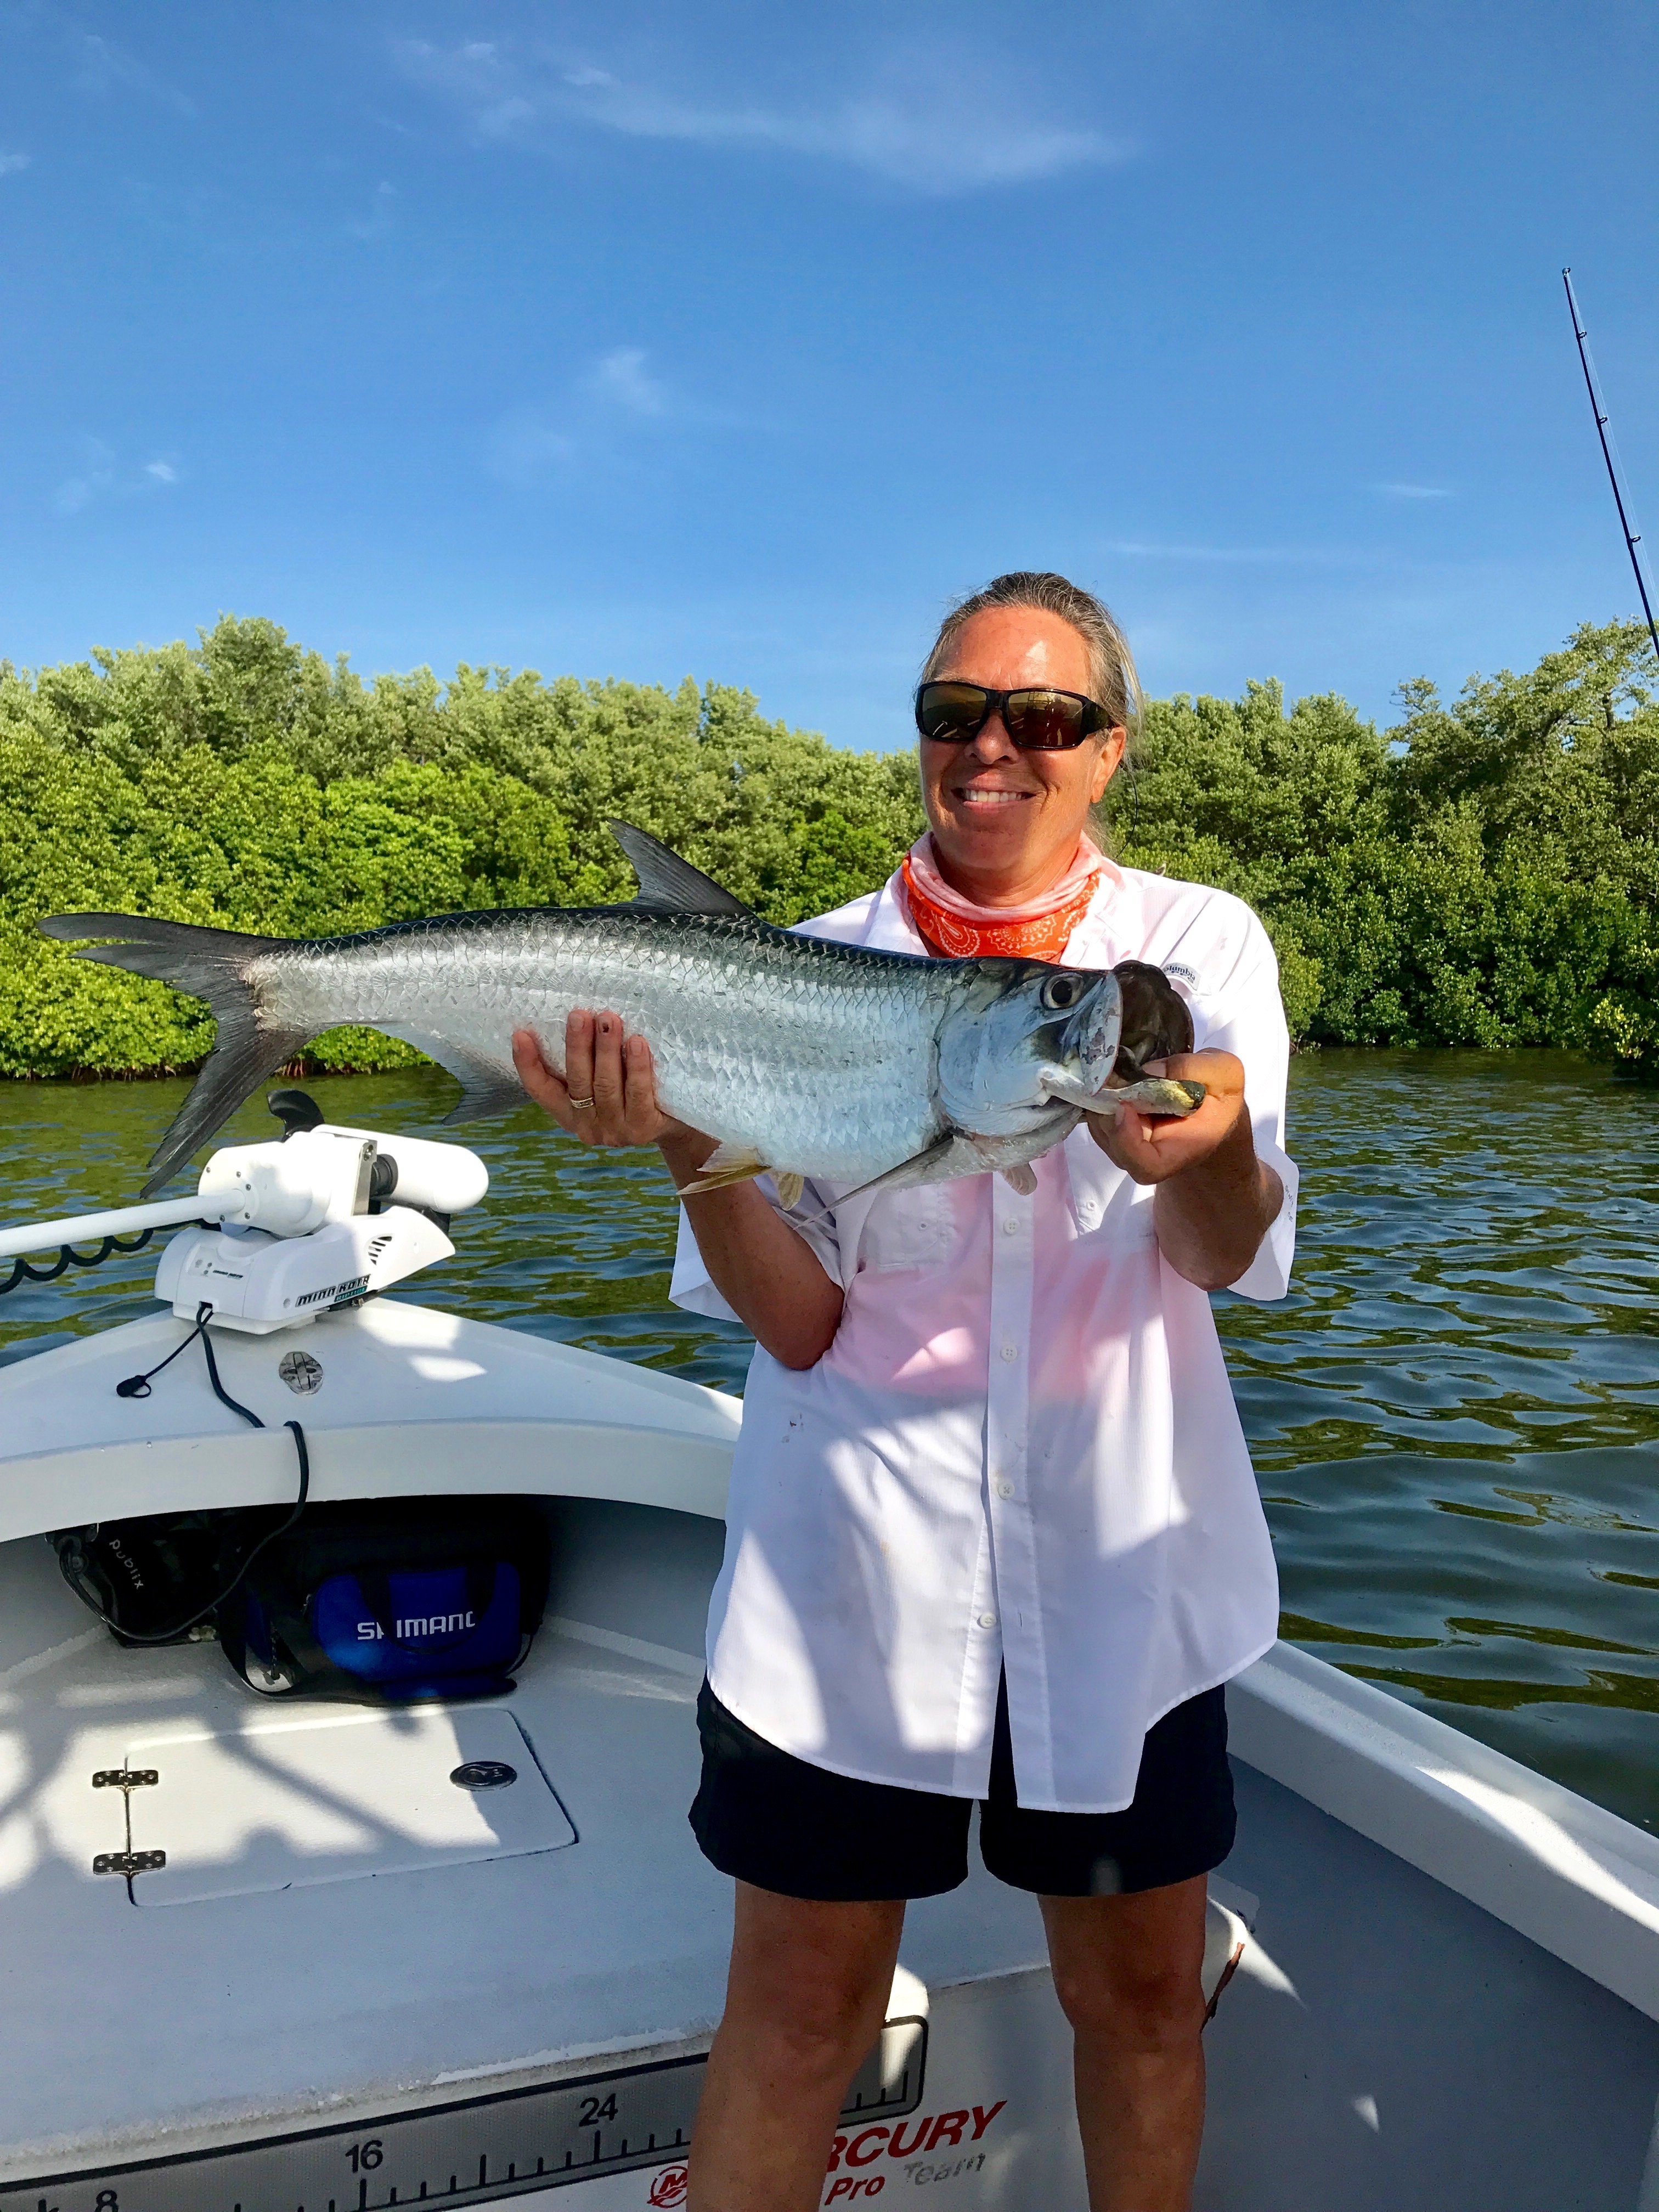

Cooler water for better action.

Picture: Mary Laser with a tarpon caught while fishing with Capt Matt Mitchell

Summer water temperatures have been hovering right around 88 degree’s for a few weeks now. During the blazing afternoon heat the water temperature in the shallows on the outgoing tide can get well over 90 degree’s. Fish like people get much less active during the hottest part of the day and seek cooler water by either going to deeper water or in the shade of mangroves and docks. Extreme heat has the same effect on fish that extreme cold has slowing the action. Afternoon thunderstorms are a welcome event as they cool off the surface temperature of shallow water.

During the outgoing tide we spent some time this week enjoying a great shark bite. Anchored up just inside any of the deeper passes with half a fresh cut mullet the rods where bent and the drags screaming. Many of this crazy shark action was Blacktip sharks up to 5ft long. These blacktips are one of the more sporty sharks to catch as they jump and make lightening fast runs and can change direction on a dime. Often these battles required dropping the anchor ball and chasing the sharks down before they dumped the spool.

Other species of sharks we caught just inside the passes included Atlantic Sharp-nose, Spinners, bonnet heads, Bull sharks and giant nurse sharks. Each time we did this we hooked into a few real monsters that after a few minutes of drag screaming fun broke off by either tail whipping the line or getting a sideways bite on the heavy mono leader. The best action on these sharks has come during the first hour of the falling tide before the current gets moving too fast.

One area that always seems to produce fish during the summer heat is Captiva Pass. The outer sandbars are a great place to sit and chum with small live shiners to catch Spanish Mackerel, ladyfish, pompano and trout. The deeper water in the pass once you locate rocky bottom holds Gag grouper and mangrove snapper. The docks and down trees on either side of the pass is great for snook. Tarpon come through this pass and sharks are always around. Captiva pass is just one of those places that offers lots of options and seems to always produce some type of good fishing action.

