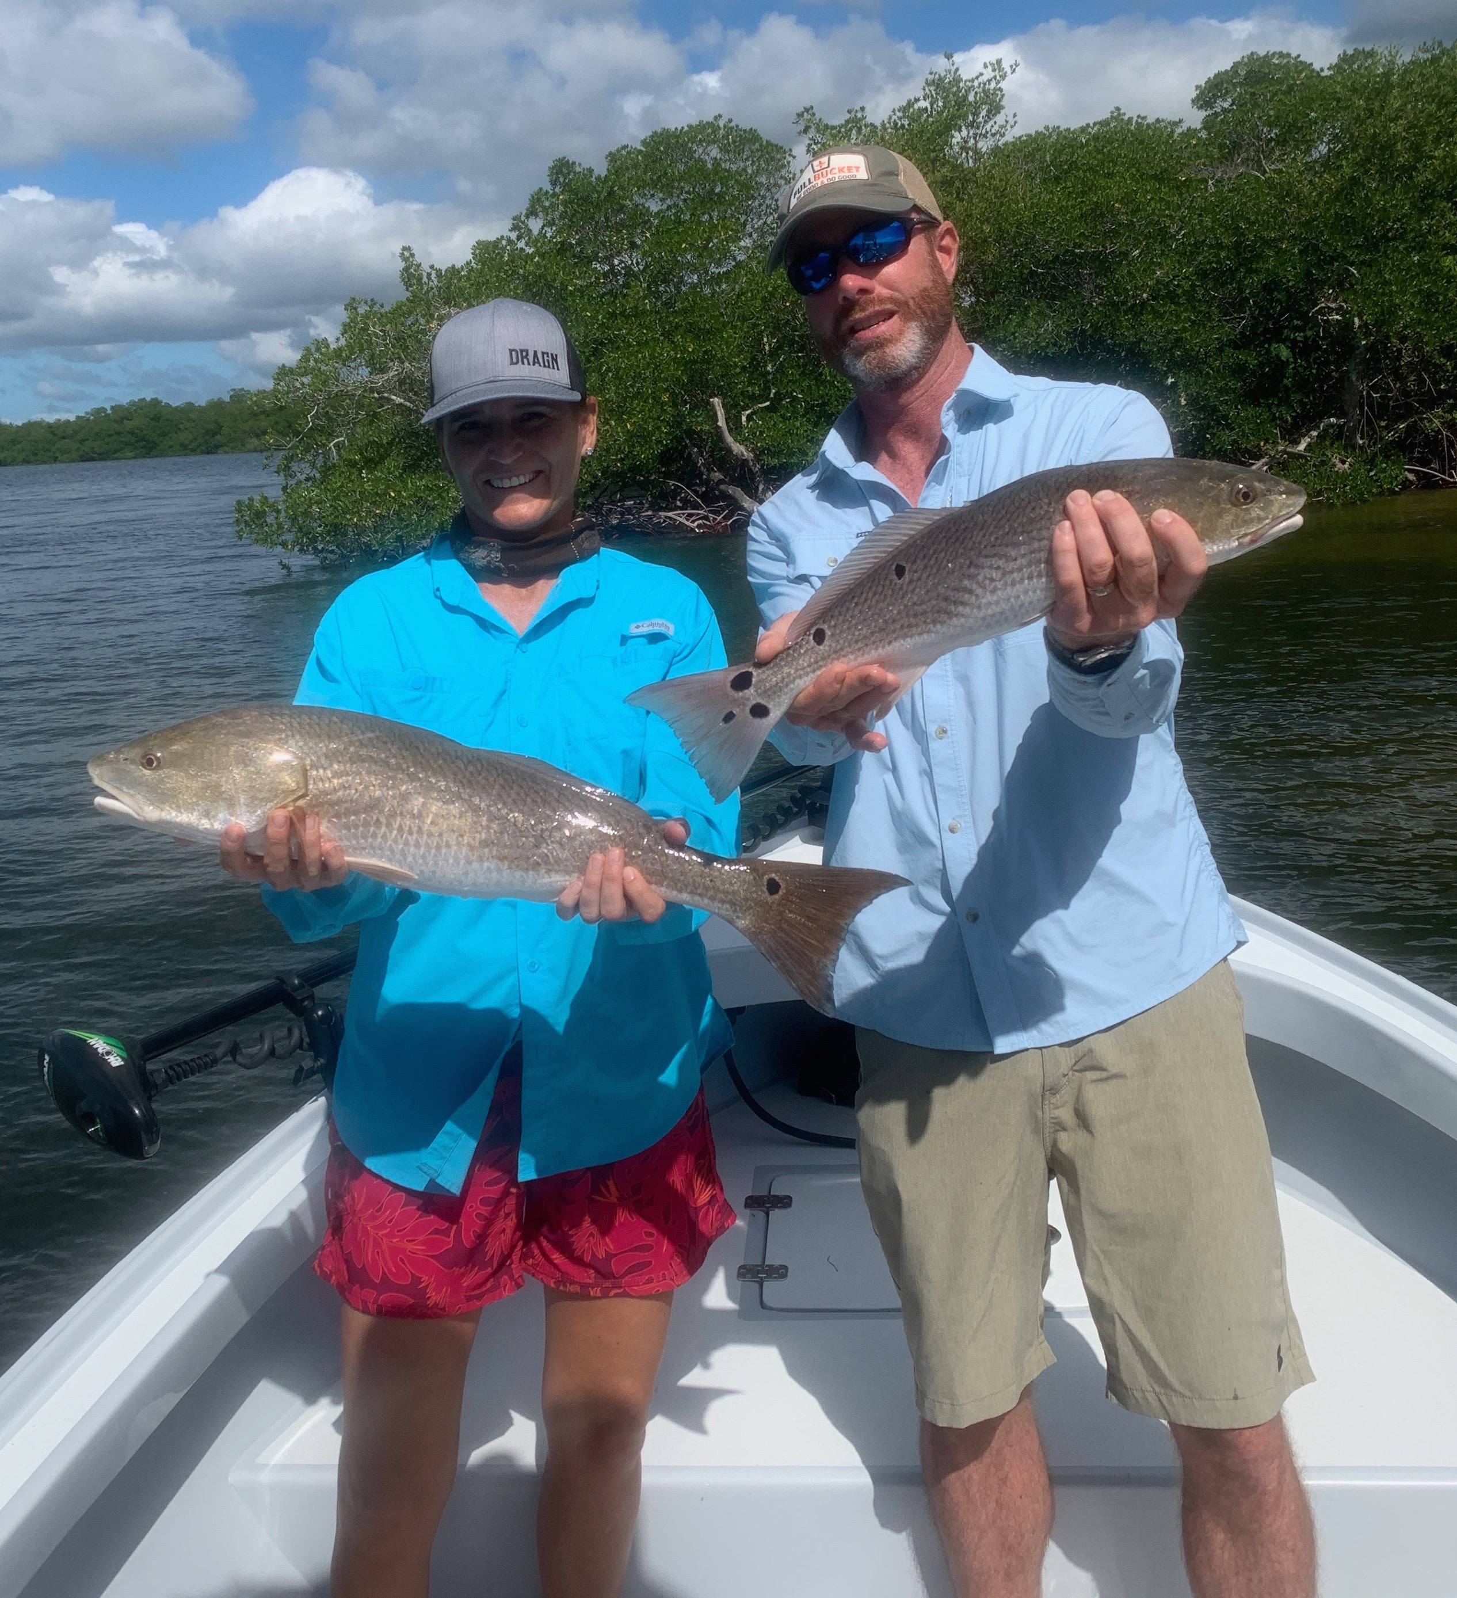

Change of season fires up the fish

Pic: Jo and Zig from Texas with a redfish double caught while fishing with Capt Matt Mitchell this week

October fishing as advertised continues to be outstanding. Cooler fall mornings have brought our water temperature into the low 80’s. This noticeable drop in temperature is a sure sign winter is on the way and has the fish fired up. The change of seasons always brings some of the best fishing of the year.

Redfish remained the main target species all week with this bite often just going crazy. While fishing mangrove islands around St James Cit, we were lucky enough to spot a school of redfish pushing through white sand holes up close to a mangrove island. Every bait we threw at these fish they ate. Our biggest one on this day was 28 inches though we had a few well over 30 inches follow our hooked fish all the way to the boat. When these hungry fish are competing against each other for a bait it just doesn't matter what kind of bait you threw, they ate.

Flats are alive with huge schools of shiners everywhere. I’ve been throwing a ¼ inch mesh net to catch a live well full of this fry bait then using it to chum these same area’s. Once loaded up on bait move out to a little bit deeper water to catch a non stop variety of trout, snapper, mackerel, jacks and ladyfish. Throwing handfuls of these live shiners out from the bow it does not take long to have fish blowing up all around the boat. Take your time and throw just a few of these shiners out every few minutes and watch it light up. Once these fish are eating cast free lined shiners to the pops and its game on!

For the anglers getting up early and out along the beaches there have been some fall tarpon to be found. Though these fish have not been as plentiful as in years past I personally think the best is yet to come in the next few weeks. The key to finding these fish is looking for the masses of small feeding birds diving on small fry bait. It has seemed the area’s holding these tarpon are in the stirred up dirty water. Until we get our first real hard cold front tarpon can be found up and down our beaches. Sitting in these rolling fish for a couple of mornings over we were unable to get a hook up though we did see enough tarpon to get our hearts racing.

