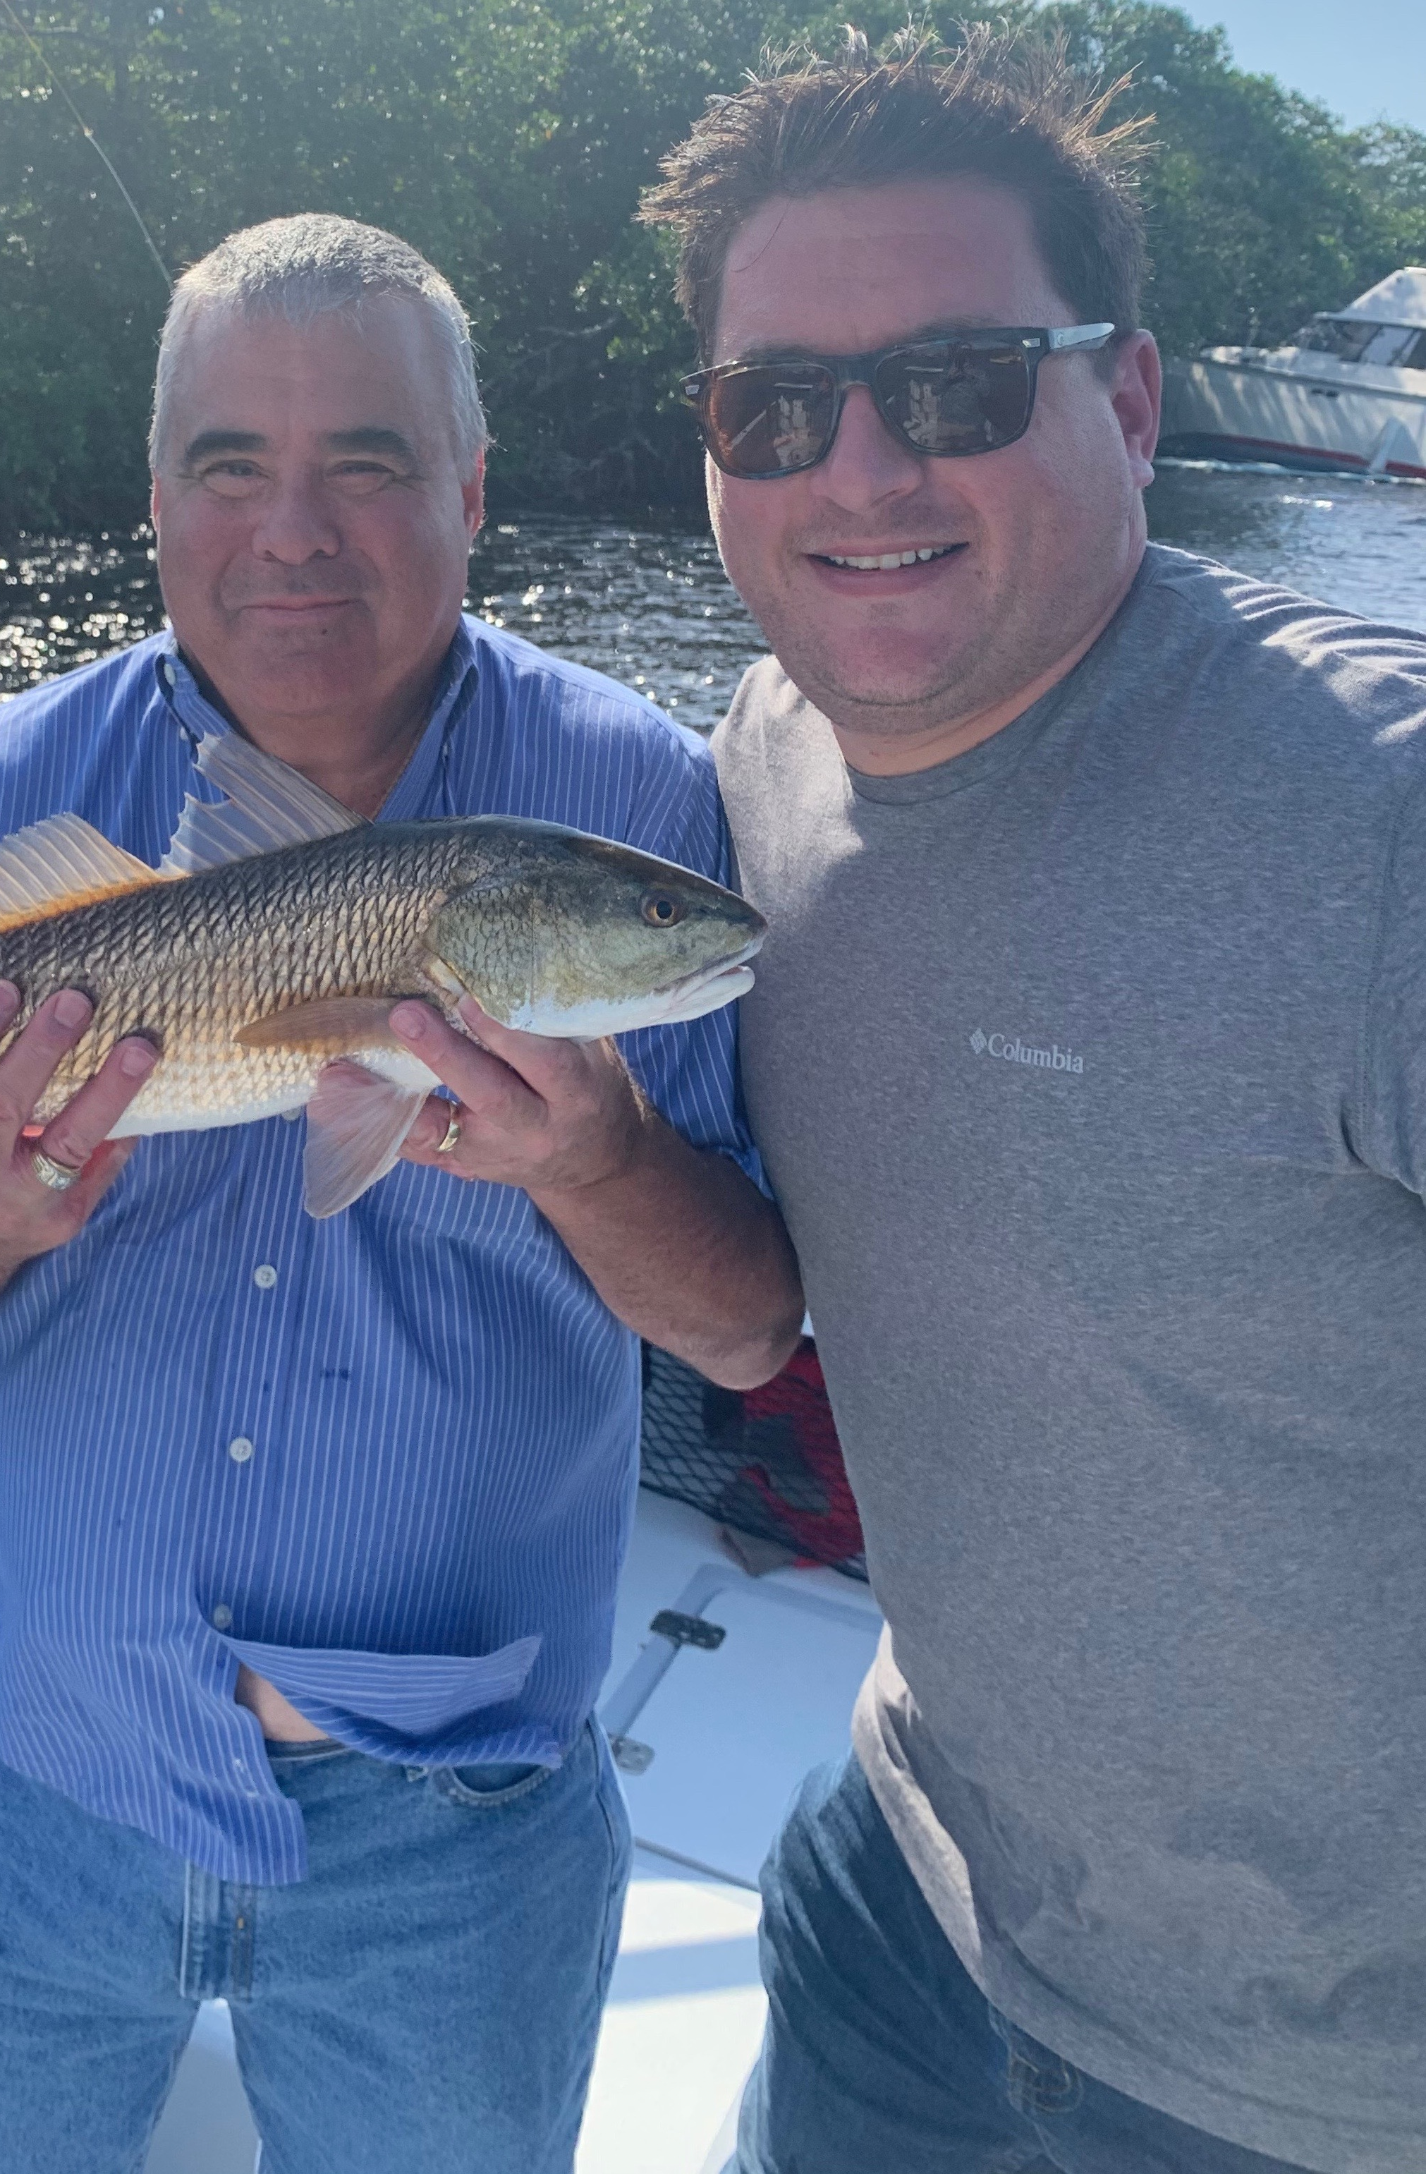

Pic: Vinnie and RJ caught a Pine Island slam while out with Capt Matt Mitchell this week

Challenging weather

Weather continues to play the leading roll yet again in not just fishing but any kind of boating. Fishing during the seemingly never ending windy days is all about hiding from the elements With very few other boats out on the water during these less than perfect days I often had what felt like the whole bay to myself. Options quickly narrow though as 20-30mph winds made open waters extremely sloppy at times.

Even though post cold front conditions made for some bumpy rides once we got tucked away we had successful trips. The mouth of the river proved to be a great option during the roughest periods with the best bite coming on higher water. During lower water I spent time in the usually busy Blind Pass. Mangrove creeks around St James city during the strong incoming tide also held a great mixed bag of species.

Despite the brown stained water in the river the snook bite in Shell creek, sword point and Punta Blanco was very consistent. On windy days these area’s are not only a short boat ride but totally out of the elements.Most of these creek systems offer deep natural channels with an oyster bottom. The fast moving tide snakes through these creeks and offers endless ambush spots to target snook and big jacks.

Low out going tides in the pass made for an amazing snook bite. The strong northeasterly winds gave us some of the lowest tides we have seen since last winter and stacked up the fish. Though most of these snook where not large when you can catch a snook cast after cast its always a good thing. Along with snook my anglers caught a few larger redfish, small gag grouper, jacks and snapper.

When you make you're living on the water fishing in far from perfect conditions is part of the job. Having some neighbourhood confidence spots that are protected from the weather can make even the windiest day a success. To keep everyone comfortable try to avoid long runs and stay out of the rough open water as much as possible. Though the wind takes away options it certainly does not stop the fish from feeding.

