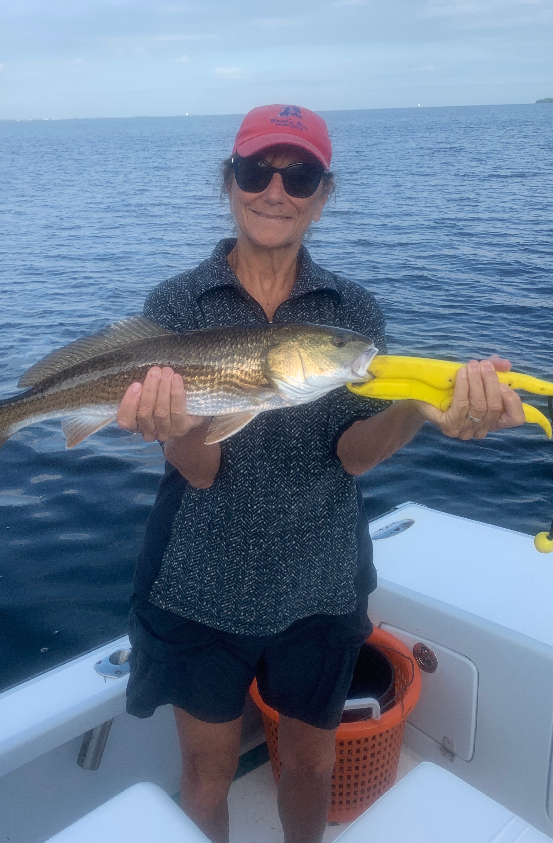

Pic: Barb Rogers from Sanibel with a Redfish she caught while fishing with Capt Matt Mitchell this week

Blown out!

Snook and redfish fishing was non stop this week with most trips loosing count of fish caught. Out along the beaches schools of Spanish mackerel made for easy rod bending action. Bait was plentiful making for another perfect week of Fall fishing. Unfortunately all good things come to an end.

As I’m writing this we have the first major cold front of fall quickly approaching. Currently the entire east coast of the US is under a Gale advisory along with a small craft advisory for the Gulf coast. The forecast winds are over 30mph for the next few days making conditions less than favorable for getting out on the water. These fronts play a big part in our fishing or not fishing from now until at least April.

Anglers who learn the timing of these fronts can see some of the most amazing action of the year. Fishing gradually improves in the few days before a front comes through. The closer the front gets the more active and aggressive the fish become. The stronger the approaching weather the better the bite. Once a front passes through fishing slows and grinds to halt as high pressure and strong northerly winds follow.

This is a relatively early cold front for south Florida. It will drop our water temperatures and will have a positive effect on our fishing by both kicking our bait migration into high gear and moving some snook slowly towards the back country. Creek mouths and mangrove points with fast moving current will begin to load up with snook. This 5 degree drop into the 70’s will really light up our fishing.

