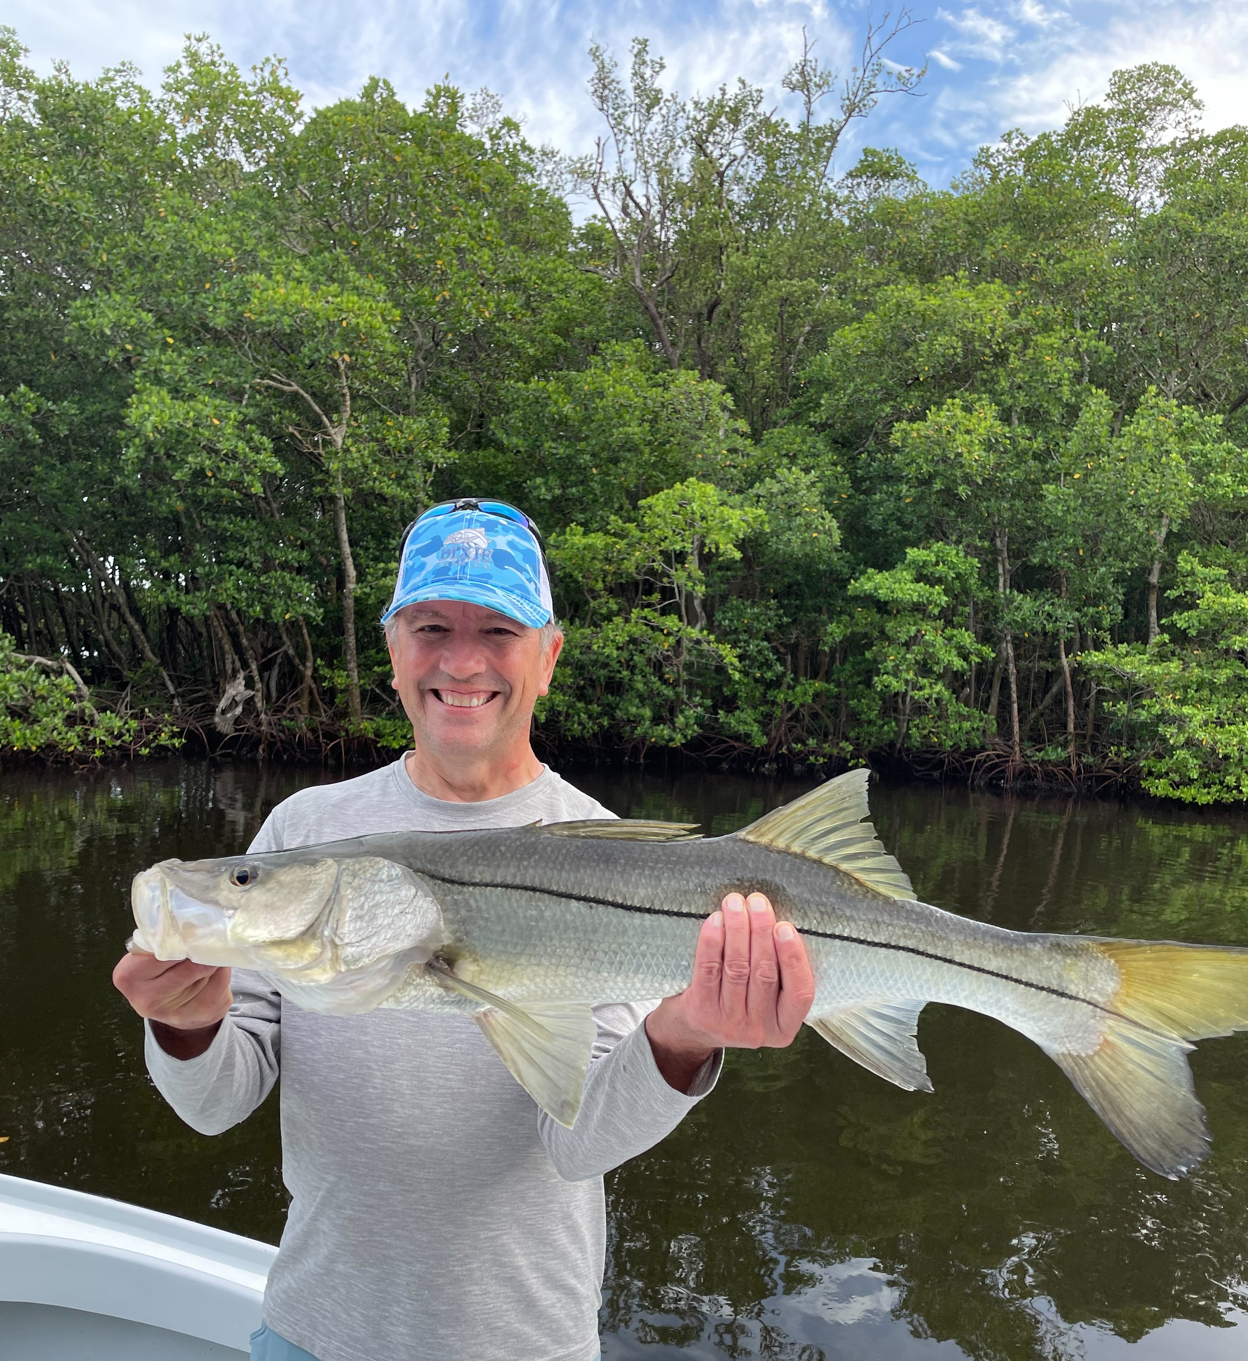

Pic: Dr Larry with a big snook he caught while fishing with Capt Matt Mitchell this week.

Big fish little bait

Tropical storms along with torrential daily rains have made our water browner by the day. This is our typical summer pattern. This tannin run off from mangroves makes for some of the best redfish fishing of the year. Snook have began to make that move back towards mangrove creek mouths and docks in the sound. Flats fishing for trout in the southern sound and river mouth is also another productive option. When fishing for any of the above species one thing has remained consistent, you will catch mangrove snapper.

Redfish fishing in area’s around the mouth of the river from St James city to Merwin key during the higher tides has lit up with all of this fresh water. Tail hooked pinfish and cut baits have both been catching these Reds. Starting at Picnic island and fishing the shorelines and islands west towards York island I’ve been picking out the mangrove points with moving current. If you don’t catch a Red within 5-10 minutes after making accurate casts keep moving. Once you find these redfish it can be non stop. Average size of these fish is from 24-30 inches.

I have switched up snook fishing from the passes and beaches to the middle sound and creek mouths and it proved to be the right move. Chumming live shiners quickly had these snook fired up. Though most of these fish are on the smaller side pitching a bait to a surface feeding snook makes this some fast paced fun action. This week clients had a few “Real Ones” including a 36 and 38 incher. These bigger fish are feeding on the same smaller baits that are so plentiful and everywhere. Using the smaller gear, 2500 reels spooled with 10# braid makes it possible to cast these smaller baits. This light gear makes for some crazy snook battles along with a little heartbreak when they make it back to the structure and say goodbye.

Mangrove snapper remained one of my main targets on most trips this week. These fish are just prolific throughout the entire sound. When fishing these snapper I have been cleaning out the dead thread fins in the live well and pitching them by the handful around docks and mangroves.With a 5 per person limit after catching enough meat for a meal we switched it up to snook and redfish.

Having lots of bait has made my life easy. The more bait in the tank the more options I have for the days fishing. Being able to live chum at every stop quickly fires up any fish in the area. Once you have the fish fired up its been just a matter of casting a hooked bait into the frenzy. For the past few weeks I’ve been catching all my bait in the southern sound including the Tarpon bay flat, St James hump and Sister keys. Once loaded up with this mix of shiners, threadfins and pinfish options are endless.

