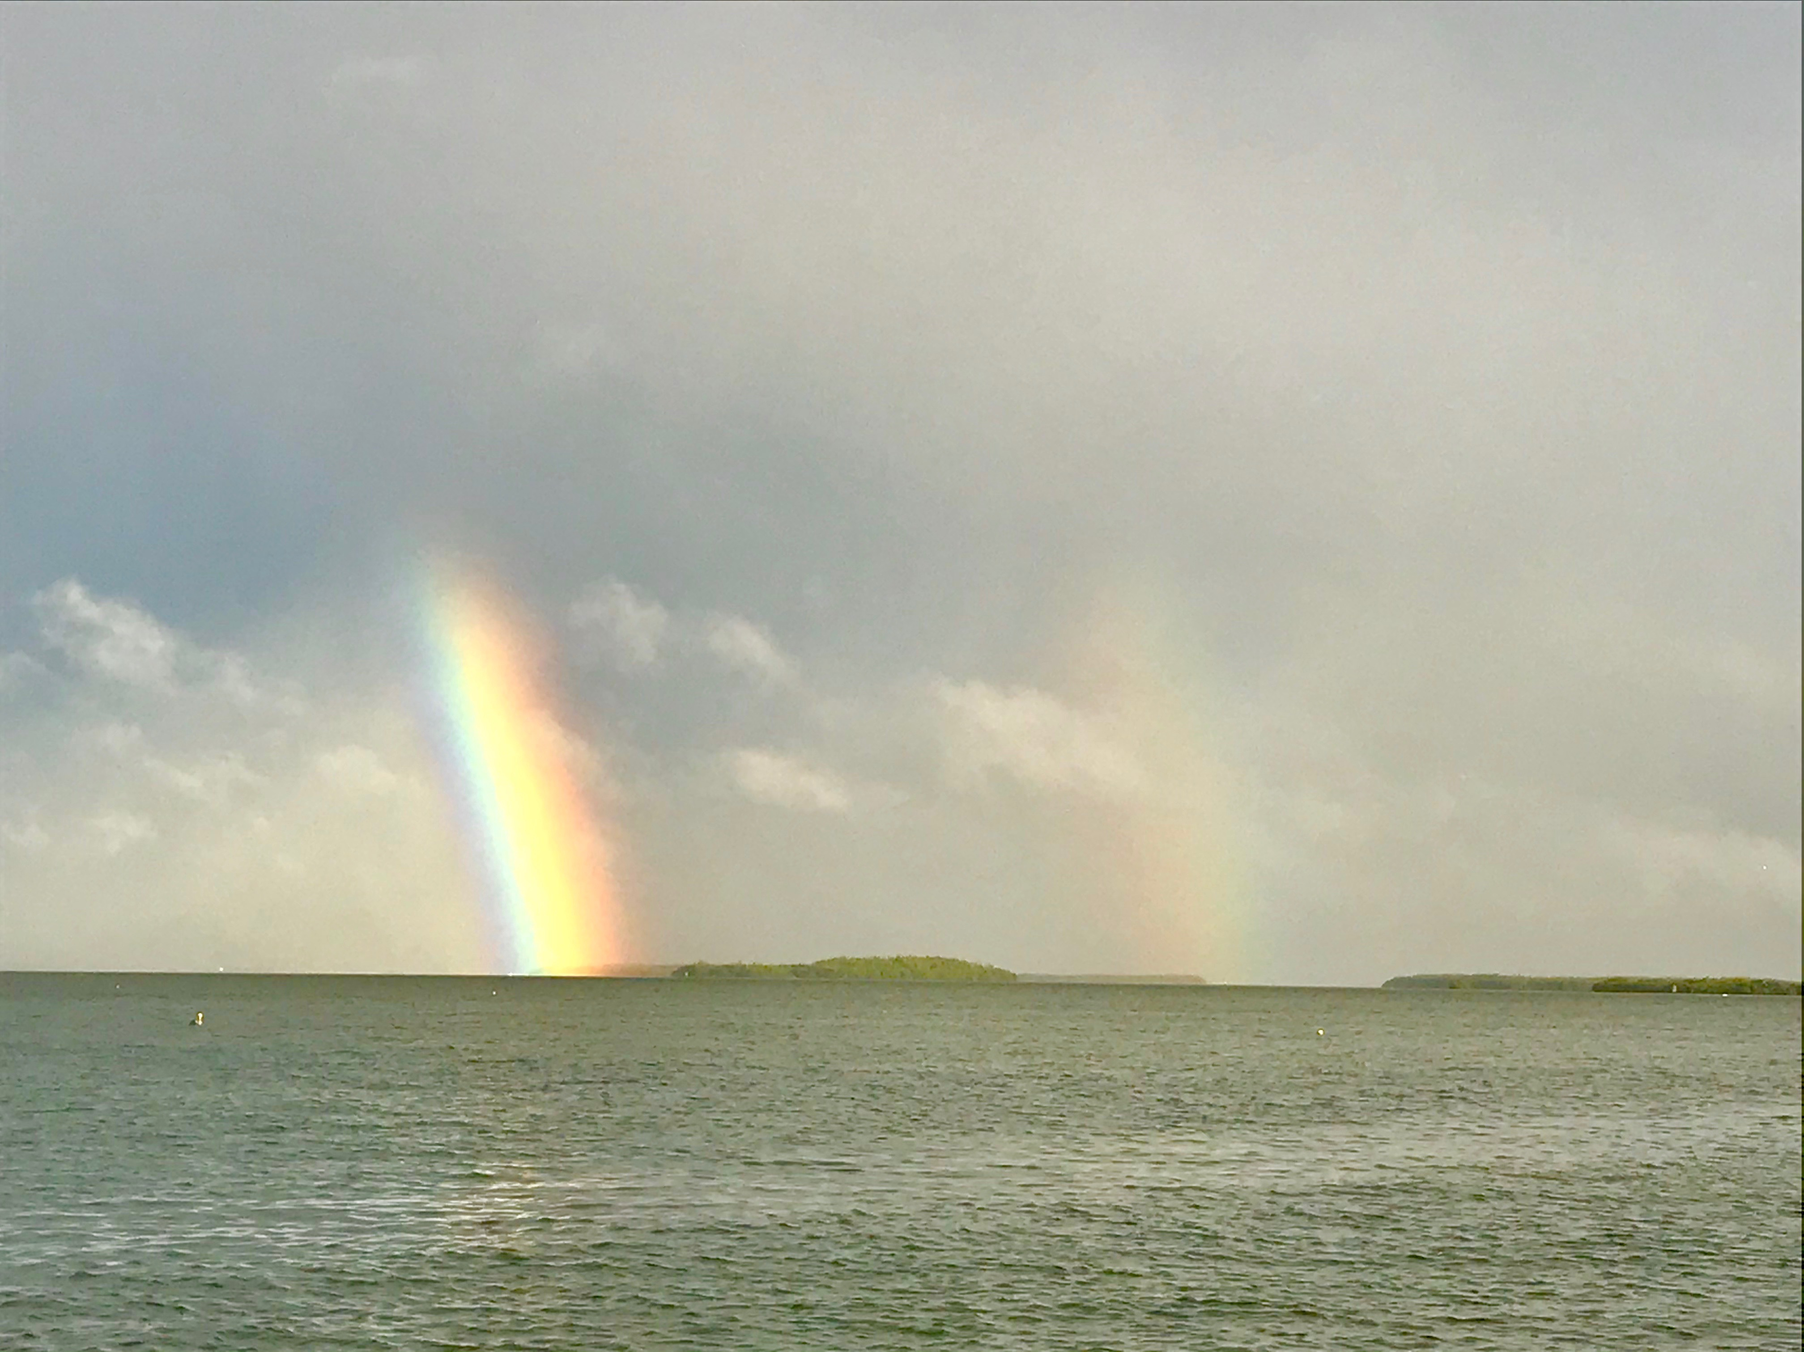

Beat the heat

Pic: Double rainbows as a afternoon thunderstorm approaches

As we move into June it’s hard to believe that it’s not officially summer yet. Crazy hot humid days and afternoon thunderstorms have made it feel more like August. If you plan on fishing or even just boating it’s much more bearable to get out early not only avoiding the mid-day oppressive heat but also the afternoon thunderstorms. These almost daily thunderstorms are fast moving and often very unpredictable. They not only bring dangerous lightening but strong winds and rain. Getting chased off the water will become more and more common.

Many days this week by mid-morning we sat sweating while fishing. Make sun block part of your daily routine. Applying several coats before you leave the house is much more effective than trying to apply it while you are on the water. Staying covered up to avoid sun burn is just part of living in the tropics. Long sleeves, large brimmed hats and sun gaiters help to keep the sun off though some days it just gets so hot you have to pick up anchor and run just to cool off.

Fish are more active too during the cooler periods while during the heat of the day the bite often grinds to a halt. Night fishing can be a great option to avoid the heat also. Heading out after the daily thunderstorms temperatures are much more pleasant. Many nights you will have the most popular fishing spots all to yourself.

Some of my favorite night fishing spots are is in and around the passes. Many docks in the passes have lights and you can see all the fish stacked up. Another favorite option at night is soaking cut baits for sharks. If you pick the right night around the full moon its often very light out. Stay close to home or in the area’s you feel comfortable running your boat in the dark. Fishing off piers, beaches and bridges is also another option for night fishing.

While fishing the passes in the mornings this week both snook and sea trout made for some great action. Seeing so many trout in the passes after they have just not been there in any kind of numbers since the red tide of 2 years ago is a awesome thing and really a testament to the FWC closure on these species. Another nonstop bite this week was Spanish Mackerel fishing between St James City and Sanibel. Big schools of Mackerel could be sight fished as they chased small bait fish up the surface. Mixed in with the Mackerel where lots of smaller blacktip sharks and even a few bigger spinner sharks.

Don’t let the heat keep you home as our fishing is hot too. Start your day early and get back to the comfort of the AC before the hottest part of the day. Summer heat just makes everything move at a slower pace.

