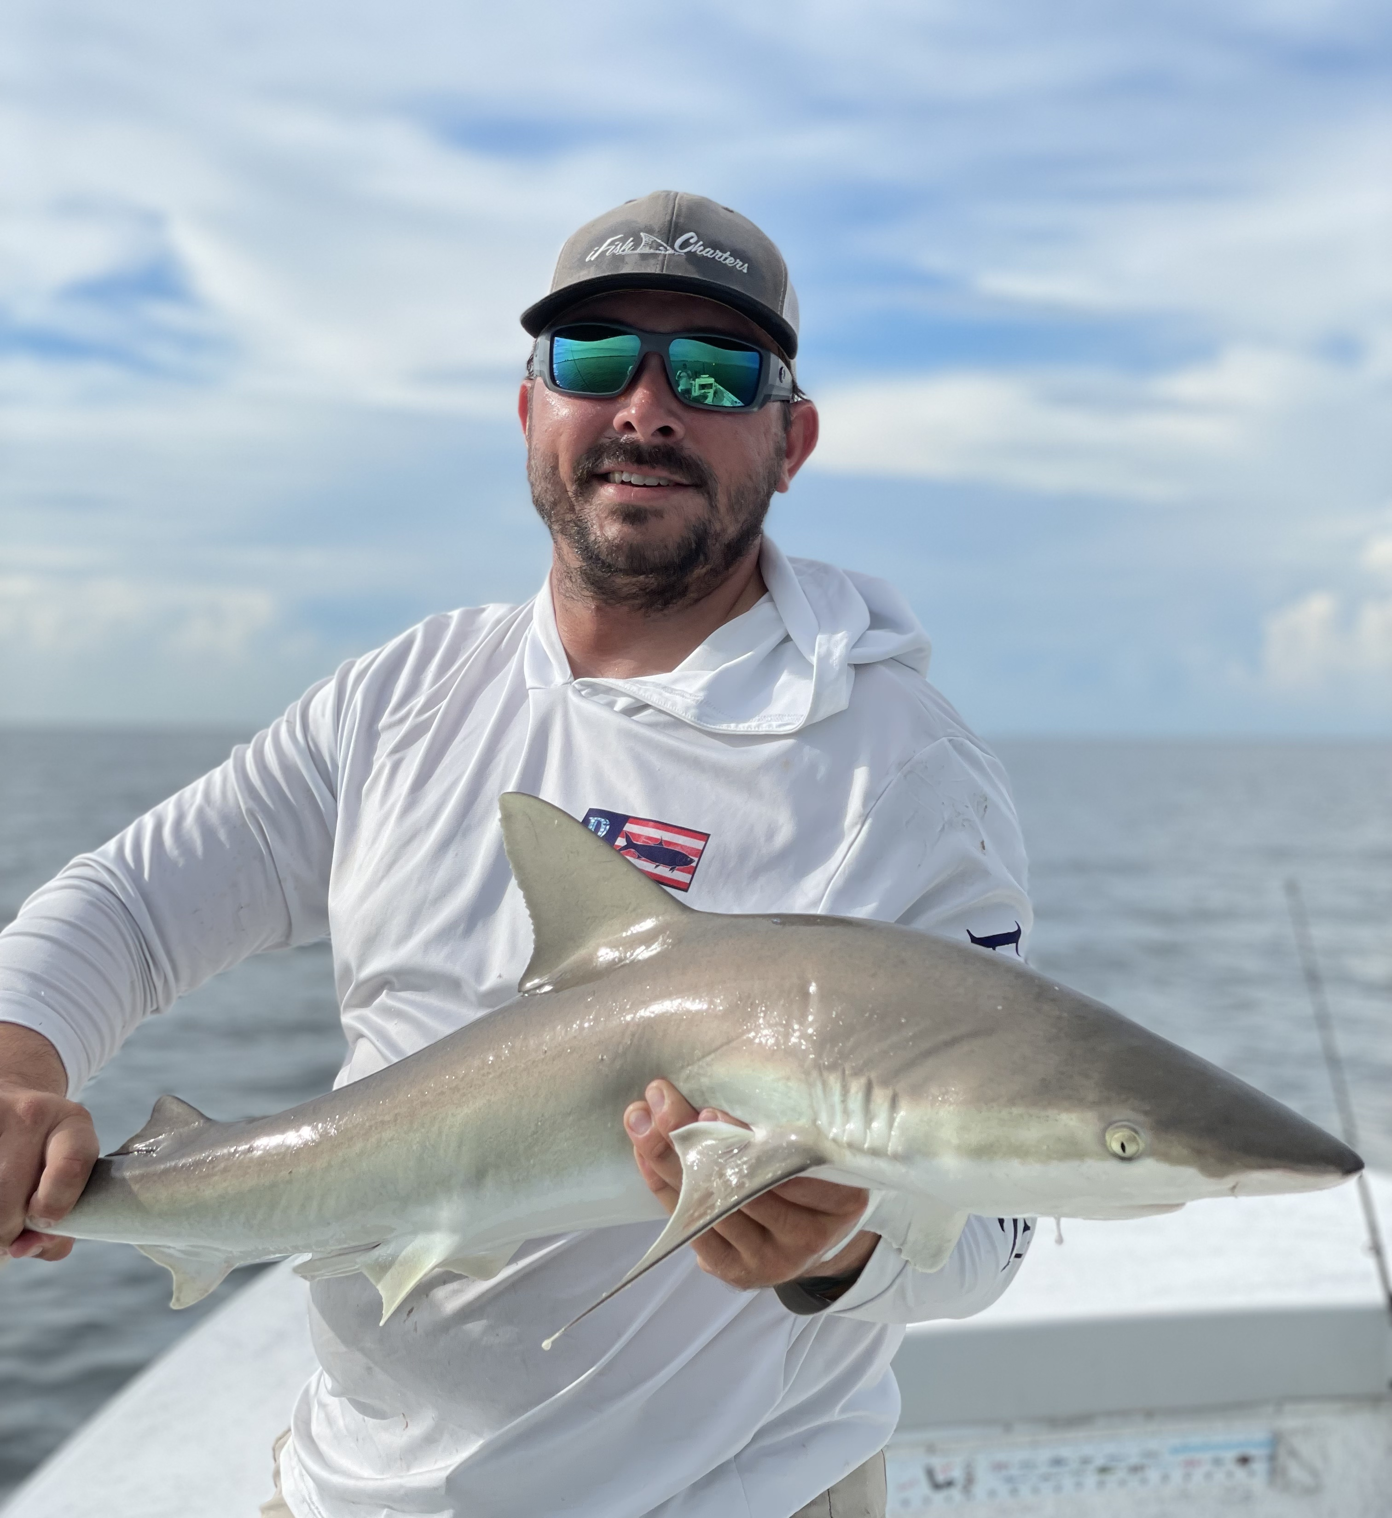

Pic: Capt Jesse Minoski with a black-tip shark caught out on the beach this week
Beach blitz
Action out along our beaches has really picked up over the past few weeks. This fall fishery presents anglers with some amazing sight fishing opportunities on a wide variety of species. Conditions are everything when fishing along the beaches. The longer our weather stays consistently calm the more predictable this bite is. During calm weather periods it’s possible to return to the same places day after day.
My main target out on our beaches this next few months is tarpon. These amazing game fish stack up on schools of bait often within casting distance of the beach. Fall post spawn tarpon are hungry as they are packing on pounds before they migrate south. Watching them crash the surface as they gorge on these schools of bait is an amazing sight. Unlike our Spring tarpon fishing these fish are much more willing to eat a bait with a hook in it.
With so many other types of fish feeding in these same baitfish schools it’s often best to wait until you get a clear opportunity to make a cast to them. Sharks, Ladyfish ,Jack’s, mackerel and even sail cats are all feeding on these bait schools too and will get to your bait before the tarpon. Live pinfish under a float are my bait of choice.
Feeding Spanish mackerel and ladyfish mark the places to start yourtarpon hunt. Usually these frenzies happen in clouds of fry bait in relatively shallow water normally within a mile or so of the beach. Anywhere from Ft Myers beach north to Redfish pass is a good place to get started. Seems the further south you run the less boat pressure there is.
Many days you will have these tarpon all to yourself without anther boat insight. Run the beaches while looking for any kind of bait, birds and life. Once you locate this life shut down and watch. Some days the signs are very subtle with just tips of tarpon fins showing while other times they can be seen breaking the surface as they gulp mouthfuls of fry bait. Something else we find this time of year out on the beach are large muds. These muds seem to disorient the bait fish and are often where the tarpon are feeding. I’m convinced tarpon are mudding the bottom by digging or stirring it up to set up a place to feed.
This action out on the beach can continue as late as January or until we experience our first major cold front dropping water temperatures below 70 degrees. The past few years this bite has finished up by around thanksgiving. For the next few months I will take advantage of any chance I get to fish this beach bite with or without clients. Although it’s not as consistent as our Spring tarpon fishery it will bring some of the most wide open tarpon fishing of the year.

