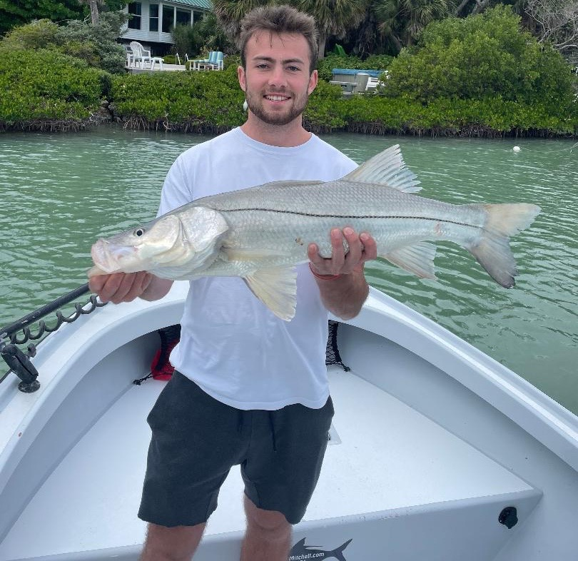

Pic: “Big Snook George” always seems to get it done

Be flexible

Some trips this week no matter how bad we wanted to catch one particular species we just had to switch it up and go a different route to the goal. Being flexible enough to spend some time on each variety of fish during the right period of the tide throughout the trip seemed to give us the best results.

During the higher tide periods we found the better sheepshead bite in and around the passes. Chunks of fresh shrimp on a jig head fished both in the channels and up tight to barnacle covered structure caught them up to 19 inches. With our water temperatures still a little warmer than I like to target these fish we also caught snapper, jacks and even a few redfish while using this method. Being able to send clients home with that coveted sheepshead dinner often required weeding through both lots of shorts along with a mixed bag of other species.

While targeting Sheepshead one morning with clients from Illinois this week in the last hour of the trip we had only one keeper sheepshead in the box though we had caught fish the whole trip. Returning to a favorite spot inside of Blind pass that we had fished earlier in the trip without success the bite had now turned on. Within 10 minutes we had dinner covered as we went back-to-back to back on 16–18-inch dinner sized sheepshead.

Being able to shiner fish while the sheepshead bite wasn't going on a game changer this week. Minus low tides proved to be the perfect set up for snook while fishing deeper mangrove creeks and pockets. Several of the area’s I love to be during the “crazy low water” take the presence of mind to get into before the tide bottoms out. This basically traps you in a creek system until the water comes up high enough to exit. This can only be described as a strong move but can really pay off as it’s like fishing in a barrel when you nail it.

One variable both when targeting Sheepshead and Snook are Dolphins. One end of the morning trip back into the Ding Darling this week we had a couple of hungry Dolphins follow us from spot to spot. Although each stop would produce a fish or two the Dolphins would charge in trying to eat the fish and blow out the spot. After being followed around by all that can be described as a wild pack of Dolphins I picked up and moved. No matter where you choose to fish at some point you will have Dolphins coming in looking for that easy meal. Please do not feed them no matter how cute they are its not only against the law it creates a nuisance Dolphin. These amazing creatures are more than capable of finding their own food.

