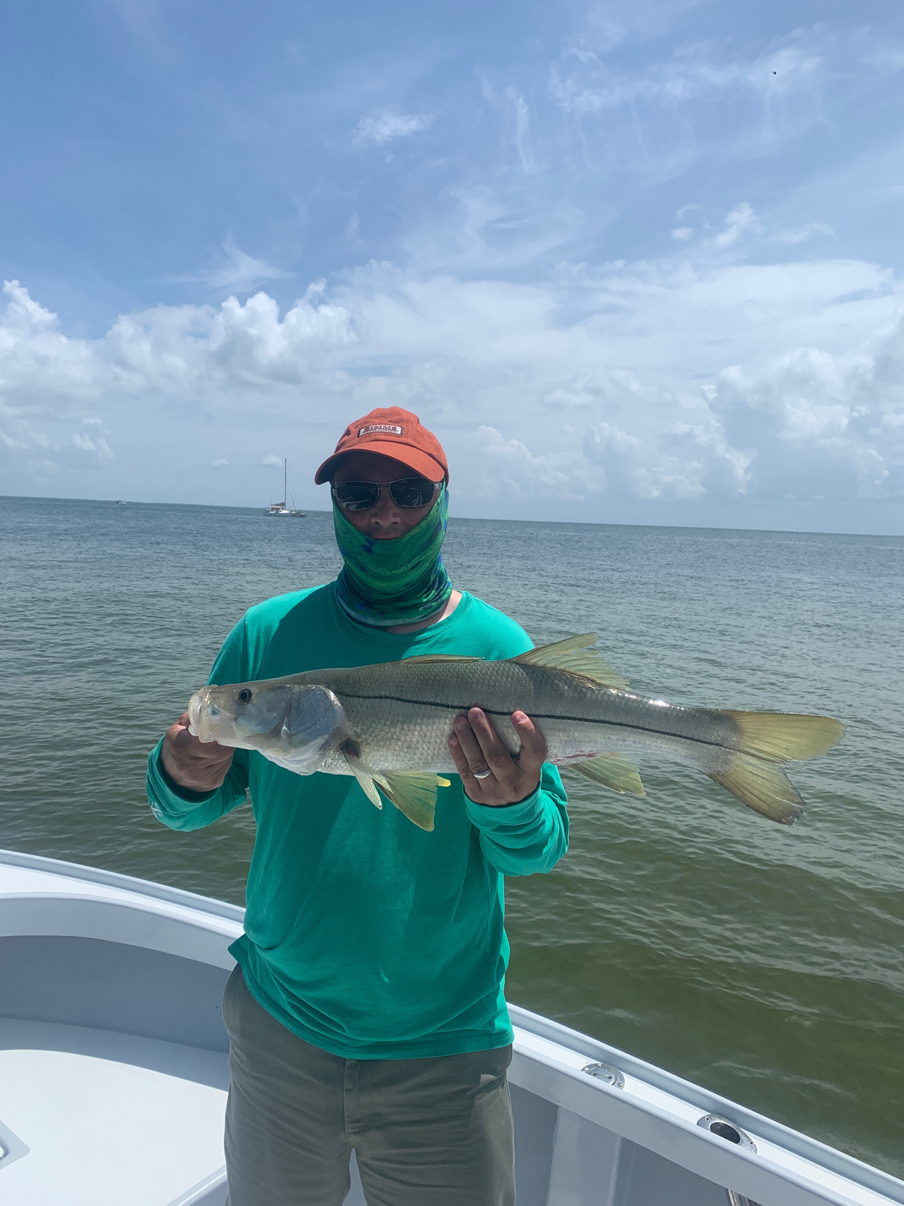

Barry fires up the bite

Pic: Greg Treep from MN with a 31 inch snook caught and released with Capt Matt Mitchell this week.

Slow moving Tropical storm Barry slowly developed right on top of us over the past week and dropped rain at almost any time. Dodging or trying to avoid the rain worked out for the most part though I seemed to get soaked at least once a day. Rains and winds associated with this disturbed weather pattern kept the water stirred up and made fishing out along the beaches just too rough. Action in and around the passes was non stop with the dirty milky looking water proving to be the perfect set up for catching Snook, redfish and trout.

Cloudy cooler days where a much needed break from our oppressive summer heat making it much more bearable. The disturbed weather patter also cut down on boat traffic as most days only a few boats could be found fishing the normally busy passes. On our trips this week we spent our time fishing in and around all the passes with the best bite coming during the outgoing tide.

Snook fishing has kicked into high gear with 30 plus fish days becoming normal. Most of these fish are not big measuring from 20-26 inches though most trips we tied into a few larger females. Along with snook in the passes we also caught redfish and trout while doing the same thing. Small pinfish and grunts put down close to the bottom with either a split shot or sliding sinker was the best presentation. Both drifting or anchoring in the passes caught lots of fish. If you see everyone drifting and catching fish don’t anchor in the middle of the drift. Some days a strong southerly wind was opposite to the tide making drift fishing impossible and requiring anchoring.

While fishing in the northern Sound during a full day charter this week I located snook on the bayside of Cayo Costa in super clear water. The 1st group of 30-50 fish I spotted where smaller males that once we got the boat set up we caught on almost every cast. Moving a little further down the same shoreline was the reason the small males where in such good numbers, a group of much larger female snook. On our first few casts we watched these big girls just cruise by the bait. Then we cast the shiners almost to the beach so the bait would slowly drift through these laid up Snook. After several casts we did get to watch one of these bigger fish flash and flair its gills as it inhaled the bait in about a foot of water. Although we only managed to hook and land one of these 30 plus inch fish it was awesome to see the ariel show in the super shallow water as this fish almost beached itself.

