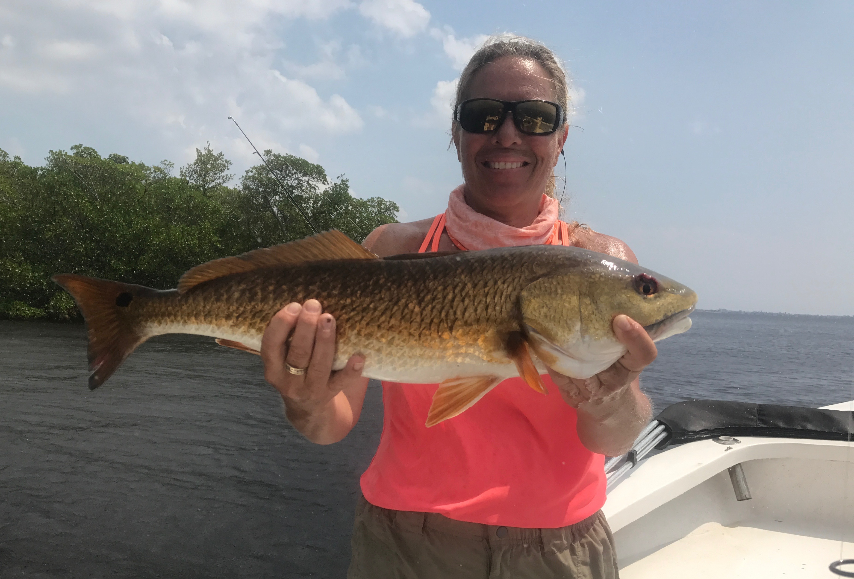

Banging hot September redfish action!!

Picture: Mary Laser with one of the redfish she caught while fishing with Capt Matt Mitchell this week.

September action as advertised is as good as it gets on both redfish and snook. The abundance of gamefish and the noticeable lack of boats on the water is just that perfect combination. Schools of hundreds of over slot sized redfish are roaming shallow flats during the low tide periods within close proximity to the flats. The amount of attention these schooling redfish attract is amazing with sharks, birds, jacks and dolphins all around them as the eat everything in sight.

Through October fishing these schools of redfish when ever possible is some of my favorite fishing of the year. Most of the mature redfish in these schools are 30 inches and larger and just make for great sight fishing when conditions are right. Spotting these schools is easiest during low tide light wind conditions but often once you locate them you can return to the same areas on the flats for a few days in a row successfully until the tide pattern changes. These redfish will eat basically anything thrown out in front of them from cut bait, live bait to spoons and topwater plugs. Having a bait that you can cast along way when these fish pop up is the main objective.

Big Jacks often are mixed in with all these redfish and at times out run the charging redfish to get your bait. The majority of this incredible redfish action happens in really shallow water. Once you get these fish in casting distance its not unusual for every angler on board to be hooked up at the same time. One of the hottest spots all week was out in the open water on the shallow flats around Hemp key. Patience can pay off big time, just be rigged and ready when the opportunity presents its self as often you will only get a few shots at a school before it moves on or drops off into deeper water.

During the higher tide periods the better redfish action has been fishing under the mangroves and around oysters bars. Although this bite is not usually as fast paced as fishing the open water schools I have pulled a half dozen or so reds off one tiny little shoreline with the majority of these fish falling in the slot size. Tail hooked pinfish are my bait of choice for this and work as good if not better than any other kind of bait this time of year.

If you need a break from all that post Irma yard work or just need some quality time on the water pick up the phone and put a Florida fishing guide back to work. Many of my fellow guides all over the state are suffering from a post hurricane slump as the whole state of florida according to our national news looks out of business when this is not really the case at all. Only a few parts of our state are in a rebuilding mode and for the rest of us its been business as usual.

