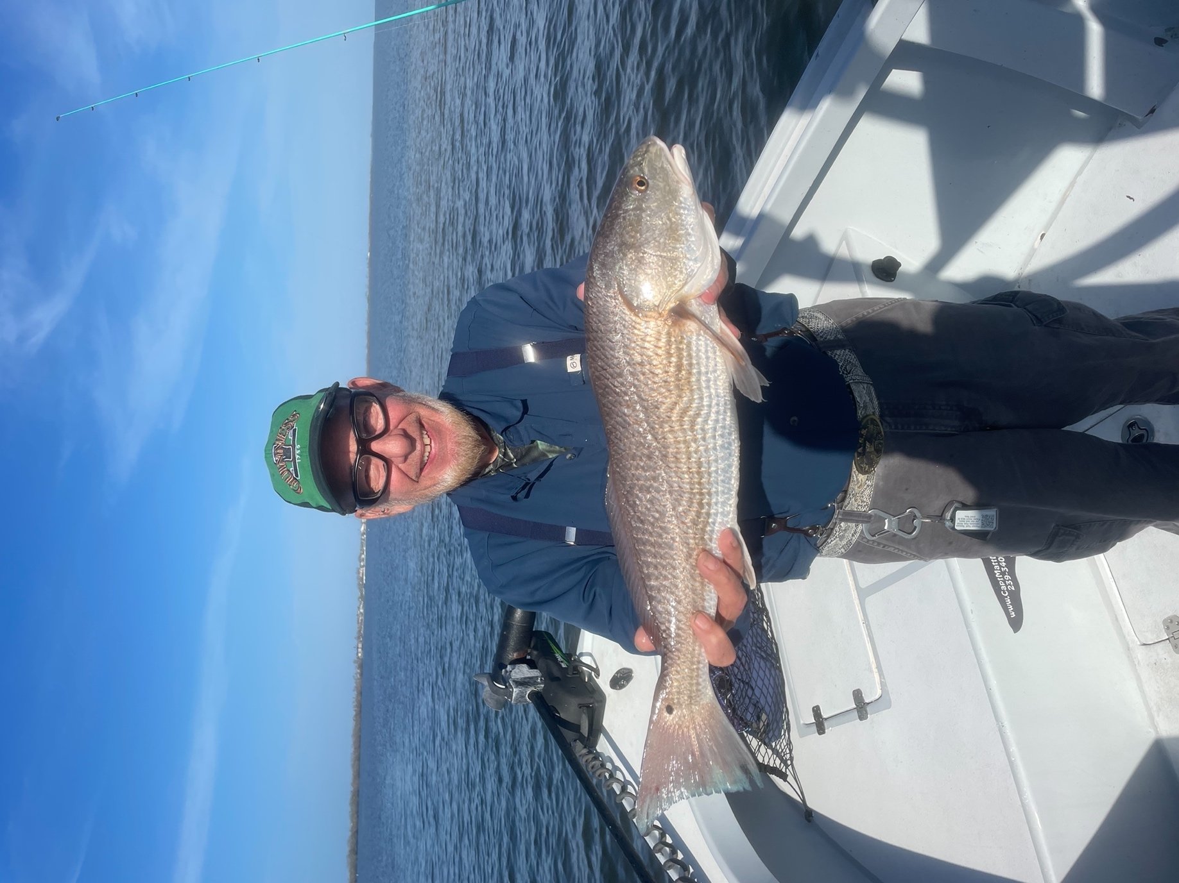

Back to business

If you live in SWFL or even watch the news you know September 28th was the day Hurricane Ian made landfall and changed our lives forever. The destruction caused by this massive storm not only destroyed many homes and business but left most of our coastal communities shellshocked. The pictures simply do not show what it was and is still like. Now more than two months later we have started to pick up the pieces and are on that slow trek to recovery.

Immediately after the storm boats played an important part to access our barrier Islands while the bridges where being repaired. The first few weeks were all about bringing important supplies to my friends and neighbours in St James city as they were cut off from the world. My daily run from the mid-point bridge included fuel, water, food and anything else required. Then I’d take people off island and back to the mainland. During this same time, we managed to salvage anything saveable and totally gut our house which was flooded with 50 inches of water. Staying busy was the key to staying sane during the 1st month.

I would like to thank the many friends and clients that have reached out to us over the past few months. This emotional support and generosity has kept us going through what continues to be one of the toughest things we have ever had to deal with. Everyday things get a little more back to normal as we are now living in a travel trailer during the rebuilding of our house. Being back in St James city is a must as we are close to the Marina, our boats, friends and neighbours.

Luckily both my boats survived the storm with no damage and getting back to fishing over the past month is a huge part of our recovery. I’m back open for business although this season will be a whole lot different as we will not see all the clients who usually stay on Sanibel and Ft Myers beach resorts. The majority of the marinas and boat ramps will remain closed both to guides and the public. Throughout this whole thing the Monroe Canal Marina in St James City has remained open and I’m very fortunate to be able to still run charters.

Fishing has been outstanding over the past month with such little boat traffic and angler pressure. We did have to deal with some spotty red tide in the sound though over the past week it seems to have left. Waterways do have some debris though it gets less and less every day. Many of our mangrove islands have lost most of the leaves though the fish seem to be in all the same places. Both redfish and snook have been my main targets.

All our local businesses are going through what’s going to be a lean year. It sad but unfortunately many places are either gone or will never reopen. For businesses that did survive trying to stay open is going to be a challenge with few visitors expected this winter. Accommodations are going to be a little tougher though Air B&B’s will be available along with hotels in the surrounding areas. When clients ask what they can do to help the simple answer is “Come down and go fishing”

