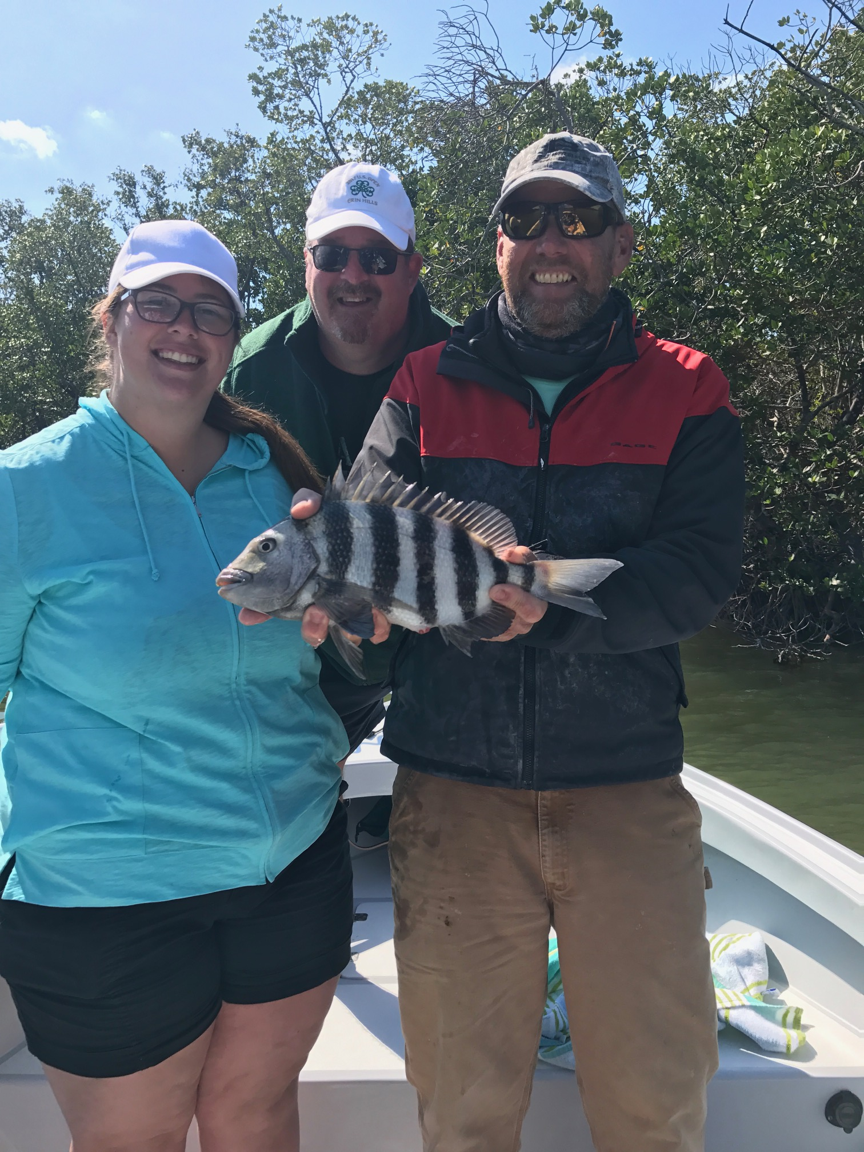

Picture: Jenna and John Scott from Chicago enjoyed some Sheepshead and black drum action with Capt Matt Mitchell this week

Back to a winter fishing pattern yet again

Yet again plunging water temperatures brought on by another cold front totally switched our fishing back to a winter pattern even though the calendar says its spring. Just as water temperatures had begun to rebound a few really cold days quickly dropped it back to a chilly winter like 62 degrees in the sound. Although this cold weather brings the Snook bite to a complete stop other species turned on and kept the action going.

Sheepshead and black drum became our target species again while hiding from the wind and trying to stay warm and comfortable. Areas around the passes and dock fishing with chunks of shrimp caught lots of keeper sized Sheepshead. One surprise this week was finding a new dock that produced lots of black drum of all sizes. One cold blustery day we manage to catch 4 legal sized Black Drum while fishing this dock ranging from 16 inches to 24 inches. The smaller Black Drum are great to eat and put up a good battle on light tackle. Returning back to this same dock we caught these black drum for three days in a row.

With a colder than average March playing out for us shrimp fishing will remain the daily go to until our water temperatures rebound. During the few days we experience south winds and warmer weather just before the passing of a cold front its worth giving shiners or pinfish a try. Until our water temperature creeps back into the high 60’s shrimp are going to give you the best action. Both live Shrimp and Shrimp chunks are giving my anglers the best opportunity to not only catch a wide variety of species but to go home with dinner too. Every species of fish that swims in our waters will eat shrimp and during these coldwater periods a small profile bait like a Shrimp will get a bite when simply nothing else will.

Some of the week’s best action came while fishing with chunks of fresh shrimp. Breaking of the tail of the shrimp and threading it on the hook backwards before pinching off the head not only makes a very small compact offering but also puts scent in the water. Although I’m seeing lots of bigger Sheepshead in the clearer water area’s the better bite has come in the more churned up water closer to the passes. Look for some of the better Sheepshead fishing around the docks within close proximity of the passes. While fishing these docks you may get surprised with a variety of other species including Drum, Redfish and Pompano.

