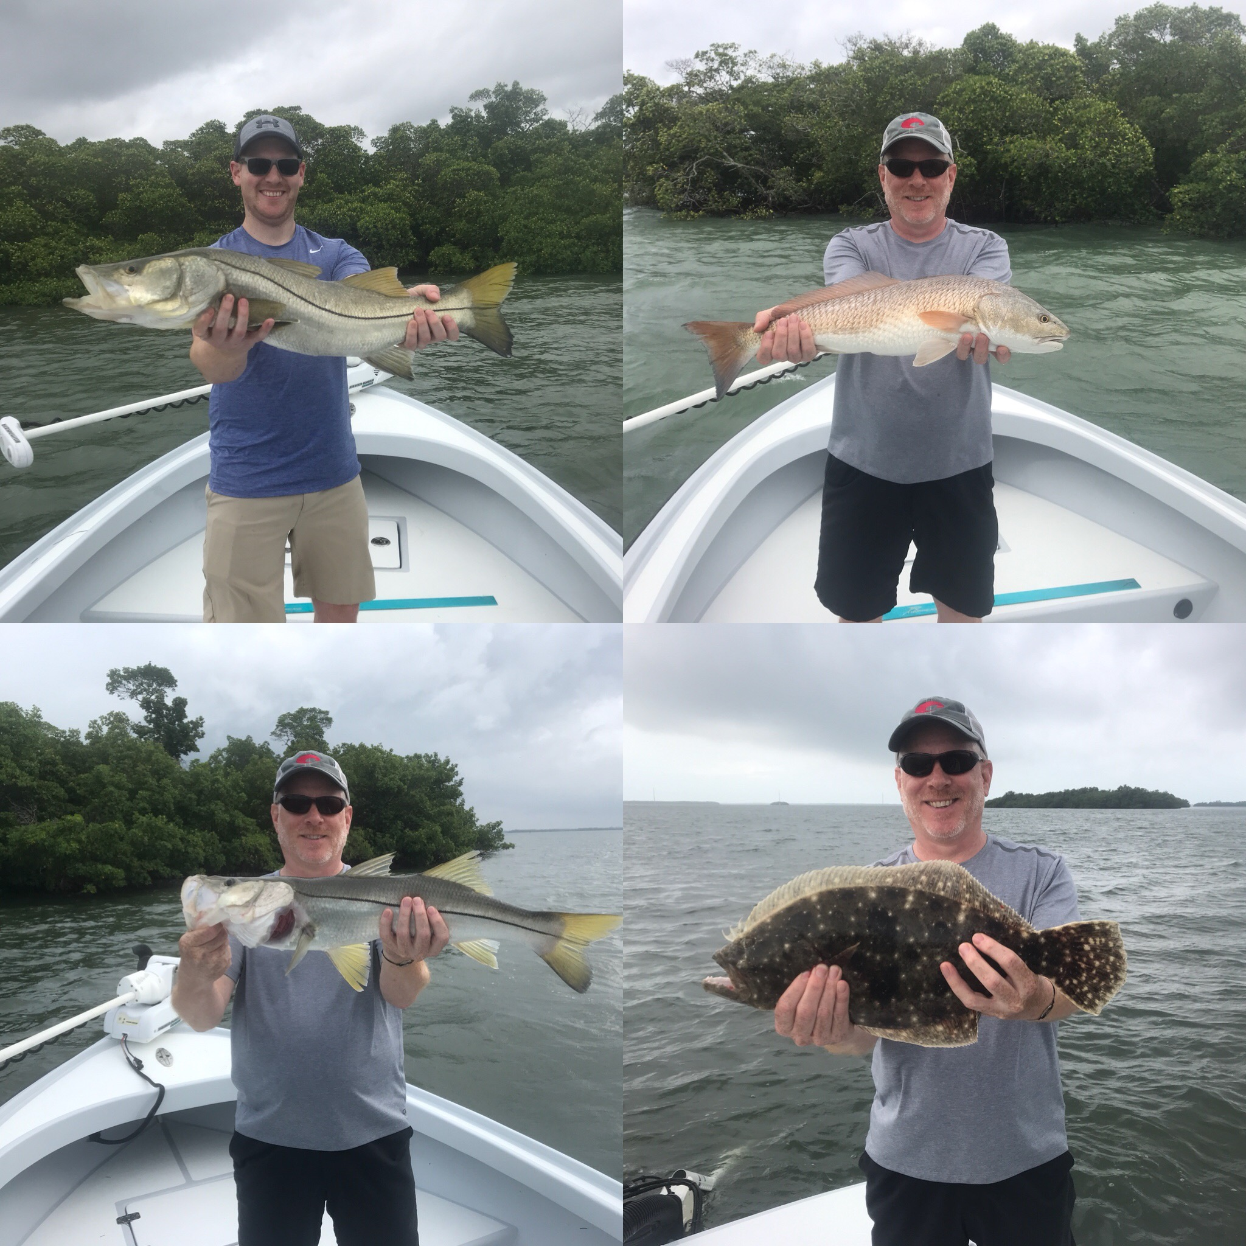

Pic: Bryan and John Majewski from Wisconsin with multiple species caught while fishing with Capt Matt Mitchell this week

Back at it after the storm

After days of rain and strong winds associated with the first tropical storm of the season I finally managed to get back out onto the water mid week. Major weather events like this always change up our fishing and also make catching bait more difficult than usual. Taking clients fishing after not been on the water for several days just does not feel right, it’s like going blind as you don’t have any intel from the days before.

Fishing for a full day the first day back on the water with long time clients Bryan and John Majewski from Wisconsin early morning fast moving rain caused us to push back the pick up time by a little bit. I did struggle to get enough shiners and had to move locations several times. Winds where still a little gusty and the skies overcast with scattered rain that we would have to dodge most of the day.

For our first stop I chose a southern facing shoreline with a deeper channel dead ending against the mangroves. Casting the shiners in close to the shoreline it did not take long for Bryan to hook up. This first fish of the day felt like the baitfish was hung up on the bottom, after a few turns of the reel the fish came up and did a head shake on the surface. The second time this fish came up to surface I realized d it was a giant flounder, quickly grabbing the landing net this was the largest flounder caught on my boat in years and measured a whopping 24 inches. After a few more casts we had a few Snook bites then landed a 28 inch Snook and a 15 inch mangrove snapper. With a big flounder and mangrove snapper in the fish box I knew I had there dinner covered and the pressure was off a little bit.

Working our way north next we did not catch a single fish for the next two hours and the bite just quit. Even with strong south winds I could just not find any moving water and saw fish laid up on every shoreline we fished. Taking a break for a lunch stop I decided we would spend our time fishing the southern sound, as it was also closer to home if we had to dodge the weather. Bouncing around the very south end of St James City the tide was now super high and the ideal set up I had been hoping for all day. Mangrove shorelines now began to turn on with a few Snook coming to the boat before Bryan hooked and landed a fat 25 inch Redfish.

John so far had only caught a few smaller fish all day but was still working hard at it. This next stop turned his day around, pitching larger tail hooked pinfish into the mangrove shadows John hooked into the fish of the day a big hard fighting Snook. After a few close calls with the mangrove roots the fish came boat side for a few pictures before a careful release. John’s “trip maker” was a fat 34 incher. A half hour later strong rain bands moving in chased us off the water as we called it a very memorable day!

