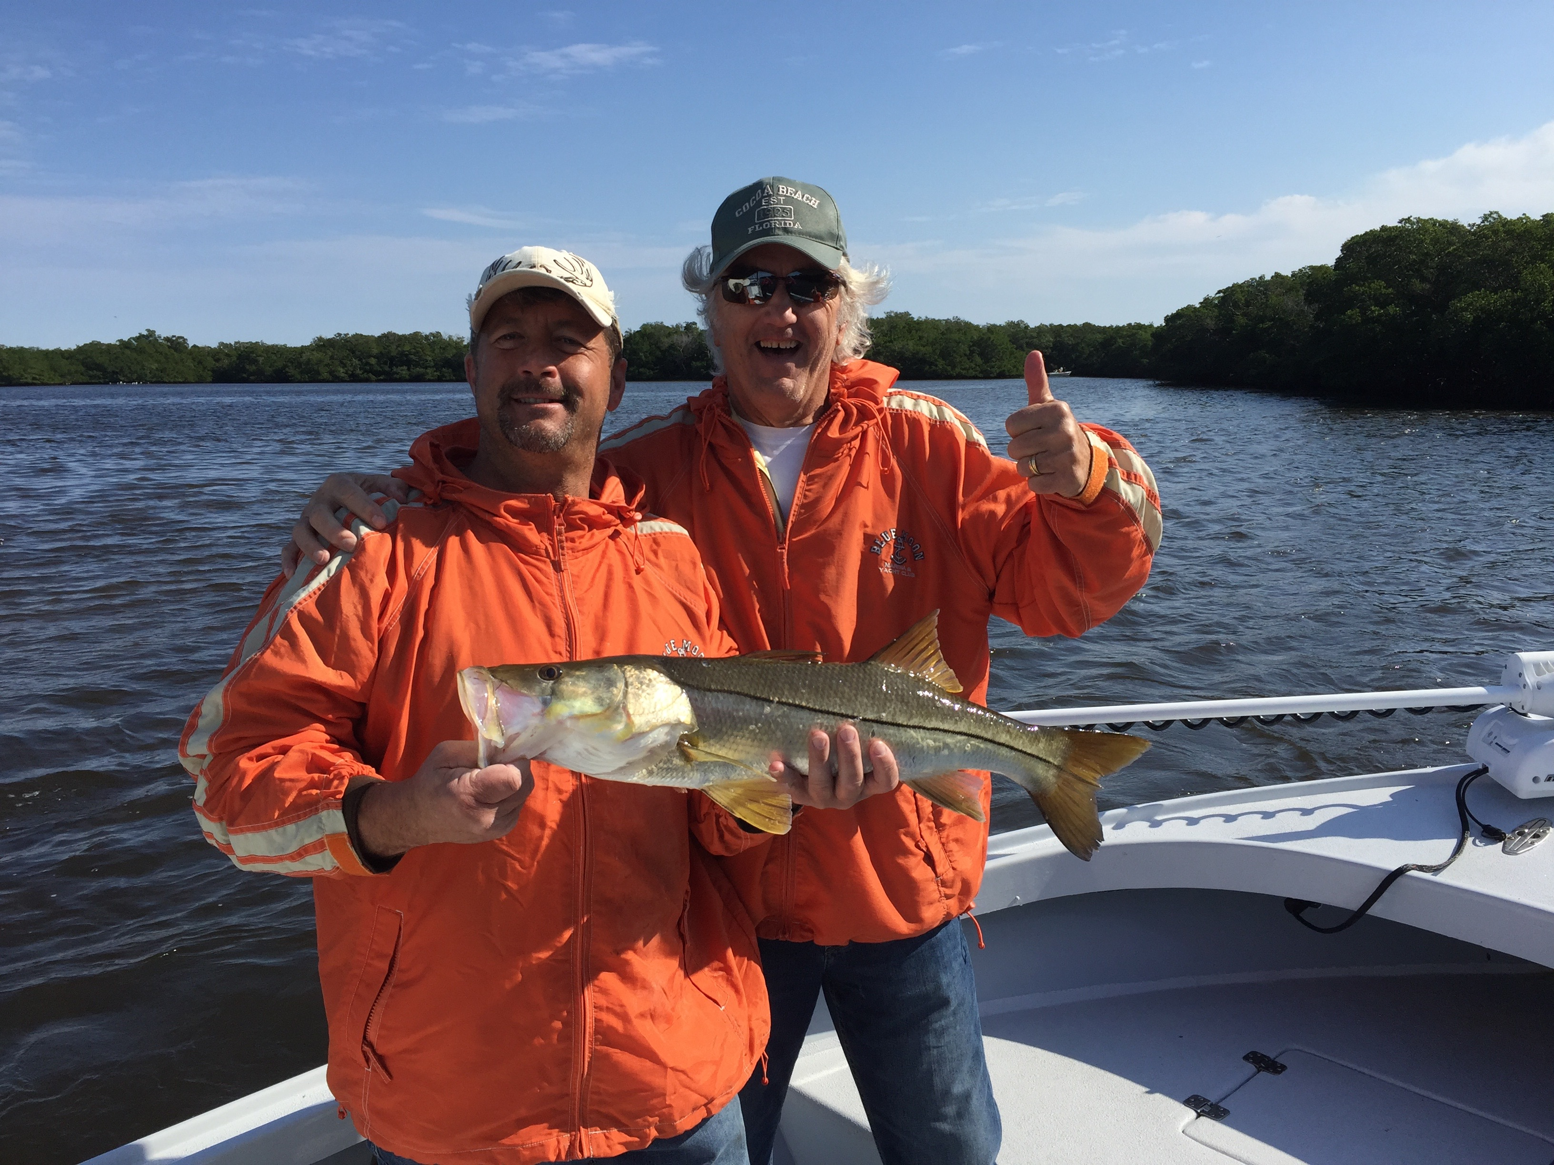

Picture: Father and Son Ray and Paul Salasa happy about a Snook caught while fishing with Capt Matt Mitchell

September Snook season opener.

Tropical rains kept anglers off the water this week for what seemed like days. The one real plus of this major rain event was the cooling off of our water temperature which dropped into the low 80’s for the first time since May. This drop in water temperature will do wonders for our fishing action and should kick some of the best redfish fishing of the year into high gear.

September 1st is the opening of Snook season and with cooler dirty water brought on by this tropical system will be the perfect set up for fishing our passes. Large pinfish and Grunts weighted down or drifted during the fastest periods of the tide will get it done if your chasing that first keeper sized fish of season. The fall Snook season which is open from September 1st till December 1st always seems the more productive of the two seasons as warmer weather has the fish more active than the colder February to May season.

Shiner fishing for Snook is my everyday method and along with chumming live shiners catches more Snook than any other technique . Both oyster bars, mangroves and docks within close proximity to the passes will be holding Snook as we are reaching the annual transition time when they move back into the bays and estuaries after the spawn. For catching sheer numbers of Snook its hard to beat live shiners but if your targeting the larger models big baits and patience are often what it often takes. With great numbers of Snook caught all summer long this Snook season should be a good one.

When it comes to keeping or harvesting a Snook I’m not apposed to it though when out fishing with clients we generally release more slot sized fish than we keep. With such a small slot size of 28-33 inches and a relatively short season landing a legal sized snook is far from a everyday event. With the excellent FWC management of the species our Snook fishery can certainly handle this short controlled harvest.

When asked by clients if Snook are a good fish to eat my answer is yes but we have better table fish to eat that are much more abundant. I think partly what makes a snook so tasty is catching a legal fish during the short season. Snook being so slow growing and one of our hardest fighting game fish are a whole lot more valuable to most anglers than just a fish dinner.

