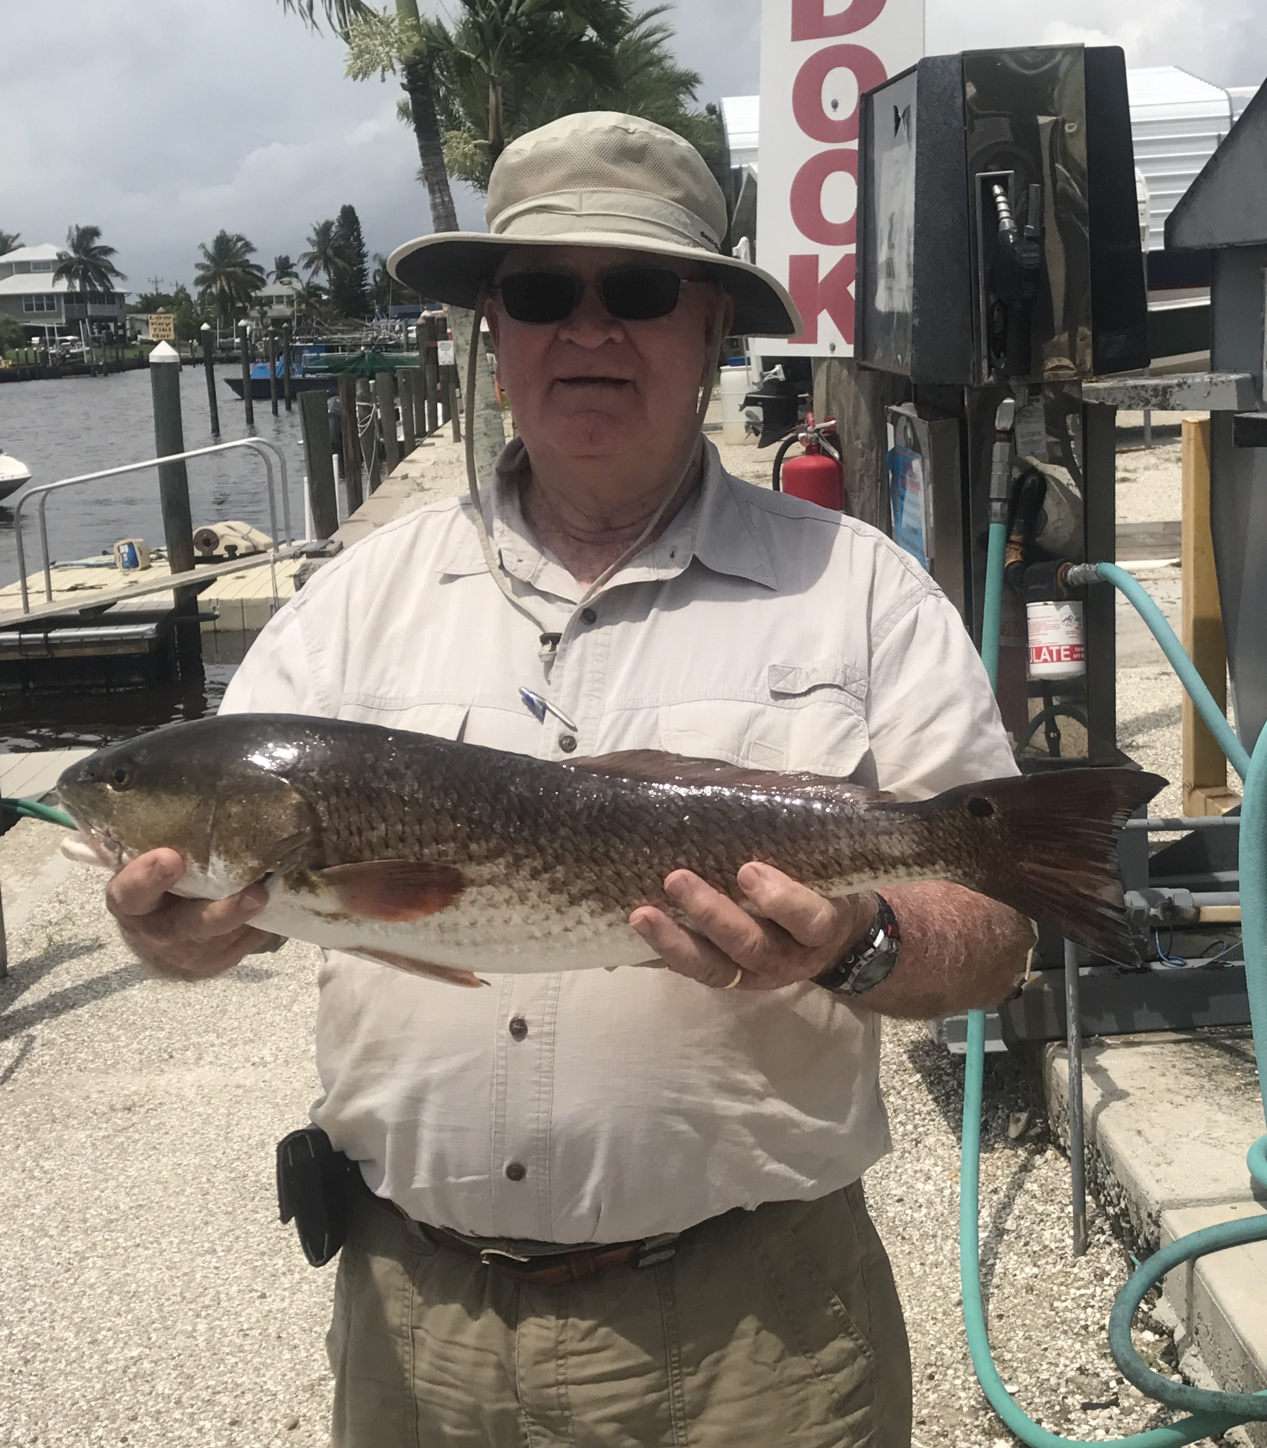

Picture; Gillie Russell from Lake Placid with a 25 inch redfish caught while fishing with Capt Matt Mitchell

Rain cooled water fires up fishing.

After more than 12 inches of rain last week I was not sure what to expect when getting back out on the water and what effect it would have on fishing. The first day out after the rains had finally slowed I was pleasantly surprised at how easy of a time I had catching bait. Usually with so much fresh water being dumped into the bay from all the rivers and estuaries the bait is the first thing to head out offshore seeking better salinity. With a live well full of shiners I picked up my clients and headed out feeling blind after not being on the water fishing due to bad weather for 4 days.

Opting to stay close to home as scattered rain was still moving through and the wind was still blowing it did not take long to bend the rods. My first stop was a favorite deeper sand hole up tight against the mangroves during the high outgoing tide. It did not take long at all to get the fish fired up as we caught snook, mangrove snapper and even a 25 inch redfish all from this first stop of the day.

Once this bite slowed I felt the pressure was off me a little bit as we had six 12 inch plus mangrove snapper and a 25 inch redfish in the cooler. These long time clients from central Florida are all about taking fillets home and with two days of fishing booked with me it felt good to get them on the meat early. Bouncing around the southern sound on day one we stayed busy catching lots of catch and release snook and finishing out limit of Mangrove snapper.

By day two conditions where much better and allowed me to basically run anywhere in the sound I wanted to fish. Making a longer run up on the bayside of north Captiva it was amazing how clear and better the water looked. This middle to northern end of the sound gets a much better flush with larger passes and the lack of river water. With birds and bait everywhere you would have never thought we had had such a major rain event. We started our day fishing some oyster bars on the high water and continued catching lots of Snook and Mangrove snapper. As the tide got lower I moved to a deeper channel that load up with mangrove snapper on submerged structure and we hit pay dirt. Mangrove snapper up to 16 inches came out of the water feeding on the live shiners I was chumming and within 20 minutes we had our limit of big Mangs.

Later in the week the 4-6ft grass flats behind North Captiva and Cayo Costa within close proximity to the passes had some crazy wide open action on a mixed bag of fish. This cleaner clearer water was loaded with Trout, ladyfish, Snapper, Mackerel and small Gag Grouper. Casting live free lined shiners we caught fish on just about every cast. There where not many keeper fish but this non stop action was just fun fishing. I returned to these same grass flats with the same results all week long. The cooler water that resulted from all the rain really did wonders for fishing.

