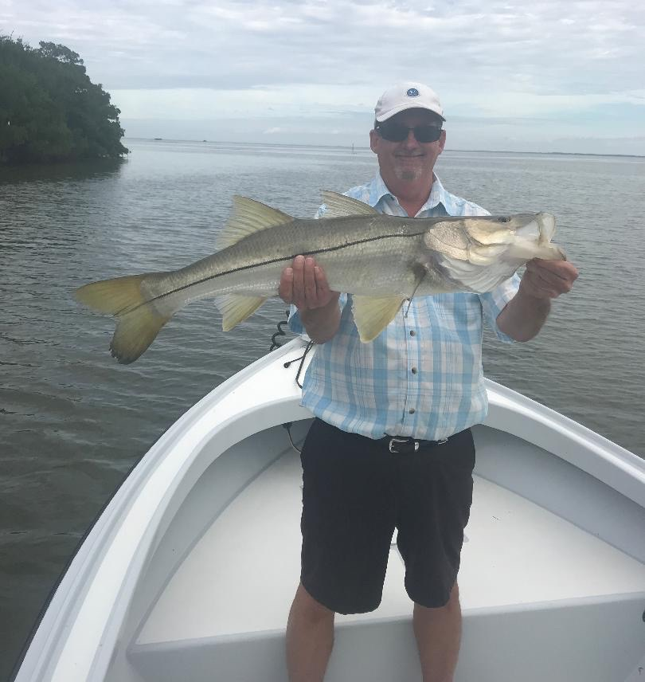

Picture: Nick Little from Columbus Ohio with a 35 inch Snook caught while fishing with Capt Matt Mitchell this week

Winter and Spring tactic’s

Most days this week started off with cool windy winter like conditions then by mid morning temperatures gradually warmed. Trying to get fish to eat live shiners for the first few hours of a charter was just not happening so we needed to switch it up. Going to the cold water winter stand by of chunks of shrimp on a jig head caught a wide variety of species including sheepshead, black drum and rat redfish. By mid morning as things warmed up we were able to switch back to live shiners and got lots of snook to bite.

Along with the morning cold and north winds we also had extremely low full moon tides making many mornings feel more like it was January. These minus low tides exposed sandbars and grass flats all over the sound that I have just not seen since last winter. During these super low tides fish stack up in deeper water area’s, this low water set up is a excellent time to catch lots of fish. A few of the places that worked really well for us on the minus low water included docks at the south end of the Roosevelt channel, the Chino Island channel and Shell creek. What all these places have in common is deep fast moving water with structure. This week brought some of the first legal sized sheepshead I have caught this winter.

By mid morning as the incoming tide started to get up we had some great catch and release snook action. Snook are still spread out from the beaches and passes to the back country as we are in a major transition time as these fish are just starting to make the move to the warmer sheltered water places they will winter. Once you locate these Snook the bite was often wide open with 20 plus fish coming out of one shoreline. Wind blown mangrove creeks and shorelines exploded with snook of all sizes being caught. Some days it took a little bit of moving until we found these fish but once we did you could often just keep bumping down the shoreline to keep this bite going. As conditions warmed by the weekend we began to catch snook earlier and earlier each day.

