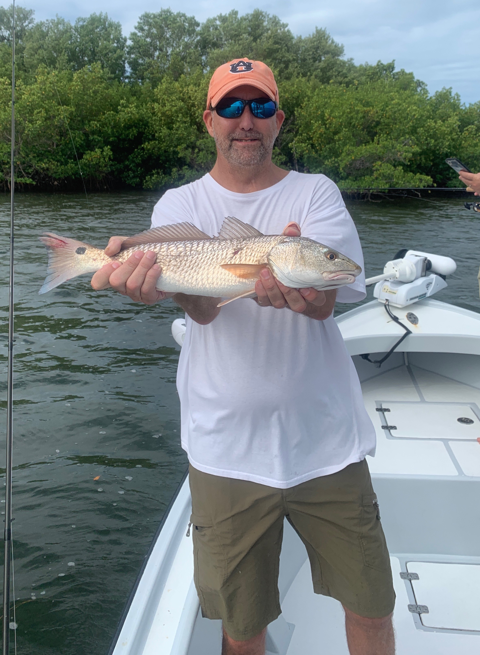

Windy start to Fall

Pic: Mark Stockdale from Panama City with a redfish caught while fishing with Capt Matt Mitchell this week.

What seemed like day after day of strong east winds just would not give us a break all week long. Luckily if its going to blow 20-30 mph east is one of the easier wind directions to hide from. Our mornings would start out choppy then winds would ramp up as the day progressed. Anywhere on the eastern side of the sound depending on the stage of the tide was the only show in town and basically the only place to keep your clients comfortable.

Flats around Demere key in roughly 3-4ft of water held wide variety of fish including Trout, Ladyfish, Jacks and Snapper. This area in the eastern middle sound has been my “busy place” for at least the last month. It has been a great stop to keep the rods bent with fish often coming on what seemed like every cast at times. Locating the feeding birds in this area was the telltale of what these fish are doing from day to day.

Anywhere from the very outer bar in to the tip of Demere key offers a few square mile area which on a east wind is very sheltered and holds lots of fish. Water color on this side of the sound has remained clear compared to the stirred up middle to westside of the sound. Some days it can take a little moving around to get these fish dialed in. This entire area offers both deeper sand holes and shallower grass flats all within a few hundred yards of the marked channel. On the higher stages of the tide I’ve been fishing over the grass then on lower stages of the tide fishing the deeper sand holes.

On a windy day charter over the past weekend we opted to stay close to St James city and spent much of our time fishing St James Creek. If you are not familiar with this creek system, it starts in the southern end of Matlacha Pass and works its way up through many shallow bays north. Many of the channels and creeks that connect these bays are solid oyster shell bottom and have extremely fast moving current. While spending a few hours tucked away we caught good numbers of Snook, redfish and Mangrove snapper all while casting live free lined shiners. This whole creek system see’s very little boat pressure and is very fishy.

With daylight savings time not coming to a end yet for over a month November 3rd can’t get here soon enough for me. If you have not noticed its still dark out in the mornings until 7am. This has made catching bait before picking up clients a real scramble the last few weeks. Our bait fish just do not appear in any kind of numbers until the sun rises. Though the cooler mornings with less humidity have been a very welcome change as summer is now officially over.

