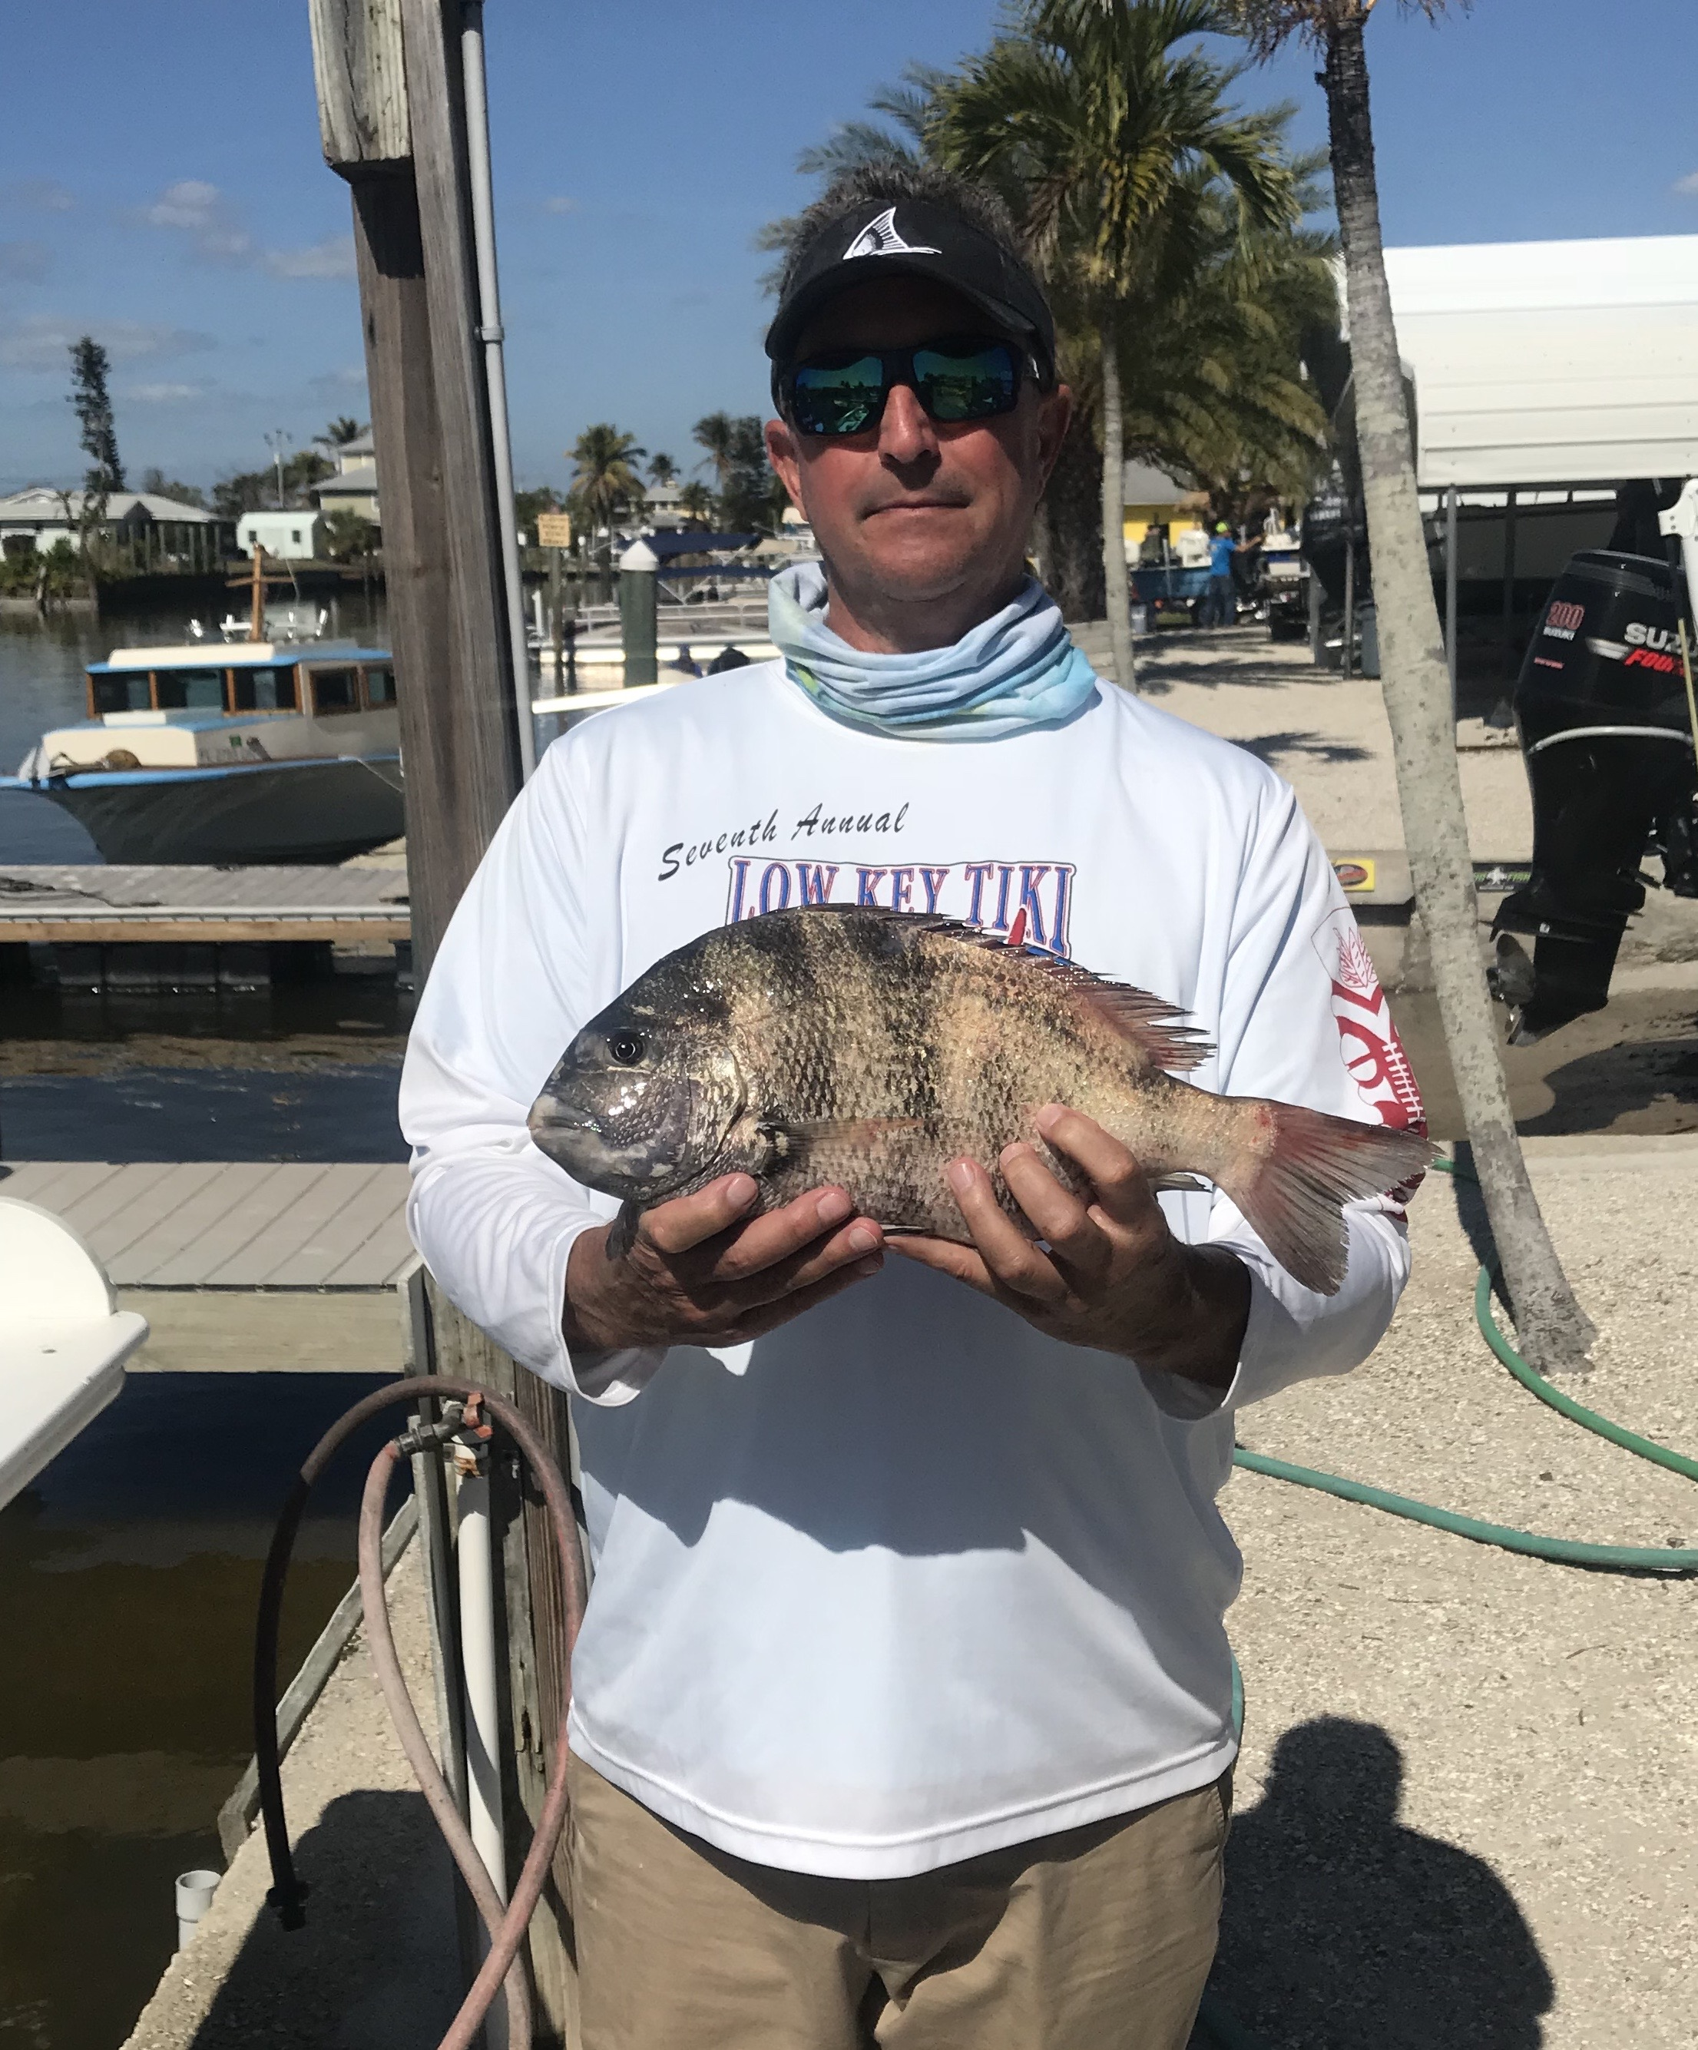
Picture: Bradley Agerton with a Sheepshead caught this week while fishing around the passes with Capt Matt Mitchell

Warm up is now underway

As we are finally entering a big warm up period forecast for the next ten days fishing is going to wake up coming back to life offering anglers lots of options. For almost a month now we have been dealing with cold water conditions. As things gradually warm back up to around that magical 70 degree mark over the next week catch and release snook fishing will come back alive after what has been a prolonged winter hibernation.

Sheepshead fishing will stay good the whole month of February as this is prime time for these fish to come inshore to pawn. Look for these fish all through our waterways or basically any place they find barnacles and structure to group up on. This past week, Sheepshead were my main target on my charters. We successfully caught them any where from the mangrove creeks in the Ding Darling during the windy times then in and around all our local passes when conditions allowed. Docks in canal mouths and along the inter-coastal also had lots of these tasty fish on them. Moving current was the key to which docks held fish and which docks did not. Coolers full of Sheepshead made it to the fillet table all week along with a few black drum and a redfish or two.

During calm periods nearshore wrecks and reefs are hard to beat for a great mixed bag of action. Large Sheepshead, grunts and snapper can all be caught fishing close to the bottom. Look for feeding birds while making the run out to these wrecks and you will find the Spanish Mackerel. Stone crab pots are also worth checking out for tripletail if conditions are right. Most of the reports of tripletail I have had this last few cold weeks have come from out in the 40ft range. As water temperature rise these tripletail will be found much closer in. Many of the more well known wrecks and reefs including the causeway reef, May reef and Edison reef are all worth dropping a bait down on, fishing right on the heavy structure is the key to this.

Although I do enjoy Sheepshead fishing my favorite winter fishing is catching snook on live shiners. With this bite almost being totally shut down by the cold water I can’t wait for these fish to turn back on. Warming water temperatures will fire these fish up, I expect this bite to go nuts deep in the mangrove creek systems at first then in the deeper creek mouths as the water temperature gets to 70 degree’s for the first time since January 1st.

