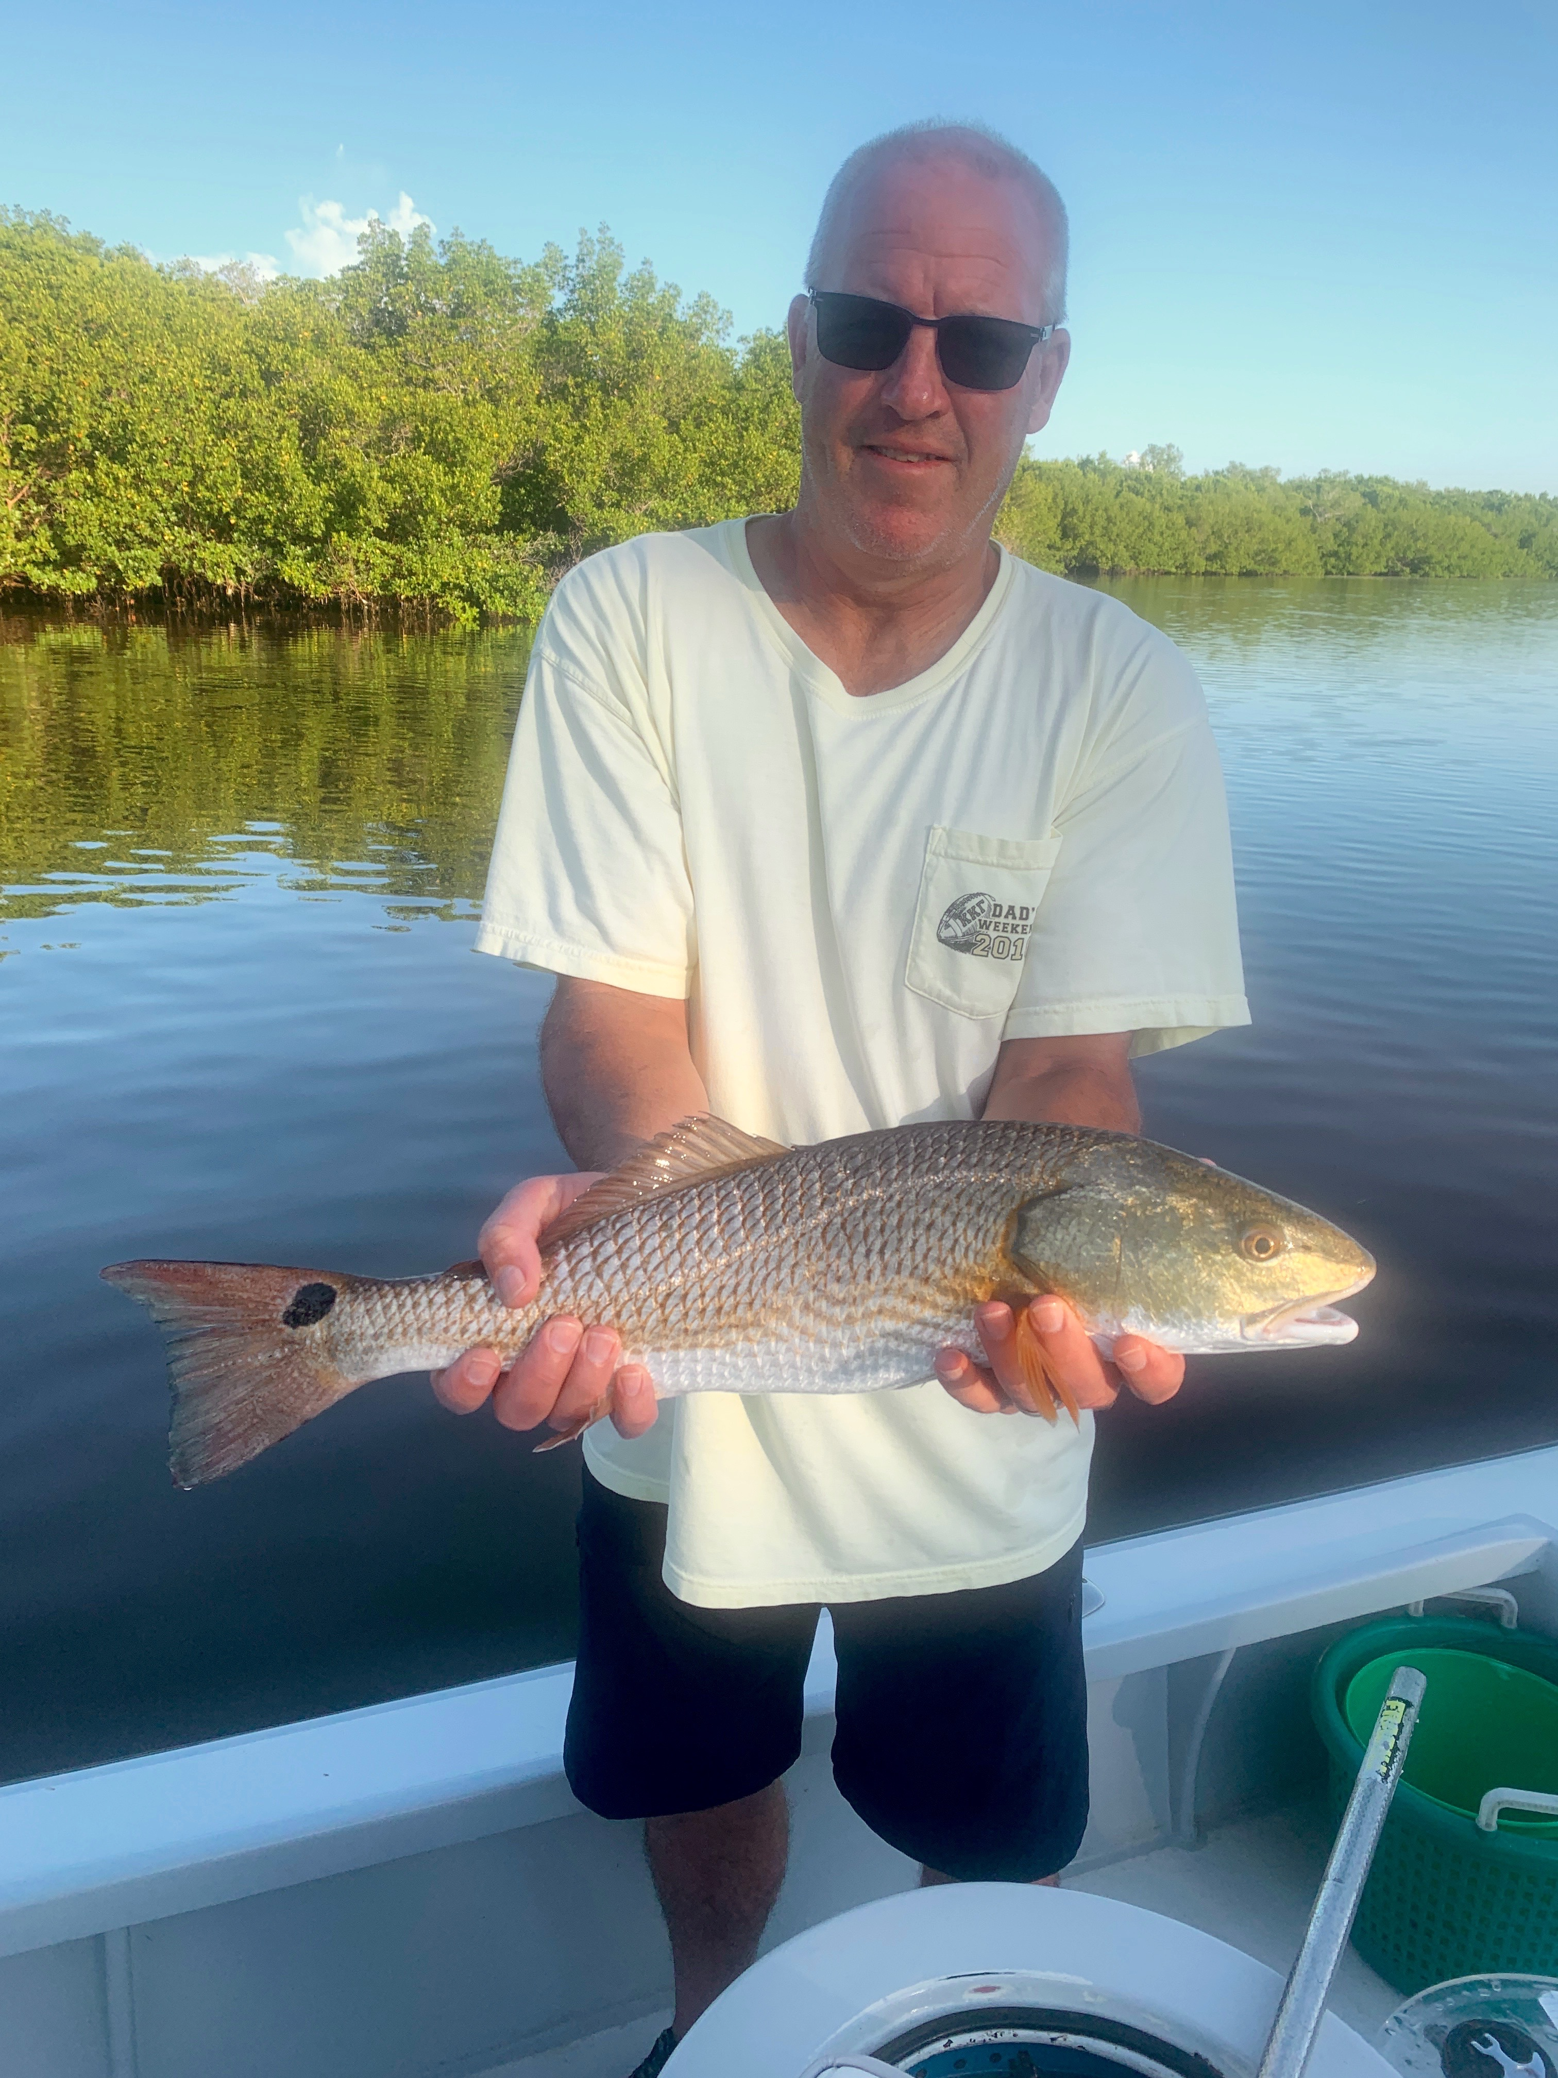

Picture: Matt from Indiana with a redfish caught while shrimp fishing with Capt Matt Mitchell this week.

Switching to shrimp.

Despite low levels of red tide being scattered throughout the sound this week fishing was so much better than it has been. After finding a few places that were just loaded with redfish i returned to these areas day after day and just wore these fish out. For sheer numbers of fish, the past few days have been hard to beat.

The low levels of red tide we are currently experiencing are creating issues for keeping our baitfish alive. Most mornings this week I had a easy time of catching shiners in the southern sound. There is tons of bait and usually it only takes a few casts of the net to get all you need. Once these baits are put in the live well within a half hour they start to die off due to the stress and the low levels of red tide. After dealing with this for a few days I started bringing live shrimp as insurance. You can be guaranteed shrimp will live when everything else dies in the live well.

Bouncing these live shrimp rigged on a jig head has turned out to be the formula for catching lots of redfish and a variety of other species. Usually I don’t start fishing with shrimp until our first cold front has cooled things off. Deeper channels with fast moving tide during the lower water periods have been producing lots of redfish of all sizes ranging from 16 inches all the way up to 28 inches. Along with the redfish we also caught snook, jacks, whiting and even the first keeper size sheepshead of fall all on shrimp.

Fishing with long time clients from Indiana for a couple of days this week we had some of the best fishing they have had in the 12 plus years they have been coming down for there annual fishing trip. Both days we started out shiner fishing and managed to catch a few quality fish then switched it up to shrimp fishing. Once the tide got low we finished up strong catching lots of redfish often having double and even a few triple hook ups.

Though having small amounts red tide around again is discouraging its something we deal with annually and it varies how bad it is from year to year. Luckily so far this year we are yet to see any big fish kills associated with it. The minor change of switching the bait up to shrimp earlier than usual has been the winning ticket for catching lots of fish.

