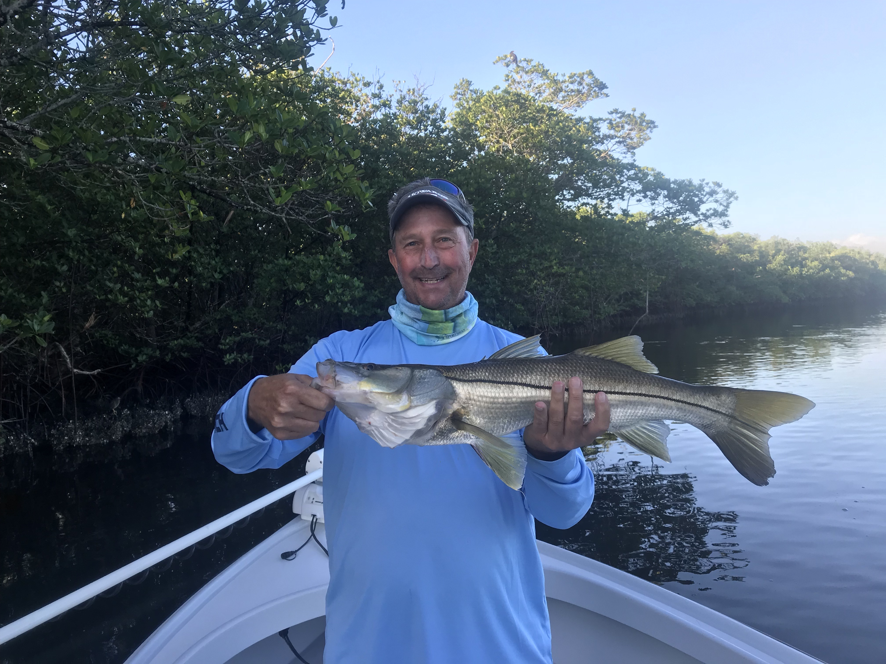

Picture: Brad Agerton with a pre cold front snook caught and released while fishing with Capt Matt Mitchell this week.

Switch to the winter pattern

Winter conditions arrived overnight this past weekend as we woke to cold wind and rain marking the start of what will be a chilly week on the water. As the wind slowly lays down anglers getting back on the water will have to adapt to the major changes cold water brings to our fishery. Snook fishing with shiners will be a thing of the past for at least a few days and fishing low and slow with shrimp to catch Sheephead, black drum, Rat redfish and trout will be the go to.

The cold will concentrate the fish into the places they spend the cooler months along with bringing in lots of pre spawn Sheepshead in from offshore. Depending on how cold the water temperature drops I’m guessing it will mark the end of shiner fishing for at least a week or until water temperatures begin to rebound as the bait moves out to the deeper warmer water of the Gulf. Bouncing a jig head rigged with a shrimp slowly across the bottom in the deeper creeks and canals will be the best way to bend a rod for at least a few days. Docks, jetties and pilings from the passes to the intercostal will load up with lots of large Sheepshead.

This wintertime sheepshead fishery can often be the saving Grace for anglers during these cold periods. Sheepshead fishing only improves with cold weather while basically ever other species we target will grind to a halt shutting down for a few days on the backside of such a major cold front. Switching to light spinning tackle sheepshead are relatively easy to catch, good to eat and put a up a good fight. My rig of choice for catching them is a chunk of fresh shrimp hooked on a 1/4oz 2/0 jig head tied with a loop knot to about 30 inches of 20# fluorocarbon leader.

With the weeks weather forecast to stay cold I’m expecting our water temperature to drop to at least the low 60’s if not high 50’s. This major drop in temperature will signal the beginning of our winter fishing pattern. Cold fronts are all just a part of life although the first big one of the season is always little bit of a surprise both to the fish and anglers. Dig out that warm clothing and rig up the smaller rods winter is here at least for a week.

