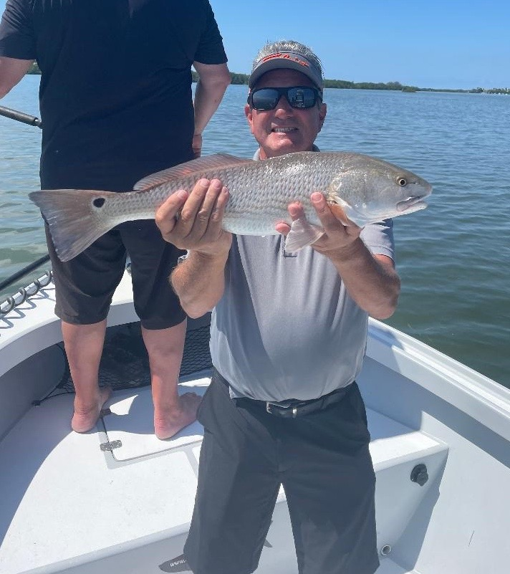

Options and more options

Pic: Jay with a quality redfish to finish up a slam he had while fishing with Capt Matt Mitchell this week.

During the month of May many fishermen are so focused on Tarpon that when you mix it up and go after snook, redfish and trout there has been little to no boat pressure. For a few trips last week, I got to switch it up and was extremely happy with the results. With our water temperatures hanging in the lower 80’s it’s been hard to go wrong.

Trout fishing remains as good as we have seen in years. Shallow flats in the 2-4ft range that have that magical salt and pepper looking appearance have been loaded up. One area I spent some time at was the Buck key flats. Although this is a huge area during clean clear water conditions you can easily locate this grass and sand bottom that trout just gravitate to. Although I’ve been doing most of my trout fishing on free lined live shiners both soft plastics and twitch baits will get it done too.

Snook are on that annual move to the passes and beaches as they spawn this time of year. I’m still catching these fish anywhere from the mouths of mangrove creeks all the way out to snags on the beach. No matter where you choose to fish for them moving current is the most important factor. Pass fishing has heated up along with oyster bar fishing during high water periods has also been a good choice. Of all the species we catch our snook fishing has produced the best numbers and action.

Redfish fishing in the middle to southern sound has been a little bit hit or miss while anglers in the northern sound have been doing really well. When I have had clients who specifically want redfish I’ve made the run to basically Demere key north to Bookelia. Oyster bars in the south end of Matlacha pass have been holding some quality redfish along with creek mouths feeding the Ding Darling. Several times this week while targeting areas for trout we ran into redfish laid out from shallow mangrove islands.

The variety our fishery offers anglers is 2nd to none. Along with the above species I mentioned this week we also caught flounder, snapper and jacks.. When conditions just don’t make tarpon fishing a viable choice, I can’t think of a better place to go bend a rod on a crazy number of other species. June is always the start of more predictable light wind pattern and by far a better month to tarpon fish than unpredictable May.

