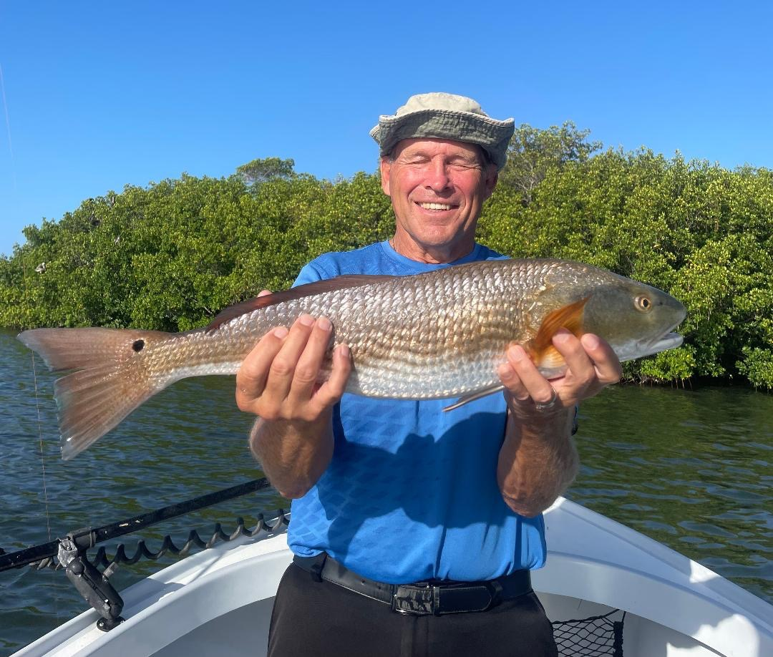

Pic: Glenn with his first saltwater fish, a quality 26 inch redfish caught while fishing with Capt Matt Mitchell this week.

Make your own luck.

Variety was the word this week with so many options for anglers. There is nothing I like more than having a pattern dialed in. For several days in a row, it just all came together as scripted. By having a game plan based around the stages of the tide and the information you gather day to day we enjoyed daily success. With tides getting later each day all that was required was a little daily tweaking and driving the bus stop to stop.

Big morning high water was the perfect set up to target redfish under the mangroves. Cut baits in the hot water worked best. My go to is a free lined medium sized live pinfish. I cut off the tail and trim the fins, this puts both a little bit of scent in the water along with slowing it down to stay up under the mangroves. Pick a wind-blown mangrove shoreline and don’t sit in one place too long. Points and creek mouths are a great place to get started. This time of year, our afternoon rains always seem to get our redfish bite fired up. The redfish action will only continue to get better as it doesn’t peak till the fall.

As the tide began to fall out by mid-morning, I’ve been moving to the flats to catch a crazy mixed bag including trout and mangrove snapper for the box. Basically, any flat in the southern sound in 3-4ft of water has held these fish. Look for the transition area’s that have a mix of grass and sand. Proximity to deeper water is always a plus too. Chumming live shiners quickly fires up these fish. Once you get them feeding this action has been nonstop. Free lined shiners or popping cork rigs are the way to go. Small blacktip sharks, ladyfish and even Spanish mackerel are all part of this wide-open flats bite.

Once I’ve got my clients dinner in the box with the flats action, I like to finish up with some snook fishing. My best action for this has come during the lower stages of the outgoing tide. Skipping shiners under the mangrove shorelines close to the passes has been outstanding. During these lower tide periods it’s possible to get a bait far enough up under the trees to tempt the staged snook. Though most of these fish are just over 20 inches watching them explode on baits it’s a great way to finish up a day’s charter. Its makes for a great day to be able to show clients several different types of fishing during a short 4-hour period.

Many times, when out fishing clients, I hear the term “Luck”. Yes, there certainly is a little luck involved to catching that fish of a lifetime though being prepared and in the right place at the right time are the most important factors. To stack the odds in your favor its more about having the right bait, tackle and knowing where your target species are on what phase of the tide than just plain luck. Everyone may get lucky now and again but preparation will insure you catch fish every day.

