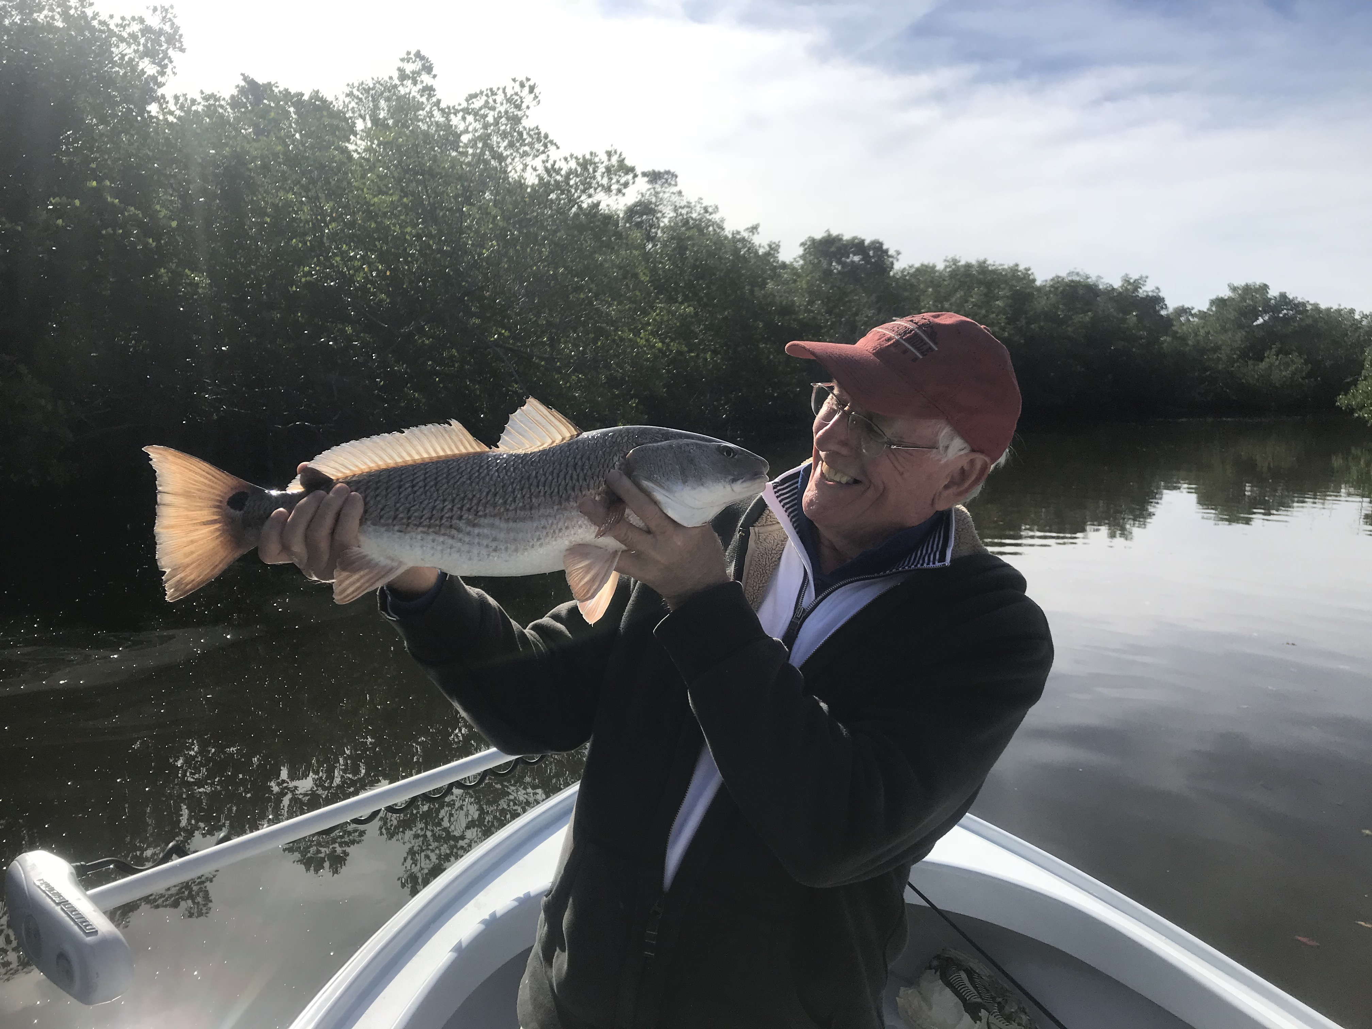
Picture: Rob from Cape Coral was ready to kiss his 25 inch redfish caught while fishing with Capt Matt Mitchell this week

Low and slow gets it done in the cold.

Yet another crazy strong cold front brought us the coldest temperatures we have seen in 6 years. Luckily water temperatures after dropping to chilly 53 degree’s in the sound rebounded and we did not get another cold water Snook kill like we experienced back in 2010. Sunny days even though high temperatures only reached the 60’s made for near perfect Sheepshead fishing conditions.

Hiding back deep in mangrove creek systems to stay warm we fished with chunks of shrimp on jig heads. Soaking these chunks right on the bottom brought my anglers at times some wide open action. Yes a lot of the fish we are catching are under sized Sheepshead but you get a bite every cast its never a bad thing. You just never really know what that next bite will be it could be a big Sheepshead, a Redfish, a black drum or even a pompano. Deep water bends in these creek systems that have good moving current seemed to bring the best action.

Getting out mid morning and fishing till mid afternoon during the warmest part of the day has been the better bite during the cold periods. Although I’m catching fish on both tides we have been in a low water pattern for what seems like months. Part of this is the low winter tides along with northerly winds blowing the water out and making it even lower During this low water target the deepest water you can find in any mangrove creek. This deeper water will stay at a more consistent temperature and the fish can hunker up in huge numbers down close to the bottom. Get your bait right down on the bottom and don’t move it, think low and slow to get that bite.

Jig heads with a chunk of shrimp are my goto rig during these cold periods. While targeting Sheepshead this week we managed to catch several bonus upper slot redfish while tucked way back in the mangroves creeks. The big redfish of the week measured almost 27 inches and was caught in a 6ft deep bend in a mangrove creek in the Ding Darling. This extreme cold we have been experiencing has brought some of the best Sheepshead fishing of the year.

