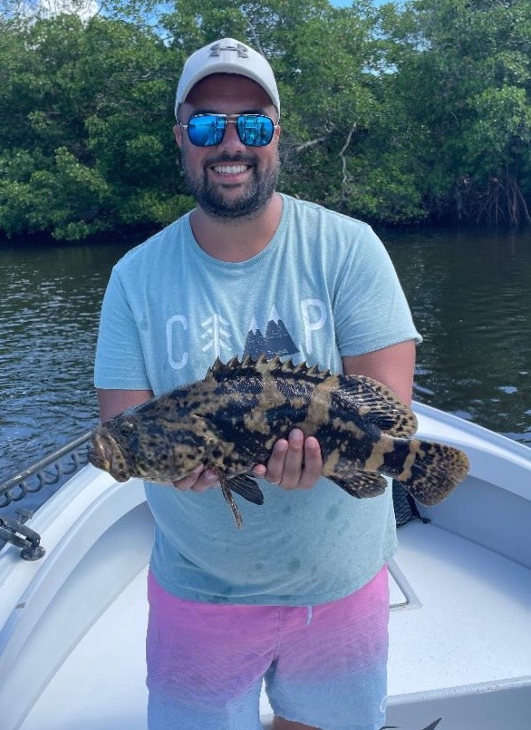

Pic: Sean from NJ got this bonus Goliath grouper deep in the back country while snook fishing with Capt Matt Mitchell this week

Loving the lack of boat pressure

With very few anglers out on the water it’s been a joy to have what seems like almost the entire bay to yourself. This lack of boat pressure always happens this time of year once the kids return back to school. Besides Labour Day weekend it will be much of the same all the way until October. Pulling up into the usually congested passes or to your favourite bait spot and being the only boat there is as good as it gets.

This past week I’ve started returning to the mangrove bays and creeks of the Ding Darling that I usually don’t start fishing until Fall. I have had great success catching a amazing variety of species both against the mangroves and out in the channels. Usually, these creeks don’t fire off until the water begins to cool off though as our days are getting noticeably shorter apparently, it’s enough to push fish back into these places.

The best tide for me in these sheltered bays and creek systems has been during the last few hours of a strong outgoing tide. Catching your entire slam at one stop has been pretty common along with a few other surprise species. Target the deeper points that have strong tide movement to catch Snook, mangrove snapper and an occasional redfish. Out in the open water channels expect trout, jacks and ladyfish. Chumming live shiners will fire off these fish, land the cast at the pop and you will quickly get bit.

Although temperatures don’t feel like Fall is close at hand the massive schools of Spanish Mackerel around the causeway bridges are a sure sign its coming. As you watch these Mackerel explode on the surface as they gorge on fry bait once in a while you will see a tarpon roll in the mix. The C-span seems to be holding the most life of any of the bridges with feeding birds and breaking fish there just about every tide phase. Soaking cut baits on the bottom or drifting a large pinfish under a float will give you a good shot at one of these tarpon.

Tripletail have also started to show up in the sound though most of these fish are on the small side of the 18-inch minimum. Just about any crab pot, marker, no wake buoy or weed line is a good place to look for these fish up on the surface. Whenever you’re traveling from spot to spot always keep your eyes open as you can run across one almost anywhere. Deeper water closer to the inter coastal seems to be best.

