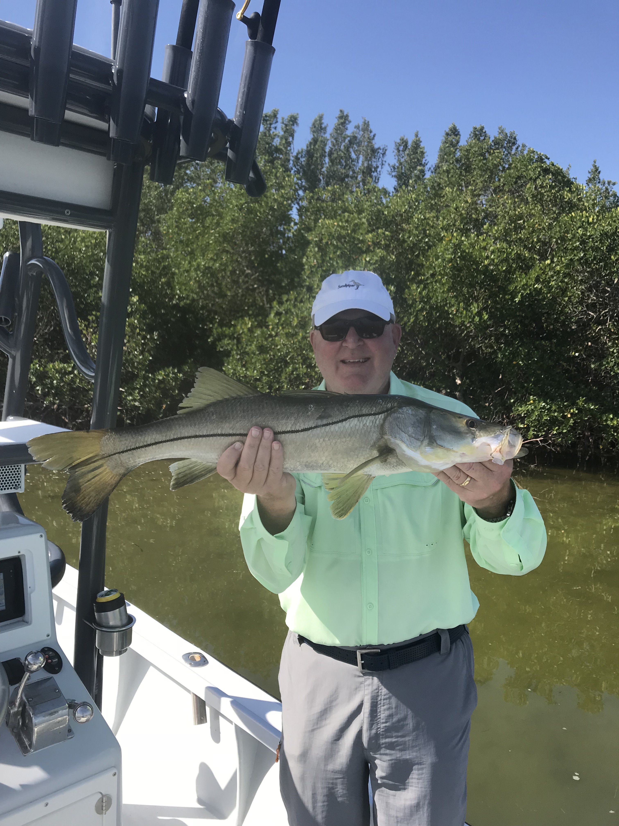

Lots of fishing options

Picture: Tom from Sanibel with a 30 inch Snook caught while fishing with Capt Matt Mitchell this week

Fishing certainly improved this week due to much more consistent weather conditions. Add to that much better bait and the wide variety of species that took part in the rod bending fun and it was a great week to be out fishing. Snook, Trout, Tripletail, Grouper and Mackerel where all part of the weeks menu for anglers.

Although we still are waiting for the Snook bite to go off in the passes the big trout bite has been as good as it gets. Limits of trout came easily in all our local passes when fishing live shiners rigged with a split shot to keep it down in the current. My clients managed a few real bruiser trout pushing in excess of 24 inches along with lots of trout in that 17 to 19 inch range. At times this bite was basically every cast and made for a much needed easy fishery that we have just not had for what seems like months.

During periods of slack tide we switched it up and went dipping channel markers throughout the sound. Many of the inter-coastal markers have man made structure either right on them or just out from them. This structure can hold a crazy amount of fish. Catching gag grouper on almost every cast is a awesome thing no matter what size they are. I’ve been starting out con these markers by dropping live shrimp on a jig head to reach the bottom then once the bite is going off, switching up to heavier gear with a 1/2oz jig head and a live pinfish. Trying to pull some of these larger grouper out of this structure is only what can be described as full contact fishing. We also where lucky enough to catch a few keeper tripletail on these channel markers this week.

Snook fishing remained a little tough with slower than normal tides for the majority of the week. Every time we Snook fished we did catch a few but just never found that wide open bite. Fishing mid week with clients Melissa and Tom from Sanibel we sat in a favorite sand pothole in the middle sound and watched dozens of 30 inch plus Snook just milling around. Even when I live chummed these fish we just could just not get them to feed. After camping and watching these big Snook swim by the boat for well over a hour Tom managed to get bit and catch a 30 inch slot Snook as our patience finally paid off.

In and around the passes look for feeding birds on schools of small bait to locate some really large Spanish mackerel. These mackerel are suckers for live shiners but will also readily eat spoons and small diving plugs. Further down the beaches more and more tarpon are being spotted and caught as we get into the prime time tarpon fishing we experience in May. Knapps point is hard to beat to find large schools of early season Tarpon. First light and light winds offer anglers some of the best sight fishing for these Tarpon although many places in the sound hold these fish when conditions are not so perfect. Along with the Tarpon we are seeing more and more sharks both out along the beaches and in the sound.

