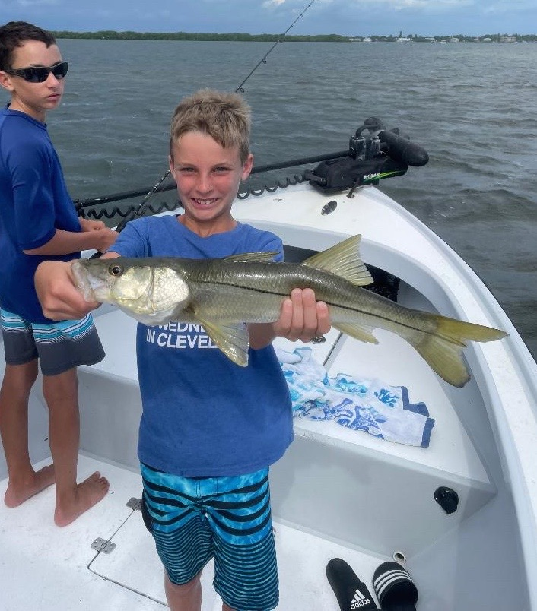

Heat and more heat.

Pic: Not all the snook I’m catching have been small

With July behind us we still have another few months of sweltering south Florida summer heat to look forward to. Water temperatures have been well into the upper 80’s making keeping bait alive for more than one morning charter a challenge. As much as winter cold can shut down the bite extreme heat also slows the fish. Look for the incoming tides bringing slightly cooler Gulf water into the sound to bring the better action.

Getting out early is generally going to be the better action though some days you just don’t have a choice and have to be out in the middle of the day. One key to fishing success during the afternoons has been to target fish in the deeper water in and around the passes. This deeper water may be 2-3 degrees cooler than the shallows of the grass flats. When fishing in the sound it’s really noticeable that the fish move out to the 5-7ft depths as the day heats up.

One bite that has remained solid almost any time of day has been our trout and snapper out on the flats. A few places that have produced a consistent bite have been area’s close to the intercoastal with deeper grass flats. Both Red light shoal and Captiva rocks has this shallow water transition that falls off into deeper grass as they stick out towards the channel. On the west side of the channel Foster point also offers anglers these deeper grass flats. When you find diving birds feeding on fry bait in these places it’s been lights out action.

Live shiners are the bait of choice rigged as light as you can. When targeting trout and especially Mangrove snapper in the above places I’ve been dropping down to 20# or even 15# fluorocarbon leader and a small light wire 1/0 hook. A slow stop and go retrieve makes the bait flutter and is deadly. It also keeps the bait from hanging up in the grass bottom. This open water bite has been the best action around and produces a amazing variety of fish ranging from small gag grouper to mackerel and bluefish. Although it’s not glamorous it’s been non-stop action.

This past week I made my way back into the mangrove creek systems of the Ding Darling a few days and was amazed to see the amount of small snook in here. Though most of these snook are 12-20 inches long what they lack in size they make up for in sheer numbers. Seeing this many snook is a great sign of the future of our snook fishery. Like just about everywhere else in the sound right now these same creeks are also loaded up with mangrove snapper.

