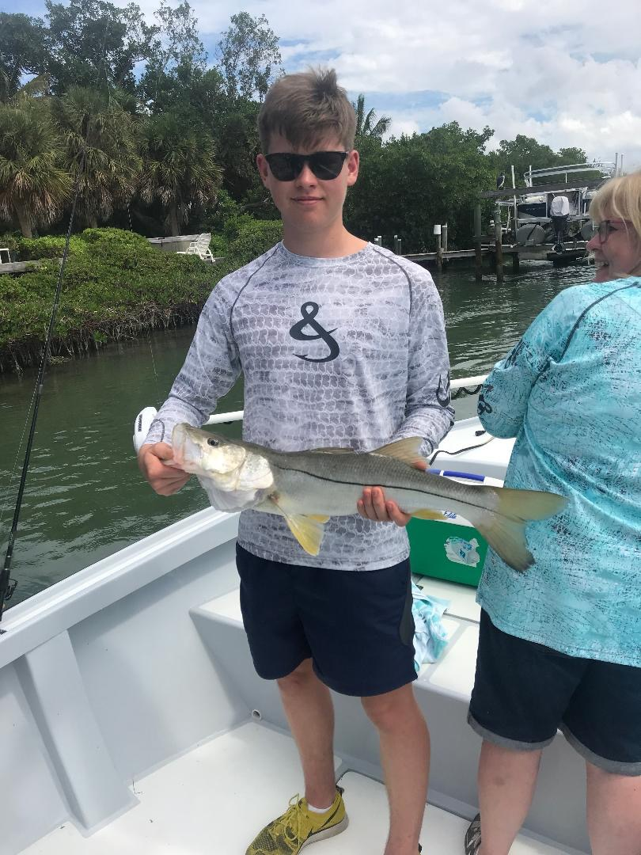

Good water, Bad water

Picture: Will Naylor visiting from England got in on the catch and release snook action while fishing with Capt Matt Mitchell this week

All in all it was a good week on the water with more boats and anglers out enjoying it than I have seen in the past 6 weeks. Fishing in most parts of the sound was awesome although in a few places we are still experiencing fish kills caused by red tide. Clients have gradually started returning and business is finally a little bit better than it has been. Without our water quality issues being sensationalized all over the national news customers who did get out on the water this week were impressed and happy at the state of our fishery despite what they had previously heard.

Limits of Mangrove snapper came easy all week long in the clean waters of the middle to northern sound. Fishing structure in 5-7ft of clear water it was a joy as you could see Mangrove snapper, sheepshead, gag grouper, snook and nurse sharks. The majority of the places I have been fishing the water is as perfect as we ever see it. Big live shrimp and live shiners had these Mangrove snapper going nuts. Over the past weekend my clients quickly had there limits of Mangrove snapper all measuring over 12 inches within the first hour of fishing and often all at the first stop of the day.

Catch and release snook fishing in and around the passes was also on fire when the passes where free of red tide. Finishing up a 4hr charter in Blind pass one day this week during the first 30 minutes of the low incoming tide basically every bait we cast got hit. Most of these snook where 20-26 inches but we did manage one larger 30 inch fish. Getting on a non stop snook bite like this brought a glimmer of hope that hopefully our fishery will be ok again.

I returned several days in a row this week to get on the snook action in Blind pass and then just a couple of days later the whole pass was full of dead fish floating everywhere. The latest red tide report shows the majority of our water is getting better. All I can think of to explain this big fish kill is that the fish choking red tide must have pushed in from the Gulf on the incoming tide killed these fish then moved right back out on the falling tide. While in the pass all the bait I had in my livewell was surprisingly unaffected which leads me to believe the red tide had come and gone.
The rest of the entire sound has been free of dead fish for the past few weeks.

Its really heart breaking to watch our marine life being wiped out as it gets suffocated by red tide fueled by polluted water discharges. What makes it worse yet is to know that nothing at all is being done short term and that no matter how much attention we bring to this problem nothing changes. Adding more to the frustration is that the solution is just so simple: Stop the water releases coming down the Caloosahatchee river from Lake Okeechobee by flooding the land south of the Lake and restore the natural water flow to the Everglades. This supercharged red tide bloom is larger than we have ever seen and it continues to be fed by the nutrient rich water coming down the river.

Fisherman naturally are optimists although its tough to be optimistic when there is no solution in sight for our water quality issues that have not been addressed for decades. Elected politicians in the pocket of ‘big sugar’ show no urgency to stop the water releases bringing irreversible damage to our estuaries.

