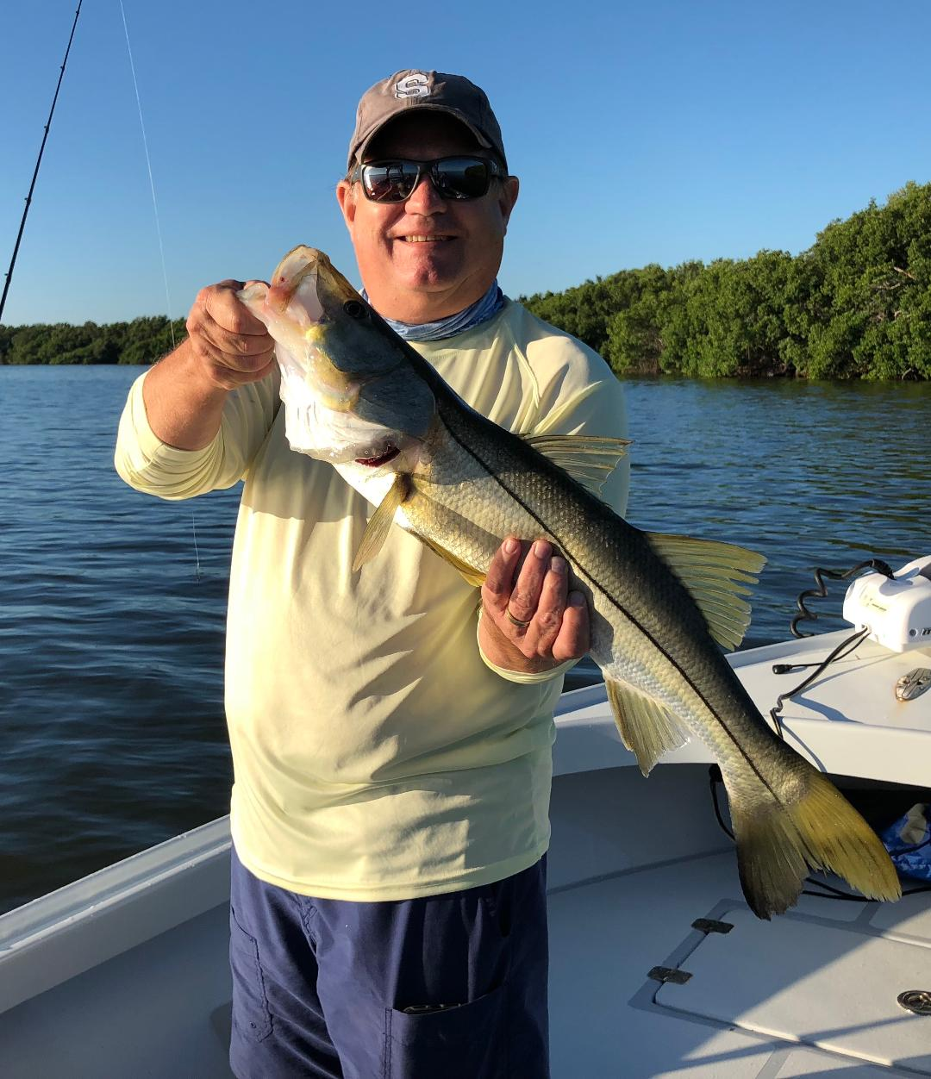

Excellent water conditions once again

The first White Pelicans of Fall just began to show up this week. I was pretty surprised to see a few hundred hanging out on Hemp key with as warm as our weather has been. These true snow birds are the first sign its cold up north already and our winter and our winter is coming soon. Conditions on the water this past few weeks have been amazing. We have some of the cleanest clear water I have seen since last winter and there is life everywhere. Out on the beaches huge schools of feeding migratory fish along with the birds are feeding hard on the bait schools as they slowly move south. The whole food change of Fall has kicked into high gear in all our waterways.

Most of my week was spent catching Snook and Mangrove snapper in the sound. We did manage a few redfish but most days just enjoyed catching and releasing lots of snook of all sizes. Area’s on the inside of the passes and most mangrove shorelines with good tide movement had lots of Snook. Mangrove shorelines inside the passes held lots of fish and where a good choice to find moving water and active fish. As the tide got higher I would cross the sound and fish the eastern side working small mangrove islands and oyster bars. Most trips this week we averaged between 20-30 Snook a trip with a few real giants in the mix.

Carry a few rods rigged with bucktails or small silver spoons was a good idea as running upon feeding ladyfish, jacks and mackerel was a daily occurrence. The St James hump between St James and Tarpon bay has been alive with feeding fish and birds most days this week along with the deeper flats south west of Demere key. Running and gunning these feeding fish is always fast paced and was great on a trip I had with kids this week. Casting through these feeding fish was non stop action while watching these fish crash baits on the surface.

Out on the beaches I’m getting more and more reports of our Fall tarpon fishing getting started up. These tarpon are most often mixed in with the baitfish and ladyfish schools. Windy days will put a cramp in this for a few days but when conditions are right this is some of the best tarpon fishing of the year. Live pinfish fished under a float and cast around the rolling fish is the bait of choice or throwing purple demon colored plastic baits is a good option too. Its not unusual to run into sharks, bonita or even king mackerel so bring a variety of tackle and be prepared to take advantage of what the day gives you.

The recovery of our waters has been simply amazing after experiencing the water quality issues of the past few months. Grass flats look healthier than I have seen them in years and with the amount of fish we are catching everyday it seems like we never had any issues. Clients have been a little apprehensive when calling to book a fishing trip after all they have seen and read about our water then once out can’t believe the excellent conditions they see. As business is now picking up it just feels good to be seeing the same annual clients that I have the pleasure taking fishing year after year.
Attachments area

