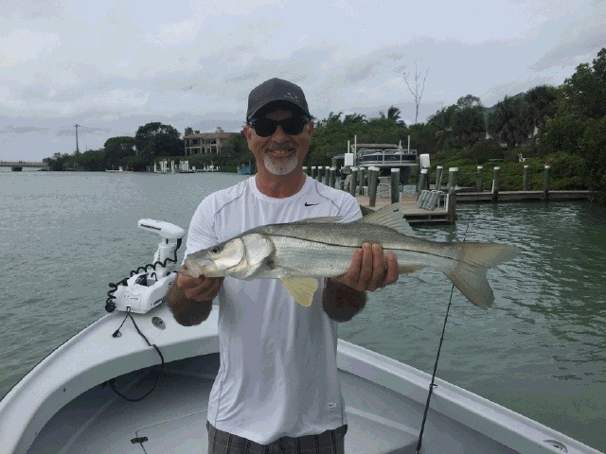

Dodging patchy red tide

Picture: I’m still catching snook in the passes when they are free of red tide

Patchy areas of red tide were the news on the water this week with it pushing in and out of the passes and causing all the bait in our live wells to die. Often these small areas of red tide we experienced in the sound this week where all located in and around the passes and moved fast. Luckily most days all it took was the tide to change for it to move back out into the Gulf.

There is not a more heart sinking feeling when guiding clients than pulling up to pick them up or into that first fishing spot of the day and all the live bait you have worked so hard to get is dead. This summers never ending patchy red tide along with what now includes some small area’s of green floating algae being pushed down the river have made it just tough going some days. This week having a few other bait options on board of either dead baits, live shrimp or soft plastic’s saved a few days on the water when all our live bait fish died.

Moving quickly away from the passes during the red tide days to the eastern side of the sound anglers found lots of life including big schools of threadfin herring and small fry bait, Bait fish and mullet are a quick tell tail sign of if the area is free of red tide as these species are some of the first effected. Many of the fish in the sound have moved east away from the passes during the red tide times and once located its non-stop action. Look for the best action on the deeper grass flats ranging from 4-6ft.

Trout, Spanish mackerel, Jacks, small sharks and ladyfish have been all around these big bait schools in the middle to south eastern sound. Plastic jigs work well here but my goto has been a small pinfish fished under a float which has been catching a fish on basically every cast. Saving some of the ladyfish for cut redfish baits while doing this open flats fishing.

I stayed away from the passes for a few days and then had no issues with baits dying. Catch and release snook action in and around the passes is still going strong . Unfortunately if your heading into the passes it’s just not possible to see the red tide until its too late and all your bait is dead. Heading to the passes went one of two ways: either non-stop snook action or catastrophic for your bait.

Until this red tide clears I will continue to bring some other bait options along everyday. Live or frozen jumbo shrimp has been my safety net as live shrimp do not get affected by the red tide. Although our live bait shrimp run on the small side this time of year some live bait no matter how small is better than non. Soft plastic baits are another option with gulps being a good choice fished under a popping cork to catch most of the flats species.

