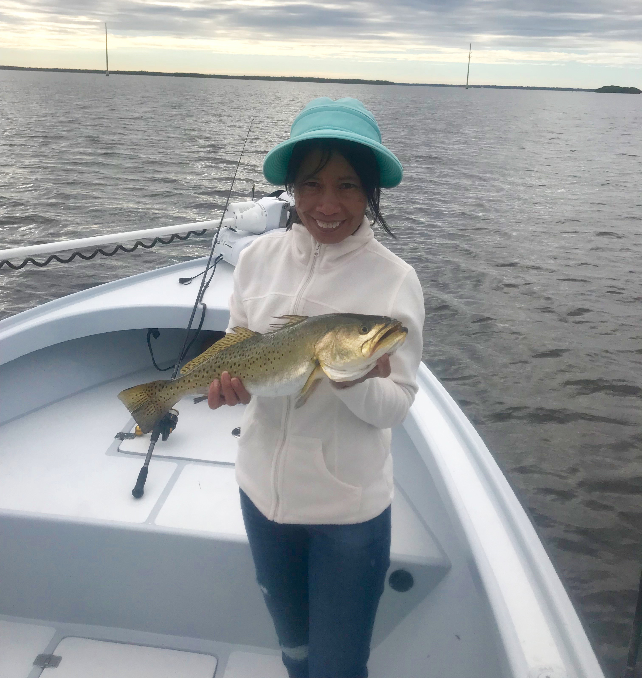
Picture: Trey McGuire with his 30 inch Snook caught while fishing with Capt Matt Mitchell this week.

Cleaner water finally!

Picture: Joy Stafford from St Louis MO with a big gator trout caught while fishing with Capt Matt Mitchell this week.

With all the reports of red tide in the news I have still yet to any dead fish in Pine Island sound. The consistent northeast winds we have had for over a week seem to be keeping this red tide offshore and moving south. Months of brown water from hurricane Irma in the sound have also started to clear up as the water north of redfish pass finally beginning to clear with pretty water now showing up during the incoming tide. This cleaner water will only continue to improve in the southern sound now that the amount of water being released from the Lake has been reduced.

Despite the far from pretty brown water in the southern sound fishing has been good with a great mixed bag of species. Mangrove creek mouths have been best during the low incoming tides with Snook, Gag Grouper, Mangrove snappers and lots of bigger Jack Crevalle. Once the tide has come up some I have been switching it up and fishing for some of the larger gator trout of the year in the pot holes on the open grass flats at the southern end of the sound. Many of the trout we have been catching are well over the 20 inch max.

Snook season closed as of December 1st for our region and this fishery is now all catch and release only until March 1st. With water temperatures still in the low 70’s the snook bite has been some of the best action for my anglers. Deeper docks with good tide flow have held some of the larger Snook while many mangrove shorelines I’ve been fishing are holding what seems like unlimited amounts of 20-25 inch fish. While catching these mangrove Snook it often does not take long for a hungry dolphin to show up and start feeding on the nook we are releasing, once this happens it time to move on no matter how good the bite is.

My personal favourite fishing this time of year is working mangrove shorelines while throwing soft plastic jigs. The brown water in the southern sound is just perfect for a root beer or dark colored soft plastic jig. Trolling motor down a wind blown shoreline while picking apart every nook and cranny. This is a great way to cover lots of water and catch some big Snook and redfish. There is something that much more satisfying when you get a big Snook to eat a artificial bait.
Trey McGuire while visiting his grandfather caught the big Snook of the week on my boat a 30 inch model. After having a pretty slow start to our day Trey caught the memorable Snook while fishing a deep channel during the first part of the incoming tide. Trey has caught lots of Snook while fishing with me over the past few years but this was by far his largest yet and was sure to put a big smile on grandma’s face for dinner that night.

Manatee zones in Pine Island sound came to a end November 15th allowing faster access to many of the islands and channels that we have just not been able to fish since April. Many of these shallow grass flats in the southern to middle sound offer some excellent big trout fishing and are awesome places to get out of the wind during the next few months. With our warm water temperatures still there are still lots of Manatee’s around so keep your eyes open while running these shallow area’s.

