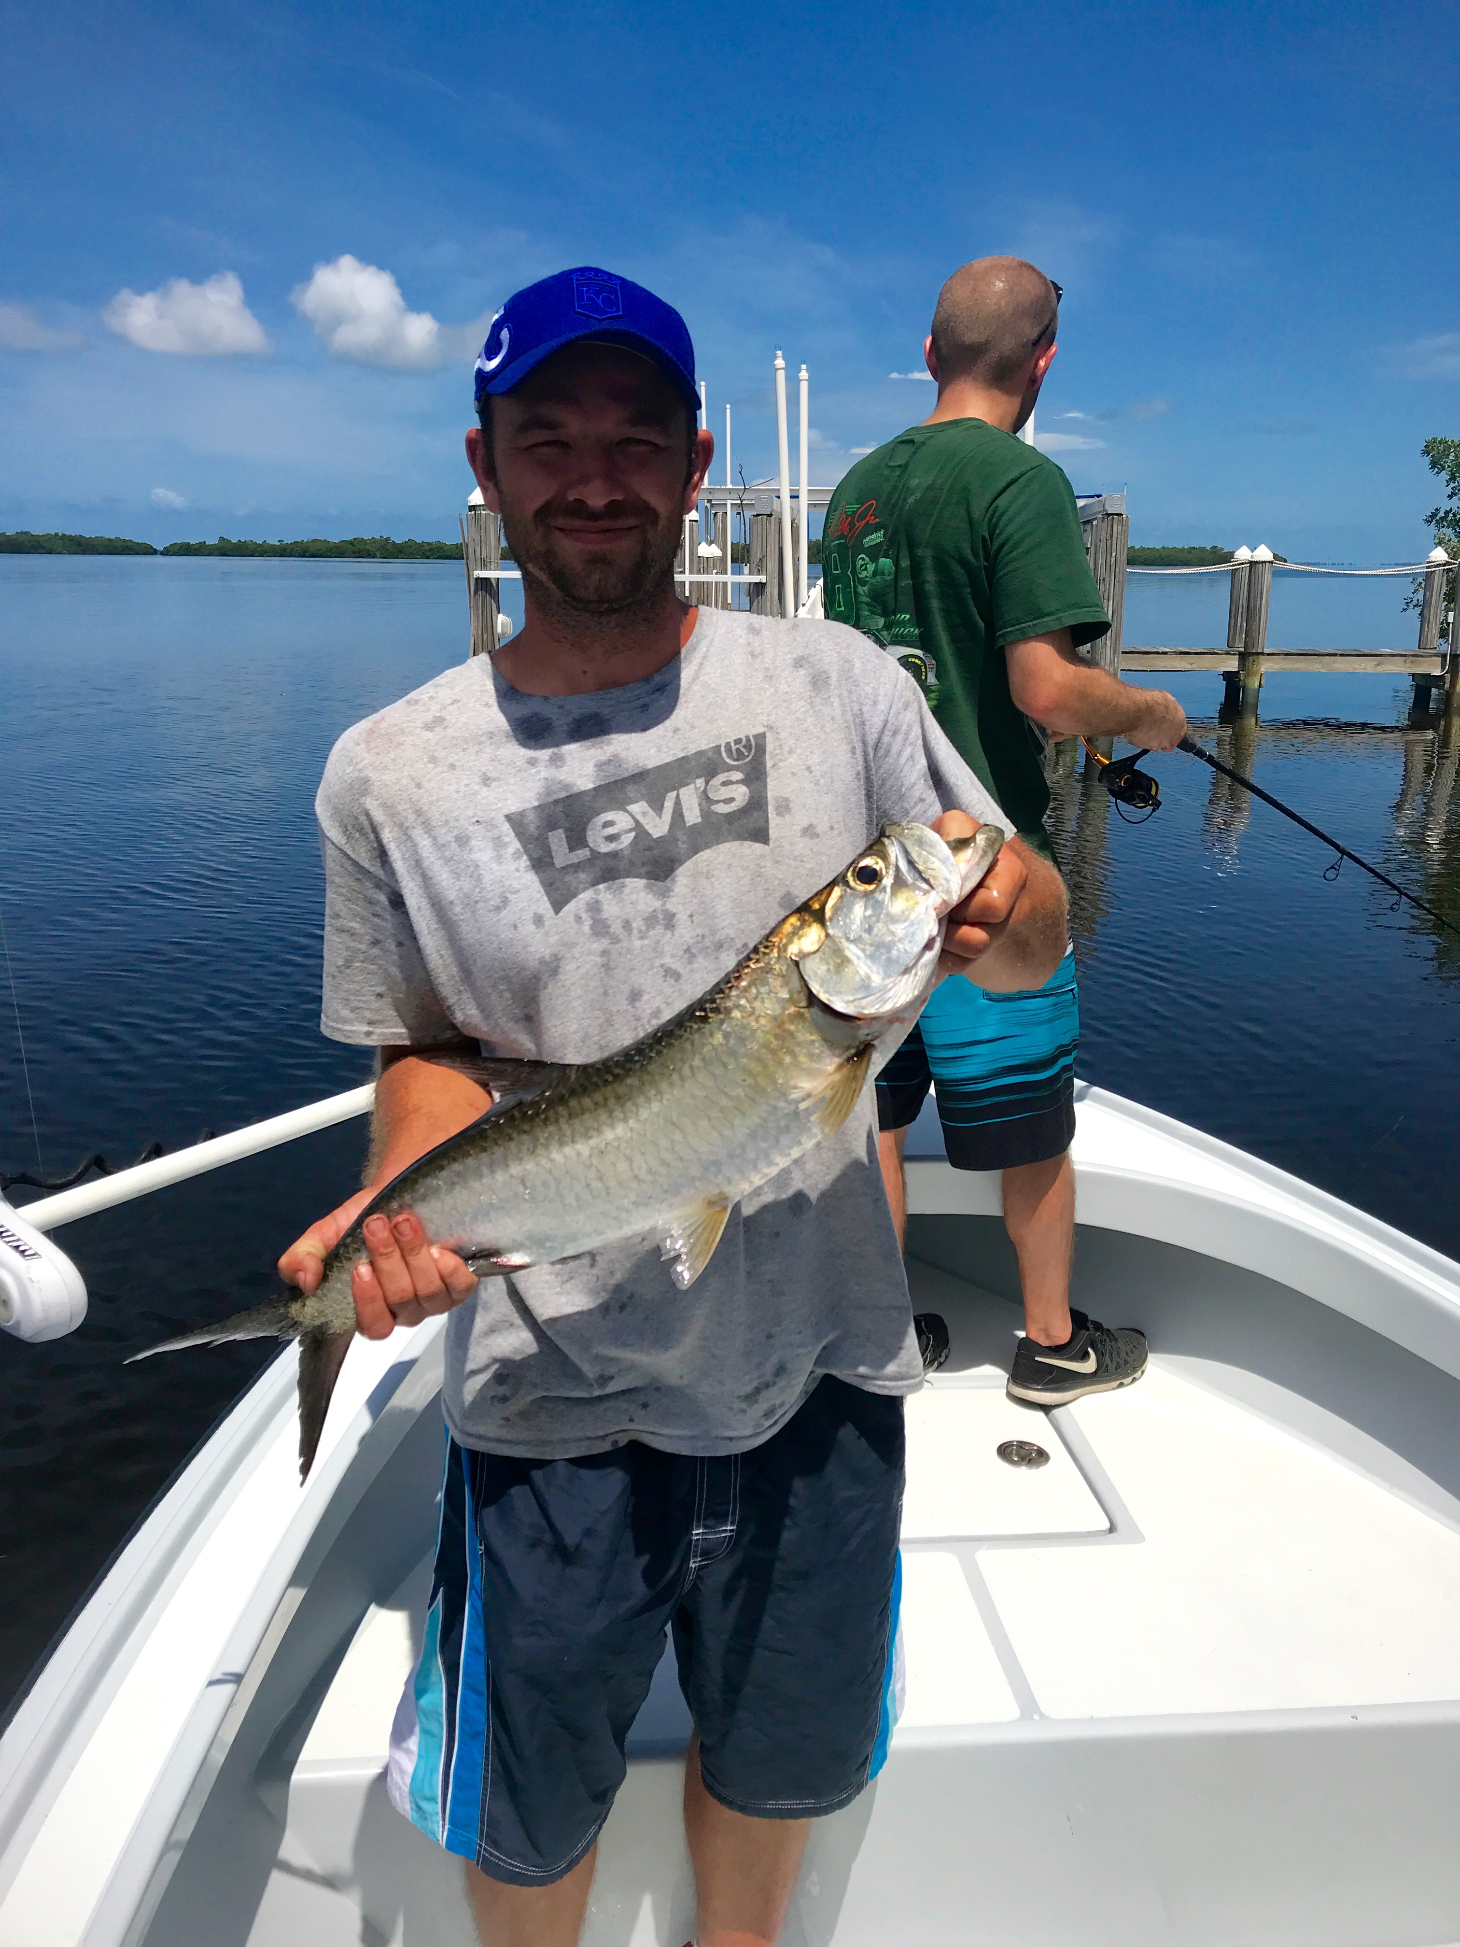

Picture: Adam from north port with a bonus small tarpon caught while targeting Snook with Capt Matt Mitchell this week.

Big high tides offer lots of options

Calm conditions and great tides made for a awesome week of charters. Snook and large mangrove snapper kept my clients busy. The tide pattern we have been on now for more than a week is as good as it gets with a huge high incoming tide coming right at mid day. 3.0ft tides like these don’t come very often and when they do it offers anglers lots of options with many mangrove islands becoming reachable and very fishable.

During the morning lower incoming tide areas around the passes have been the places to be with some of the best catch and release Snook action of the year now happening. Along with the Snook we did mix it up with a few Trout, gag grouper, mangrove snapper and even a few Spanish mackerel all right in the passes. As the tide really starts to flood in and the current gets too fast to pass fish I’ve been moving to the area’s both inside and just outside the passes to keep this non stop Snook bite going.

During the last few hours of the incoming tide the options are endless with the water being so high. Oyster bars have been a good choice with the ones on the western side of the sound bringing the better Snook action. When fishing these bars either the action is almost every cast or not at all. If you throw a few baits and don’t get bit its time to move. Several of my favourite oyster bars resulted in double and even triple hook ups on snook for 20-30 minutes. What these Snook lack in size they make up for in sheer numbers and when there are so many smaller males around its only a matter of time till you hook into a much bigger female.

Mangrove islands around St James city, South Matlacha Pass and the mouth of the river have also been on fire during the very top of the tide. Both the very end of the incoming and the first hour of the outgoing has resulted in some crazy action on big mangrove snapper up to 16 inches, giant drag screaming Jack’s and Snook. Many of these places in these area’s I just don’t fish until we have these super high tides. Watching 10 pound plus Jacks and big Mangrove Snapper crash baits on the surface is a sight to be seen when this bite goes off.

As we are getting later through the month of June more and more larger mangrove snapper are being caught throughout the sound. The fish houses, docks of the inter-coastal, deeper mangrove shorelines and any submerged structure can be just loaded big schools of these hard fighting fish of summer. Live free lined shiners or small pinfish are key to catching these Mangrove Snapper along with a small light wire hook and light fluorocarbon leader as these snapper have really good eyesight. Limits of these excellent table fish will become more and more common over the next few months and become my go-to fish when my clients want to take home fillets.

Although I did not Tarpon fish this week I sure did see lots of them all through the southern sound. Most days while catching bait up off Regla Island I would see rolling fish in the slick calm morning conditions then while returning to St James city or the causeway area there where rolling fish south of the power lines in the deeper water. Then when heading to Punta Rassa I would go under the C-span of the causeway there they were again. After not being able to find any Tarpon for the last few weeks in the southern sound I was making a run to at least Foster point and north to locate them. Now that these fish do not have all the boat pressure on them they did since mid April this bite will only get better.

