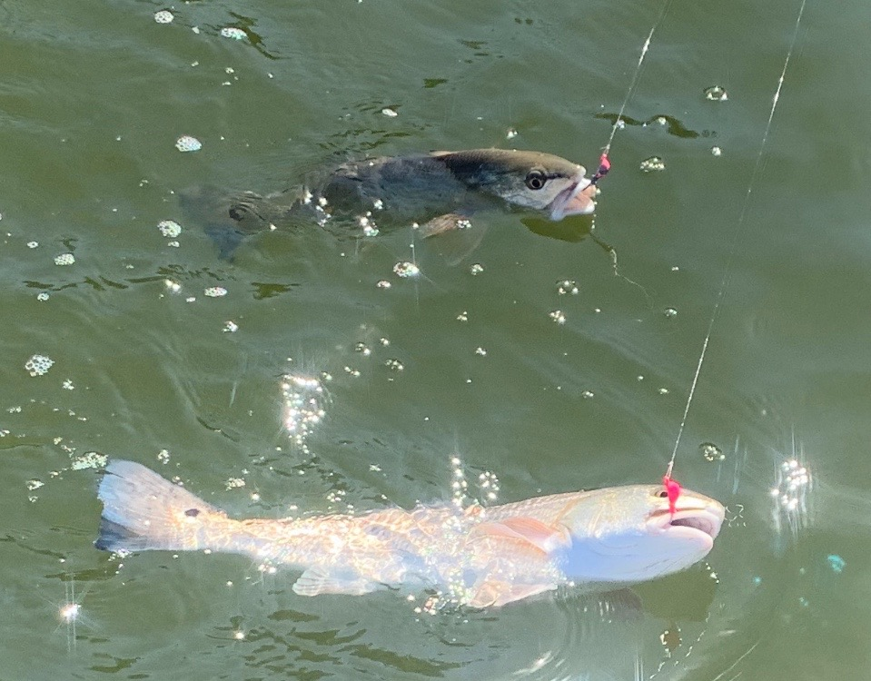

Picture: Redfish double headers have been common

Wrecking Reds.

Over the past month the redfish bite has been as good as I can remember it for the last few years. Clients have been catching 20-40 redfish per trip with this bite often being almost every cast. Live shrimp have been hard to beat and even when I’ve put in the extra time to catch shiners the bite has still been better on shrimp.

Cooler water temperatures are the main reason for this crazy shrimp bite. With so many shrimp being found throughout the sound these fish are just dialed in to them as the main part of there diet. Healthy grass flats are the main reason for all these shrimp.

This proliferation of redfish I don’t think can’t be attributed to one factor. A few of reasons that come to mind include the release of thousands of redfish by the CCA after last summers ride tide along with the closure to harvest for the last year. Most of these redfish we are catching appear to be around 2yrs old and range in size from 16-20 inches. Redfish in Florida can live to be over 30yrs old.
Keeping our redfish fishery closed for another year can only help these fish continue to rebound.

Some of the places these redfish have been most predictable are around Blind pass including the Roosevelt channel and Dinkens Bayou. Creek mouths and channels that butt up to the mangroves on the eastern side have the sound have also been a good choice. Further north docks by Captiva pass and on the south end of Cayo Costa have also had great numbers of these redfish.

While targeting these redfish they have been moving a little bit from day to day so if you don’t find them where you found them previously work the same area and they may be as close as the next dock or point. Watching multiple redfish follow in your hooked fish is a sure sign you have located them.

