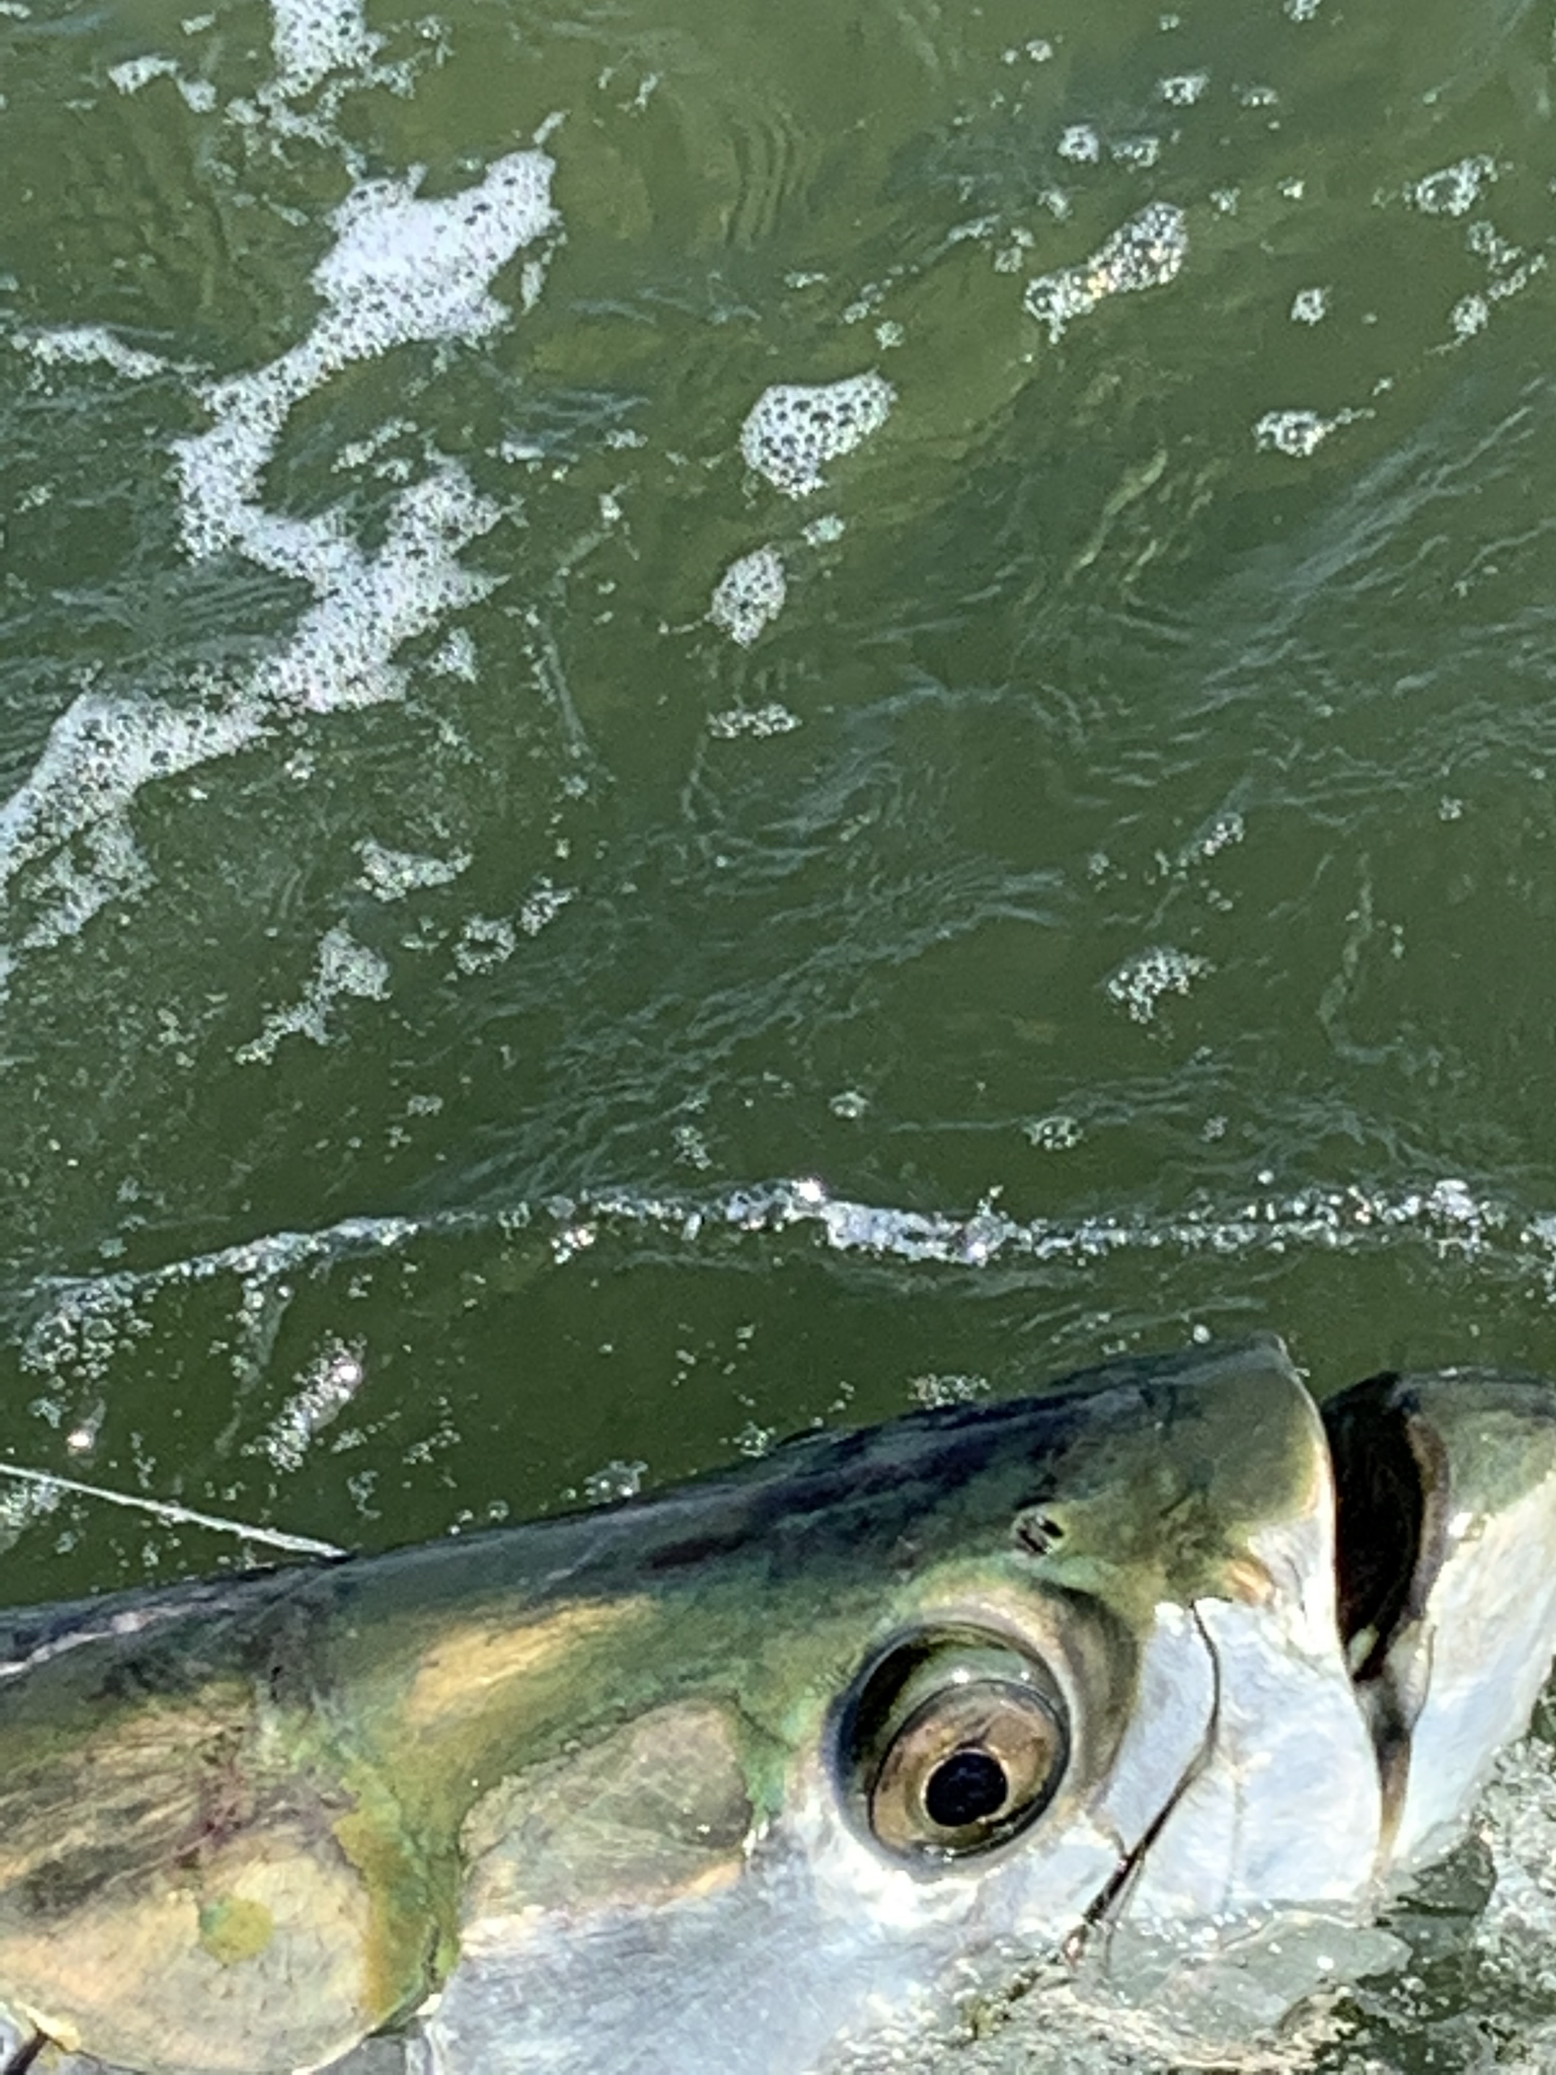

Wind is the enemy of tarpon anglers

Pic: A Tarpon comes boat side before being released

A day’s weather along with wind direction is never more important than when your tarpon hunting. If you pick the right day with smooth water and light winds its easy to spot these fish from a mile away. Once you find them its amazing how many fish there are. Get that windy rough day and you can look all over and never see a single fish. During rough periods especially during strong NW winds these tarpon simply disappear.

Depending on the days wind I plan my trips circuit accordingly. I spend my time moving between these tarpon spots that are in the lee and usually at least calm enough to see if they are holding fish. Just like hunting locating tarpon is the first part of the equation. Different locations often require different methods of fishing to be successful. Many bay spots work best with cut baits while spots on the beach require threadfins and crabs.

During Periods of east wind look on the eastern side of the sound from Regla island north to Rocky channel along with out on the beaches from Knapps point north and along with Ft Myers beach. West wind means tucking away from Blind pass to cabbage key and everything in-between. South wind can work out well for anglers fishing the southern end of the sound getting tucked up close to Sanibel from the lighthouse to the power lines. North wind forces anglers to fish from the lighthouse to Knapps point along with the southern end of Matlacha pass.

Strong winds from any direction are the enemy of tarpon fishermen. Its not unusual to be sat in tarpon for several days and have the wind change direction and pick up. This can and will quickly shut the tarpon fishing down until conditions stabilize. During periods of strong winds and far from perfect weather and tarpon anglers options quickly narrow. Spending your time sitting in a confidence spot is often all you can do in poor conditions.

After sitting in hundreds of tarpon in slick water for a few mornings this week it was mesmerizing. Watching tarpon after tarpon show themselves is as good as it gets. Once the wind switched up with an approaching front to northwest these fish relocated and the frustration level climbed as the hunt began again. I often tell my clients when tarpon fishing “All of this waiting will be quickly forgotten once your hooked into one of these incredible fish”.

