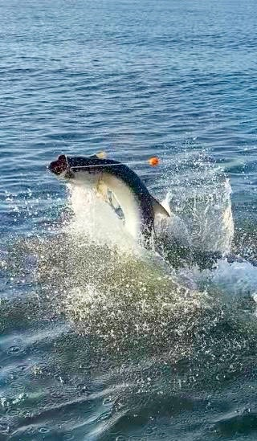

Wide open redfish action

Pic: Fall tarpon fishing is only getting better

All the rain we have experienced over the past week has done wonders to cool off our waters and fire up the fish. These late summer rains have made getting out on the water a little sketchy as thunderstorms have come at almost any time. Staying closer to home and keeping a eye to the sky has been key to staying dry at least most of the time.

Strong southerly winds also blow the water in and create huge high tides which we saw this week. During these massive tides the first thing that comes to my mind is fishing shorelines that are usually not accessible during regular tide cycles. One favourite area is the many mangrove Islands from Demere Key north to Pineland. No matter how long I have fished this area I always seem to find somewhere new that produces fish. Start on the windblown sides of these mangrove islands concentrating on the points and in the small creek mouths.

If you plan on anchoring up or more likely dropping the power poles a tail hooked half dollar sized pinfish or cut bait is hard to beat. Don’t stay anywhere for very long until you find the fish. My favourite ways to fish these shorelines is on a trolling motor or push pole throwing soft plastic jigs. This method allows you to cover lots of ground and basically pick a whole shoreline apart. With so many options on soft plastic’s I generally go with a DOA Cal or a Z-man swim bait on either a weighted weedless set up or a 1/4oz jig head. This style soft plastic bait is easy to skip way up under the limbs. Go with a 3-inch bait in a natural color that resembles a shiner or pinfish.

Our amazing Redfish fishing will continue over the next few months with big schools pushing into the sound. These fish can be caught in a wide variety of places using lots of different methods. Over the past week I’ve had several reports of Redfish being mixed in with feeding Bluefish and Jacks in the Redlight shoal area of the middle sound. When you’re in a wide-open blitz like this the bait just doesn’t matter what’s more important is you are rigged and ready to go. Every bait gets attacked as these fish have that pack mentality racing towards anything and everything they can eat.
Both Redfish and Captiva passes are ground zero for these schools of redfish as they move in from the Gulf. Both drifting these passes or setting up on the many docks with live weighted baits is a great game plan. Shoals and spoil banks just inside the passes are the highway for these roaming schools of hungry redfish. Most of these schooling redfish caught will be over the slot of 27 inches and need to be carefully released.

With most anglers spending their time chasing these schooling redfish I like to sneak away when conditions are right and look for tarpon. Although this Fall bite has not kicked into high gear yet if you locate these fish, they are very happy to eat a well presented bait. Out on the beaches Ft Myers beach and West Rocks on Sanibel are always worth a good long look. A pinfish under a float is seldom refused once you do find these fish. Being the only boat on tarpon will happen more as our Fall bait migration heats up.

