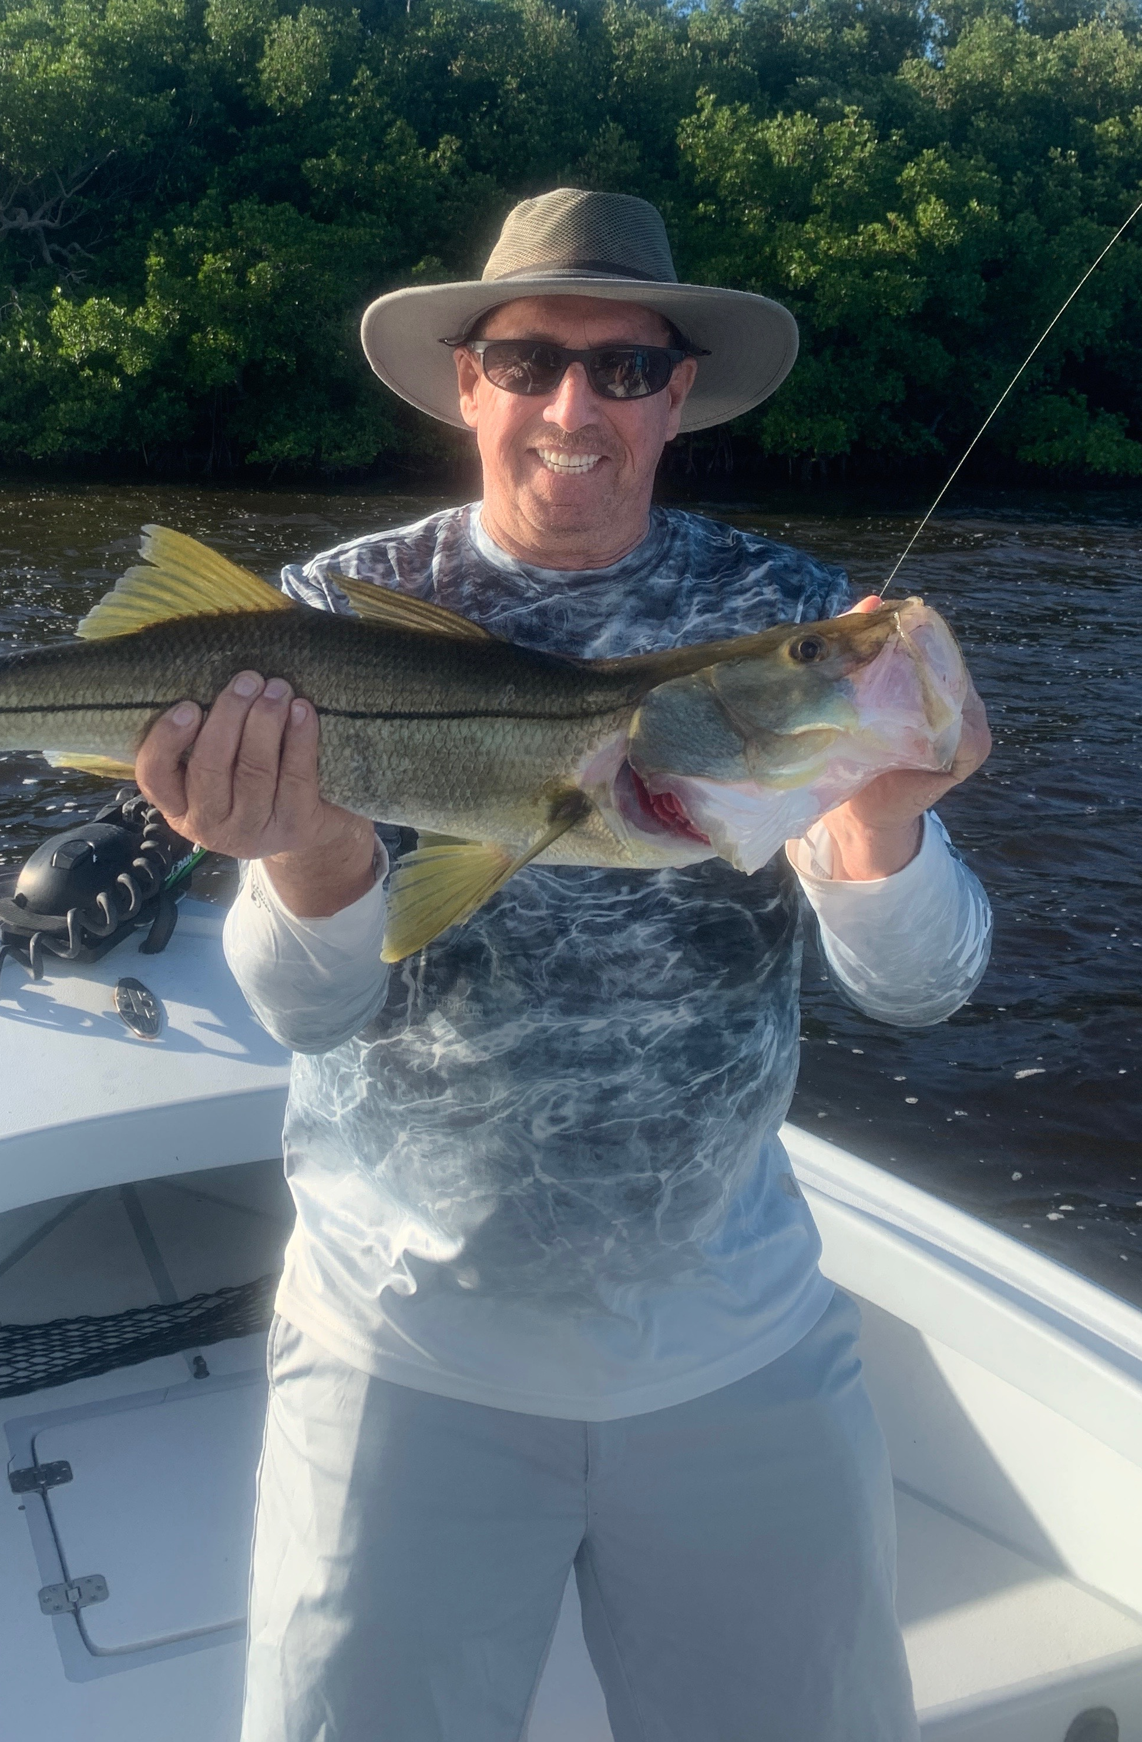

What a week
Pic: Randy caught this 30 inch plus snook while visiting from Orlando over the holiday week while fishing with Capt Matt Mitchell

All I can say is what an amazing week of fishing I was lucky enough to enjoy with my clients. Trips not only produced great numbers of Snook, Redfish and Trout but also a few memorable fish per trip. Favorable weather conditions for the holiday week along with great tides made catching fish relatively easy. In my now more than 20 years of guiding this had to be one of the most consistent weeks of fishing I can ever remember.

One of the most outstanding trips of the week came will fishing with long time Sanibel client Jim along with his visiting son and grandson. What started as a very foggy wet morning turned into one of the most action packed trips ever. Starting out on a favorite oyster bar we put a total beat down on the fish.

By 8:30am that morning all three anglers had a pine island slam. By 10:30am we had moved only 100 yards down this same oyster bar and had lost count of not only the amount of fish we had caught but also the amount of double hook ups we had. Though most of the redfish and snook where average size the action was crazy. Moving into the pass for the last hour of fishing the bite did not let up with hungry snook chasing our baits on the surface and then finishing out the trip with 2 much larger redfish.

Fishing many of the same places throughout this whole week it was hard to believe the amount of fish we caught. The key to our success was picking an oyster bar or shoreline with lots of mullet and life on it. This would quickly change from day to day. Some days it would take a few stops to get the action dialed in then other days it was the first stop. Even during the lower water periods that I don’t usually target these fish on the oyster bars they would be found out just a little further in a nearby deeper sand hole. Most of this non stop action came in 1-3ft of water.

When fishing these bars the most effective way has been slowly working a live free lined shiner back towards the boat. After making a long cast to the very edge of the bar I would have my clients lift and slowly wind keeping the bait out of the grass. This slow retrieve makes the bait flutter down and proved deadly with the fish inhaling our baits. When we had large mullet schools close enough to cast into into the bite was almost guaranteed. Seeing so much life on all these oyster bars as our mullet get ready to spawn is what our fall fishing is all about.

Out in the middle sound around one of the many shallow shoals trout fishing was also as good as it gets. On dayswe did not catch our trout while fishing the oyster bars for snook and redfish I headed up towards the many bars west of Demere key. The water in this end of the sound is much cleaner and is full of trout from 16-24 inches. Pitching our live shiners into 3-4ft sand holes quickly completed our slams for many of my clients.

As I’m writing this everything is going to quickly change by the beginning of this week as the strongest early season cold front we have seen in years approaching. Sadly, all of the patterns I caught fish on this last week will be finished. Quickly falling water temperatures will give us a big push of sheepshead into the sound and shut the snook bite down for at least a few days. This week of cold temperatures will call for switching gears and slowing it down. A live shrimp or even a chunk of shrimp fished on a jig head close to the bottom will be the method of choice. Although I will enjoy this change of pace for a few days hopefully temperature rebound and we can get back to the amazing fall fishing for our big three species.

