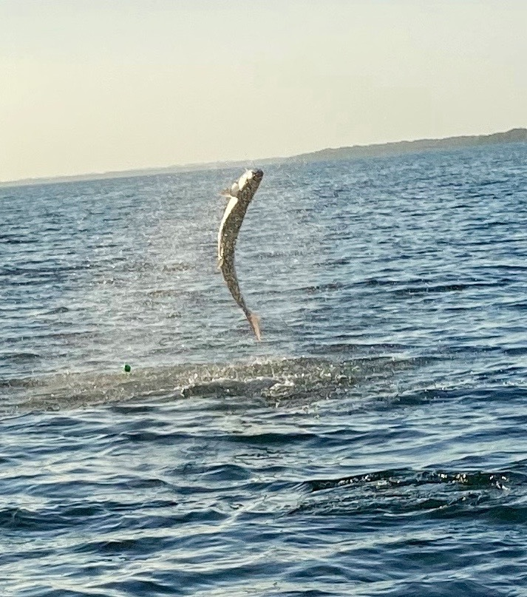

Pic: Wave goodbye on this last tarpon jump of the battle.

Closing the deal isn't easy

Chasing tarpon this week we had great success getting that bite most days. Getting a fish to the boat for a release though was a different matter. On our best morning my clients had 4 fish hooked up and we still just could not get that face grab. No matter how much you explain the importance of bowing to a jumping tarpon its just not a natural response for most anglers. Once that 100 pound fish goes airborne all pre bite direction is often forgotten and watching a client pull against the jumping fish your heart sinks as you know its probably going to be all over.

The first 30 seconds to a minute of a tarpon fight is wild, crazy and unpredictable. Multiple jumps, fast changes of direction and powerful runs make keeping an angry charging tarpon hooked up tough. If you can make it through this first part of the battle your odds have greatly increased. Even after the fish begins to settle down they still have moves that can break your heart more than a half hour in. One such fish this week we had on for 10 minutes and had chased trying to put line back on the spool. While still out over 100 yards this fish came right at the boat. Reeling as fast as possible we began to think we had lost the fish until the line came tight right at the bow as the fish started jumping again. This was a game over move.

Having lots of shots at rolling and laid up fish with very few bites was the other way our tarpon trips seemed to play out. One memorable morning this week while on the flats skiff I followed a pod of hundreds of tarpon across the intercoastal. During the slick calm conditions you would pitch a bait at what you thought was the lead fish of the chain only to spook another group of tarpon you did not know where there. This massive amount of tarpon we had fished for a few days simply picked up and moved down the sound, it was wild.

While having these fish all to ourselves for a while we had multiple shots at them. At times chains of 30 or more fish would push right next to the boat. Seeing these fish laid up with fins above the slick water is an amazing thing. Casting live baits on floats to the outside edges of these fish we did have one fish inhale the bait but after one jump going away it changed direction coming right towards the boat, it was impossible to stay tight as we stared down its throat as it jumped right towards us before throwing the hook.

Over the past week it seemed most of the large groups of tarpon where located in the southern sound. Even during windy conditions these fish just stayed put. Then a small cold front and northerly winds over the weekend and there were very few tarpon to be found. Tarpon do not like north wind. The hunt began again today with only a few fish showing here and there. As conditions improve and get back to warm sticky humid mornings these fish will reappear.

When it comes right down to it tarpon can be extremely frustrating and hard to catch. It’s the challenge of these fish that makes releasing one such an accomplishment. Every tarpon battle is different and stays fresh in your mind until you manage to land that next fish.

