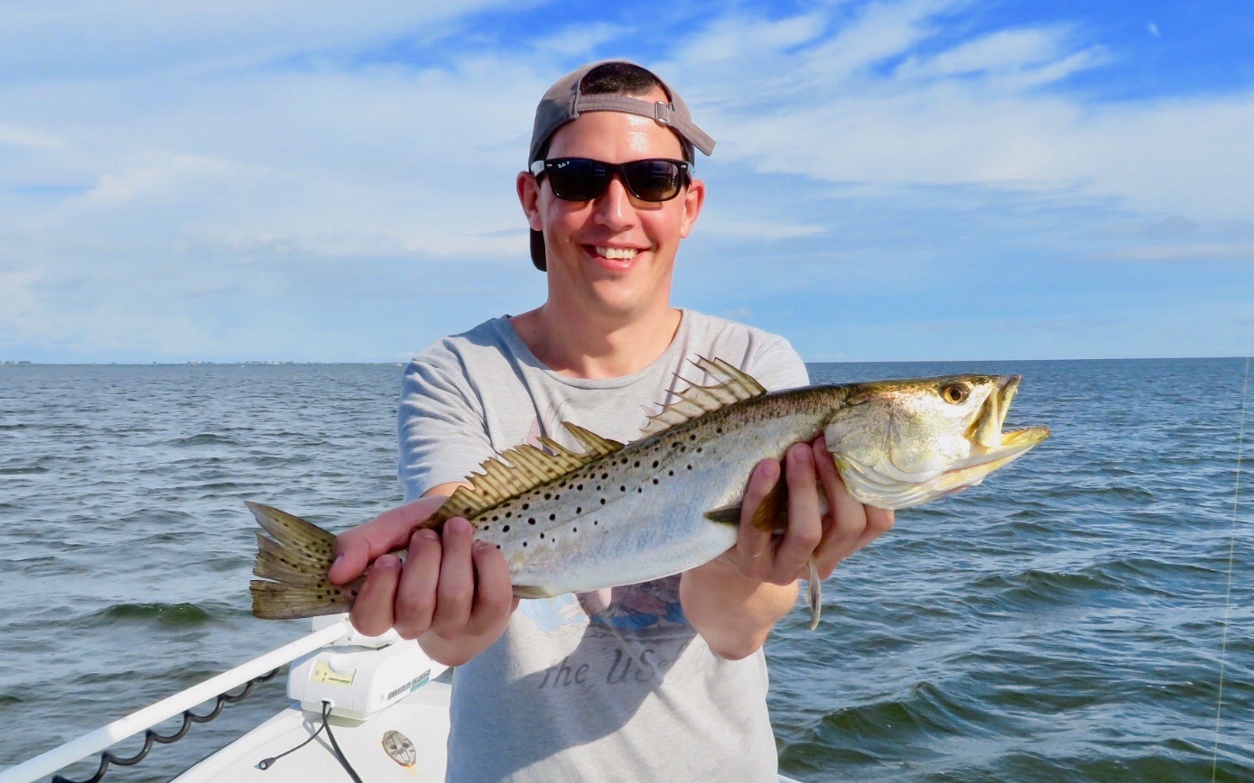

Pic: Martin got in on the trout bite while visiting all the way from England this week

Trout recovery nothing short of amazing

My weeks trips continued the family fun not only with fishing but some days we mixed in sightseeing, dolphin/manatee watching and even a stop at the beach for shells. Getting to share the amazing resource we affectionately call our backyard never gets old. The amount of ways to spend the day out on our beautiful waters is almost endless.

While up on North Captiva this week erosion on the northern end of island has created huge shell mounds along with a sheltered lagoon over the last month. The natural shifting sands have made the perfect sheltered spot to pull up inside with a boat and spend some beach time. All the beaches and sandbars on our northern barrier islands still are totally natural and look a lot like they did 100 years ago. These beaches have never been re nourished making them the prettiest beaches around.

Drifting the flats while popping bobbers baited with shiners gave clients of all ages some awesome action on a wide verity of species. I’ve been staying close to home fishing the flats in the southern sound from St James City to Captiva in depths of 3-4ft. This trout bite is like we have not seen in over a year with these fish making a amazing recovery since the red tide of last August wiped them out. Though most of these trout are from 14-16 inches we caught several each trip that went over 20 inches.

While fishing for these trout we have also been catching ladyfish, jacks, mackerel, mangrove snapper and bluefish. Switching up to a soft plastic jig when the bite is on has been a fun way to catch em too. Remember our Trout fishery remains catch and release as its closed until at least May. A good idea is to use a hook out tool to unhook these very delicate fish. The less you touch them the better off they are. If you want a photo with a good one wet your hands before quickly gently getting that picture.

