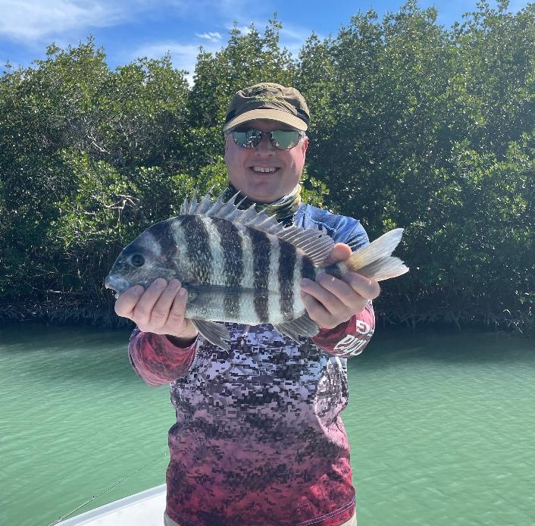

Pic: Mike from Peoria IL with one of many Sheepshead caught while fishing with Capt Matt Mitchell this week

Trout and Sheepshead for the win

With water temperatures slowly rebounding to the magical 70-degree mark anglers had a few more options this week than just trout and sheepshead. Shiners slowly began to reappear as conditions warmed up making snook fishing a good choice during the hottest part of the day. Although this bite was never great it felt good to have shiners and catch a few snook here and there after almost a month of using shrimp for bait.

During higher tides the eastern side of the sound had lots of scattered redfish. Once located in clean clear water these fish jumped all over a shrimp or even shrimp chunk. Returning to these same area’s during the windy days we simply did not do as well. While targeting sheepshead around the passes clients also managed a few larger redfish while soaking baits around docks.

Flats fishing for trout continues to be the best bite and action. From Fosters point on North Captiva all the way back to the power lines every grass flat seems to be loaded with trout. Often these fish are on the small side of the 15-inch slot though once you find the bigger ones a limit has come easily. Fishing for these trout with a live shrimp under a popping cork at times means a bite every cast. Recently I have been starting my day on the water targeting these fish and quickly getting all my clients on the board before moving off to a species that’s a little tougher to catch. Learning not to set the hook and just reeling until the rod bends is the most effective way to catch these trout.

The Sheepshead bite was still strong this week even though fishing for them during warm days just does not feel right. Redfish and Captiva Pass where the most productive. Getting the boat set just right so you can keep your bait close to the pilings or structure was the difference between catching or not. Nuisance dolphins in these passes get very aggressive and will even grab a fish while its hooked. One morning this week we lost several giant Sheepshead right next to the boat before I could get them in the landing net. Feeding dolphins is not only against the law but creates a problem for years to come.

All in all it was a great week on the water with lots of trout and sheepshead going home with happy clients. The next few months of high season, most clients are more interested in taking home fish than they are in targeting our glamour species. Even though everyone likes a fresh fish dinner after a charter its extremely important to this resource to only take what you intend to eat even if the limit is higher.

