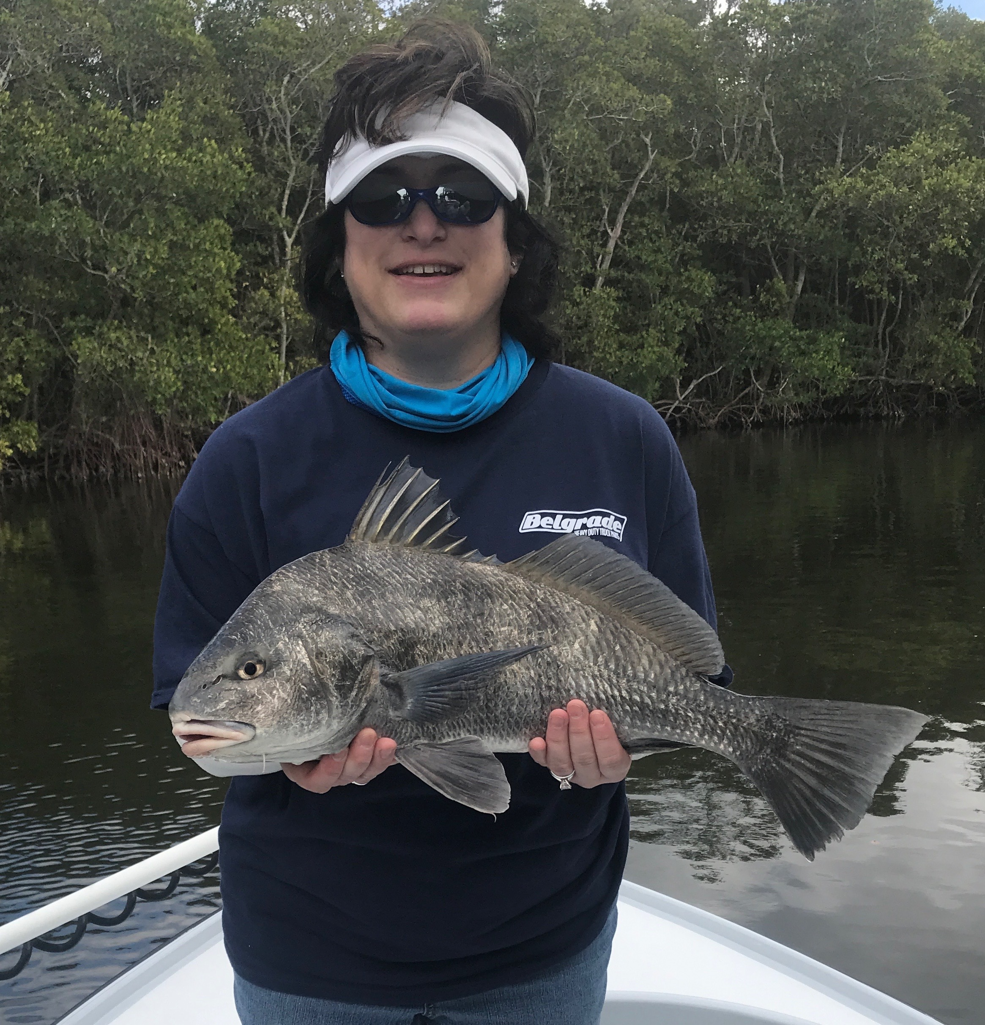

Pic: Gale from PA with a black drum she caught while fishing with Capt Matt Mitchell this week

Thermals in Florida?

This was yet another weeks fishing in what can only be described as very non Florida like winter weather. Our conditions were not only unusually cold but also another passing front brought yet another a full day of rain. Despite the poor weather our winter fishing has been outstanding with lots of sheepshead, redfish and black drum keeping everyone happy.

Giving my clients a enjoyable experience during these far from picture days starts off before they climb onboard by having them wear enough clothing. I understand that most of my clients this time of year are accustomed to much colder northern weather. Running around at 30mph on a open boat during 50-60 degree days is cold no matter where you are from. Being cold and miserable is not good for either the angler or the guide. During these cold mornings I wear thermal’s as my base layer and often gloves. It is important to have enough layers of clothing on to stay warm when making open water runs and then to be able to peel it off by layers once we stop and the day warms.

Crazy low tides have also played a big part in knowing where to fish for success. During minus lows fish get bunched up in great numbers in the many deeper channels and creeks found throughout the sound. Being able to reach many of the sheltered areas requires crossing a open body of shallow water. Once into one of the fish refuge’s take your time and fish slowly. Cold water temperatures equal slower moving fish. Soaking shrimp chunks in the deepest water in these places will often catch fish when no other method works.

Don’t be afraid to venture out and go fishing even though nature may not comply with the shorts and flip flops you want to be wearing. There are lots of fish that still will cooperate even when its cold out, better yet remember its only 8 degrees at home so why not go fishing.

