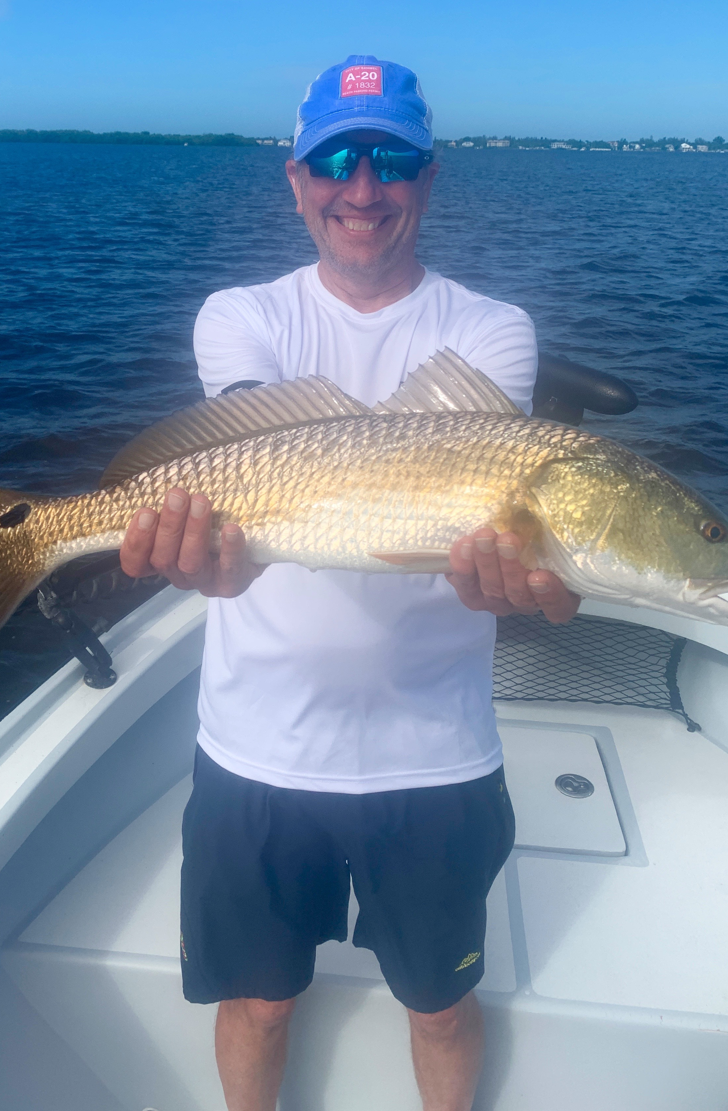

Pic: Larry from IN with a beautiful golden redfish caught while fishing with Capt Matt Mitchell.

The pattern for success.

Big high morning tides along with the same easterly wind direction made my job relatively easy this week. Returning to oyster bars during high water we caught big numbers of snook, redfish and even a few trout. Once I worked out this pattern we were able to catch fish on this same set up day after day.

Winds and tides change daily so staying on a certain pattern for more than just a few days rarely happens. One big advantage of being on the water daily is being able to take the information you learned in previous days and apply it to the current days fishing. As long as conditions remain the same fish will generally remain in the same places.

This oyster bar pattern has remained nothing short of amazing this entire week. Bars from Matlacha pass and the sound are all loaded up with snook, redfish and jacks. I’ve been fishing two ways with live shiners. When free-lining fish them with a slow retrieve gently raising the rod and letting the bait flutter down. Continually pick up the slack line keeping the bait out of the bottom. Another option is to use a float and let the bait drift down the edge of the bar. Make the bait move naturally for the best presentation.

Beach fishing from Captiva to Knapps point has remained strong. Schools of surface feeding Bonita, Mackerel and sharks make easy sight fishing targets. With east winds all week, conditions out along the beaches were smooth. With so much life out here be prepared to catch a crazy variety of species. Small jigs and spoons are a great way to get started as you fish your way up the food chain.

This annual Bonita fishing is some of my favorite fishing of the year. Running and gunning from one school of feeding fish to another makes for exciting visual action. These under rated gamefish are hard fighting often making 100 yard screaming runs. They are a blast to catch on both spinning tackle or better yet a fly rod.

