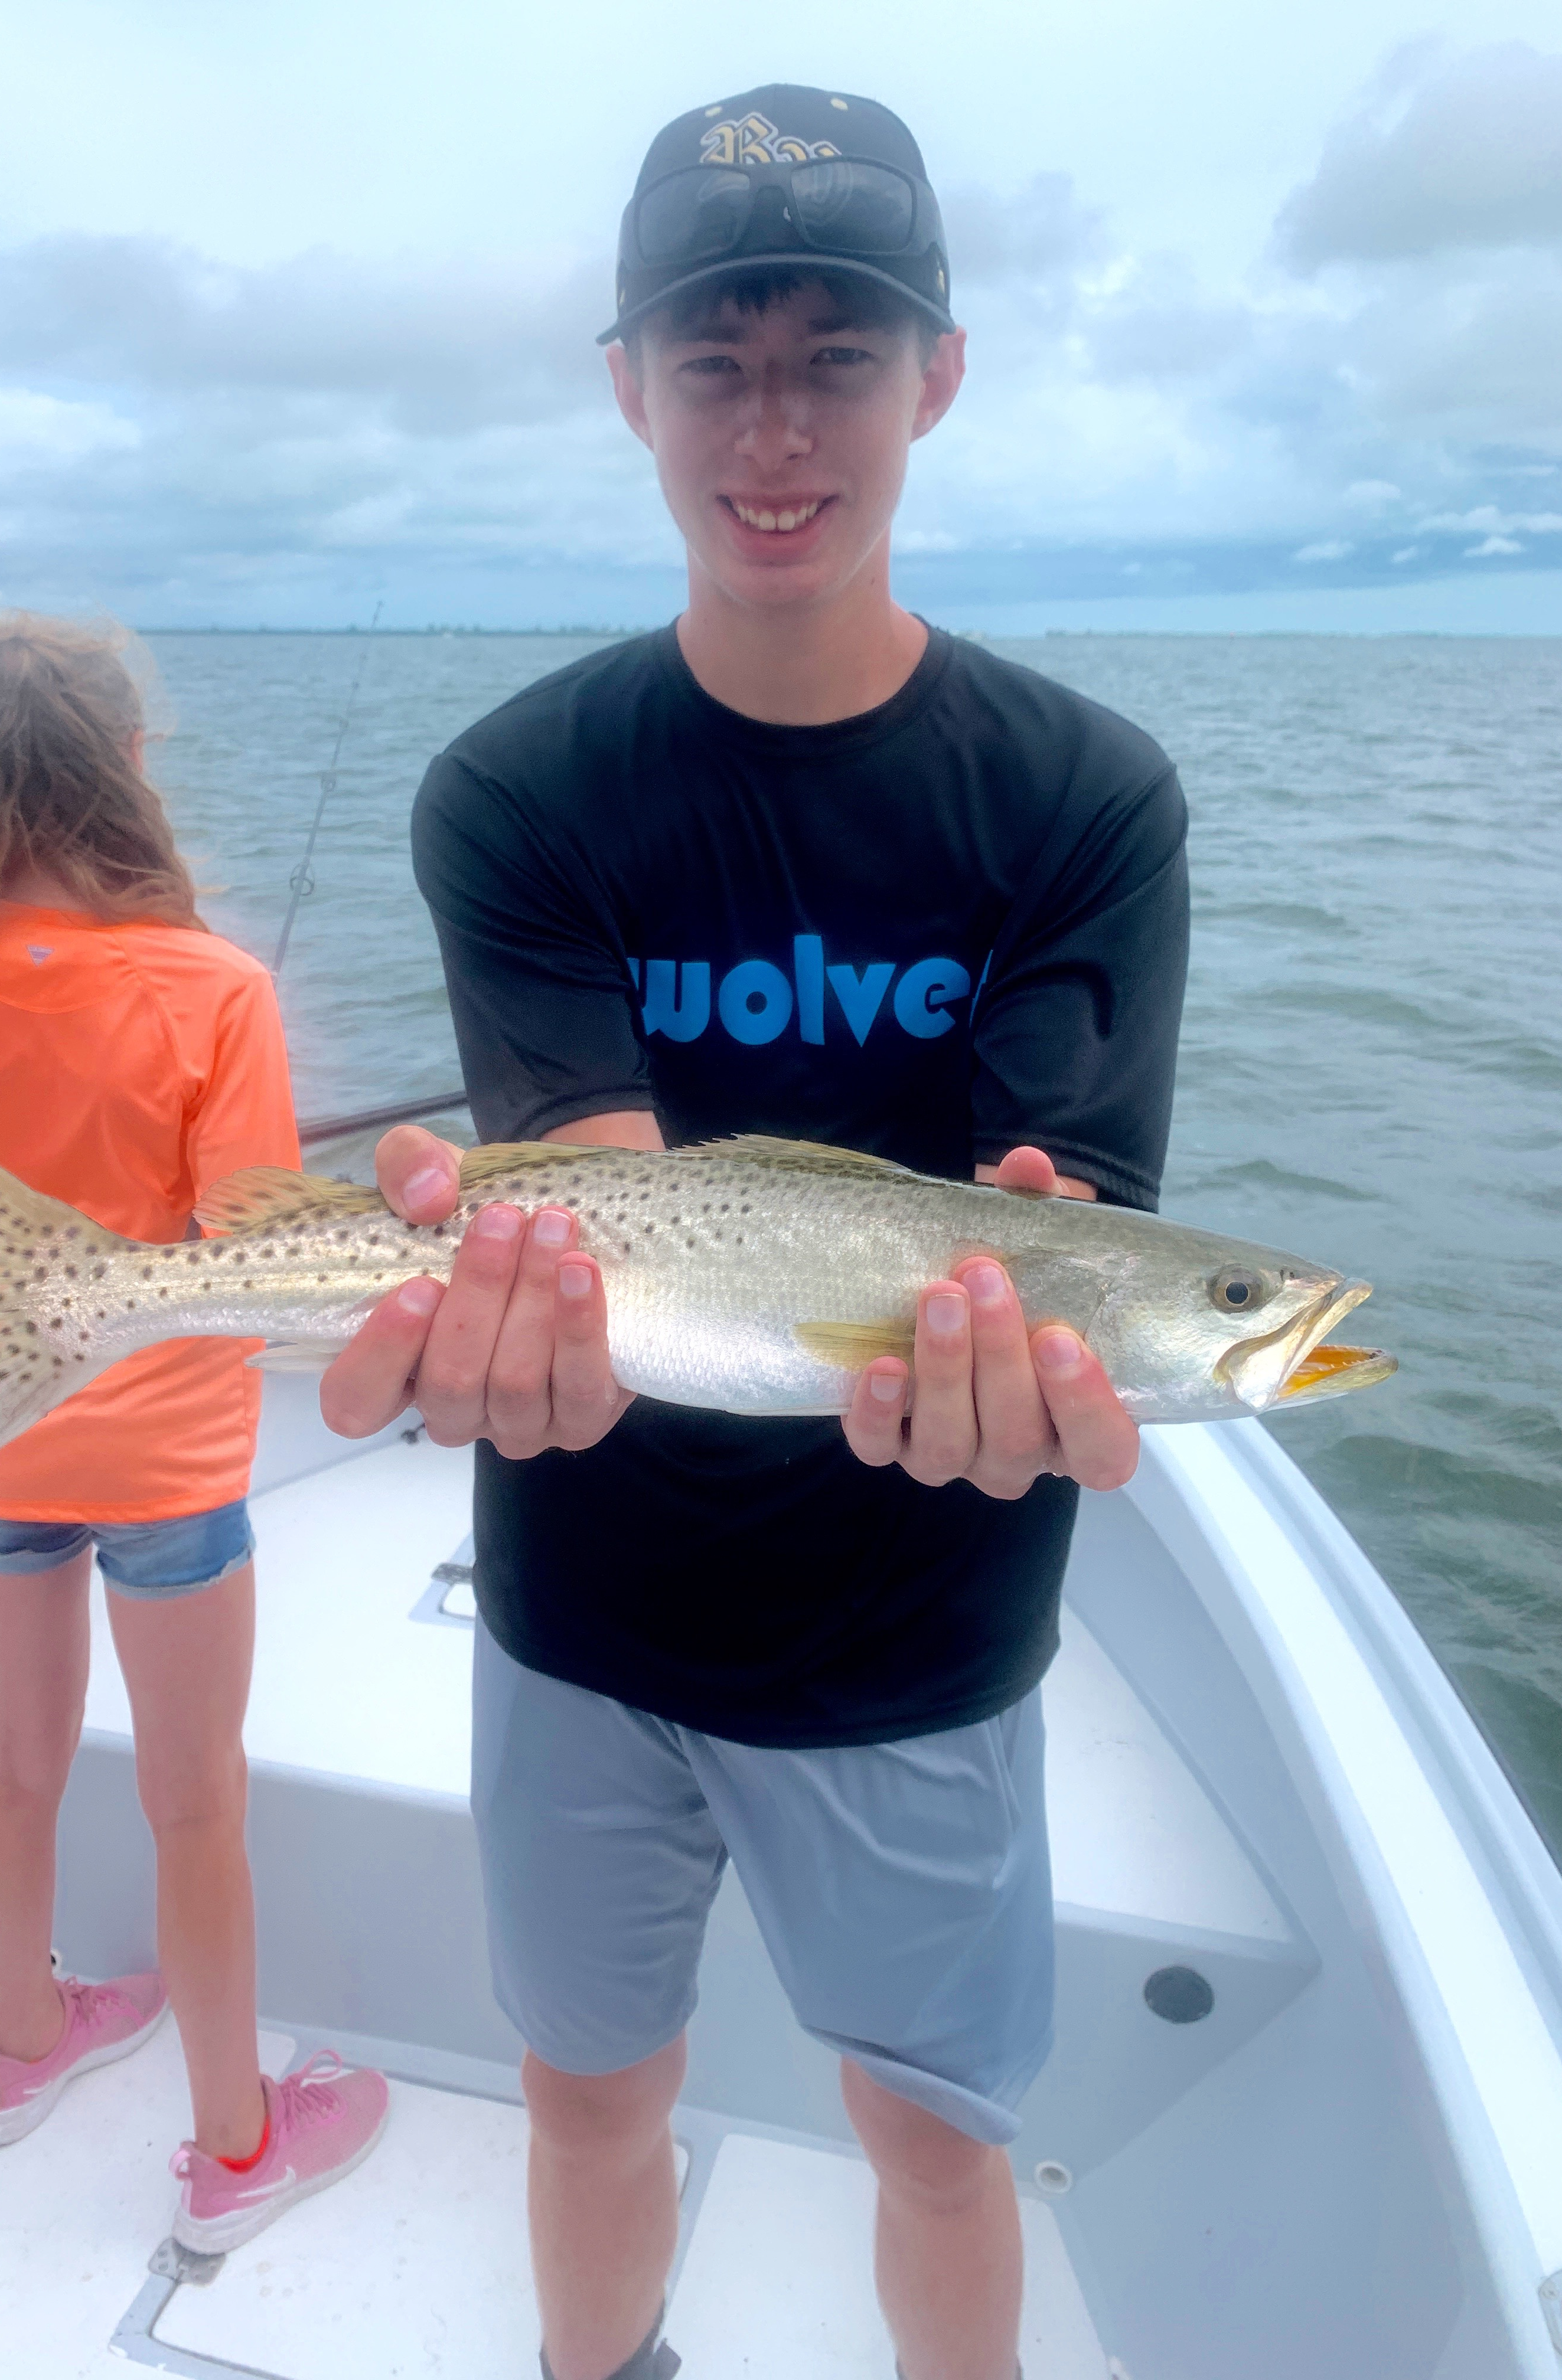

The closure has been a win for everyone.

Pic: Everybody loves easy, fast paced trout fishing.

One of the most frequently asked questions when we get a call from out of town clients looking to book a charter is “what can we eat”. Explaining that our main target species of Snook, Redfish and Trout are closed to harvest due to a red tide In 2017/2018 sometimes does not go over well. Letting them know that the rebound our fishery has seen since this closure is simply amazing often sells the trip. Although some people just cannot fathom going fishing without killing fish and bring fillets home.

In retrospect now that we are more than two years past the worst red tide we have ever seen the vast improvement in our water quality is heart warming. The FWC executive order to close harvest to our main target species has saved our fishery for generations to come. Seeing the vast rebound of life along with a recovery in our fishery faster than anyone could have predicted is amazing. Fishing out on the now healthy grass flats we have been loosing count of how many big sea trout we catch and release. This is evidence that this closure has been so important for the long term recovery of our estuary, Much more critical than going home with a bag of fillets at the end of a trip.

Some trips we just have to get creative when looking to take fish home. During our colder winter months Sheepshead where our target species. Now Mangrove snapper are our goto food fish. Blacktip sharks are also plentiful and a good fish to eat. Being so focused on catching dinner can really take away from your chance to enjoy some of the most exciting catch and release fishing for snook, redfish and trout we have seen in years.

Catch and release measures on Snook, Redfish and Trout since our red tide nightmare of 2017/2018 have done wonders for our fisheries. Now every fisherman gets to reap the benefits. Take time to enjoy releasing lots of healthy fish while immersing yourself in the nature around you. Don’t rate your trip by the fillets in your ziplock bag, rate it by the experience!

