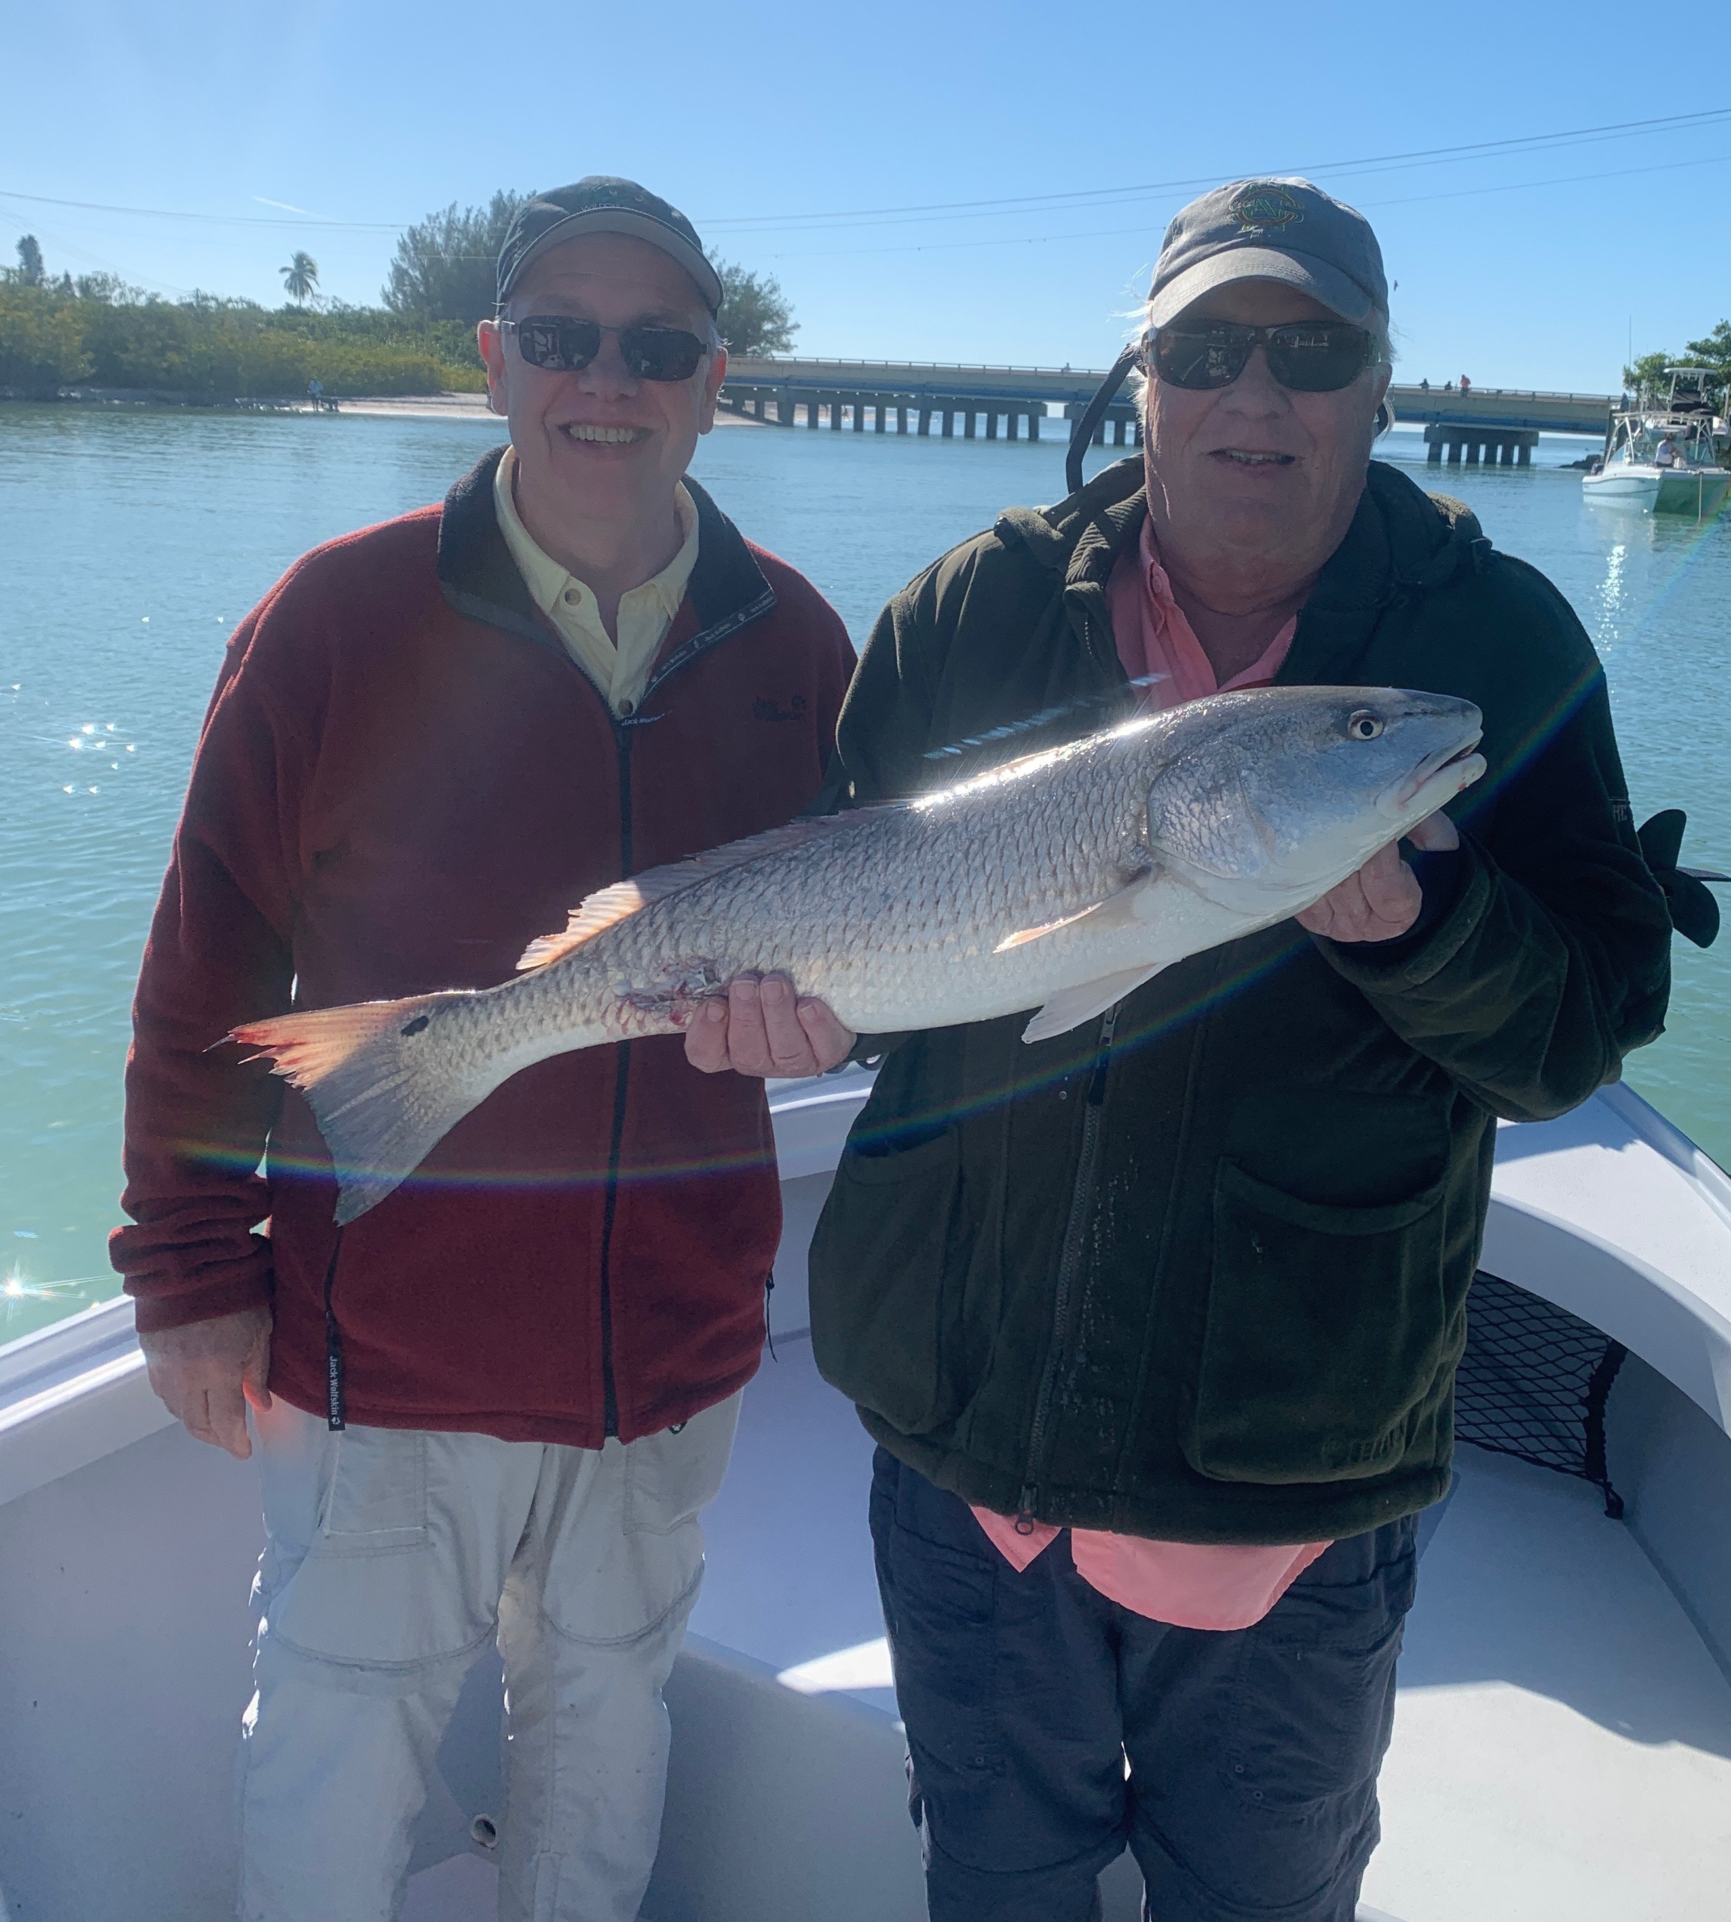

Pic: John and Doug got in on the Bull redfish bite this week with Capt Matt Mitchell.

The beloved sheepshead.

So far this December fishing has been much better than in the past several years. Generally, by this time we have made that annual switch from shiners to shrimp fishing and are catching sheepshead and rat redfish. Though this bite is going on while shrimp fishing the bite on larger snook and redfish has been awesome around all our local passes. These unexpected bigger fish have required larger baits like pinfish and shiners. Catching multiple fish over 30 inches while flipping big baits is just not a normal December thing.

The sheepshead bite is gradually improving with the cooler water. Clients looking to go home with dinner caught these striped fish on chunks of fresh shrimp rigged on small jig heads. Barnacle crusted pilings and areas with shell bottom that have faster moving current held some of the first decent size sheepshead we have seen this season. Most of these fish have been between 10 to 15 inches with no real giants showing up yet.

The fishing for this much beloved food fish of winter will only continue to improve with February being the peak spawning month. Florida Sheepshead regulations are 12 inch minimum with an 8 per person limit. Personally we don’t keep anything smaller than 14 inches as there is very little meat and lots of bones on these little guys. Only take what you will eat.

I often hear people complain about how hard sheepshead are to clean. With a sharp knife and a little practice, they are well worth the effort. Not cutting through the rib cage when cleaning them along with not cutting the fillet completely off the carcass before skinning are a few pointers that help. Cutting through the rib bones doesn't give you a better yield and quickly dulls your knife. I see more and more people cleaning them with electric fillet knives even though I’m not a fan. I feel I get a better yield and end up with a better looking fillet with a sharp quality fillet knife.

Don’t let the colder weather keep you off the water, get out and fish.

