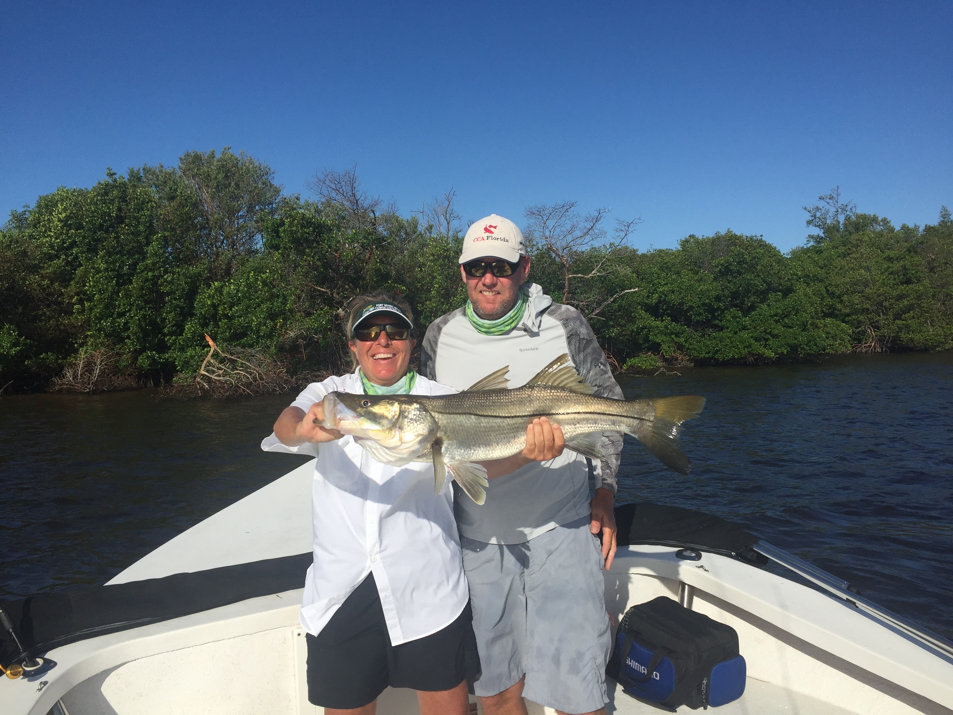

Picture: Mary Laser with a 32 inch snook she caught while out with Capt Matt Mitchell

The beginning of Fall fishing is here.

Mornings on the water over the past two weeks have finally began to feel a little bit cooler as we slowly move closer towards fall. Although we rarely ever see a major cool down living in south Florida until at least late November this little change is just enough let the fish know fall is coming.

Our inshore waters are still extremely brown due to the never ending hurricane Irma run off . The water color around the mouth of the river can only be described as black. Whats amazing to me is that in this dark water the bait and wildlife is plentiful. The amount of life around the causeway bridges in this black water at first morning light is as good as we ever see it in even the spring or fall. I can’t explain the acres of baitfish flipping all over the surface along with diving birds and rolling tarpon which are the last thing you would expect to see in this nasty stained water.

Snook fishing was my goto this week and brought us great action on fish of all sizes. Shiner fishing caught us the highest number fish both on mangrove shorelines and around oyster bars. With our snook slowly making that annual move from the beaches and passes towards the back country anywhere in the middle sound with good moving current and structure will be holding snook. For larger snook use live pinfish either in the passes or on docks around the intercostal. The mouth of the river during the outgoing tide is also holding some much larger snook if you have large shiners or threadfin herring to free line to them on the deeper mangrove points with fast moving current.

Redfish fishing also remained consistent with the most productive methods of fishing generally being done one of two ways either looking for schools on open shallow flats or fishing up under the mangroves on the higher periods of the tide. Finding the roaming schools of redfish required running flats behind the barrier islands and covering lots of ground until they often just pop up as they shower bait fish while grazing. Fishing the schools takes a little more patience to find them but once you do its only a matter of getting a bait out to the schools and its basically a guaranteed hook up.

Fishing the rips and tide lines on the outside of the passes brought a variety of species for anglers looking to catch lots of fish by simply throwing artificial baits including small spoons, jigs and plugs. Ladyfish, Mackerel and jacks are out on these tide rips gorging on all the little bait fish getting sucked in and out of the passes. Often this fishing is as easy as finding the feeding birds which will lead you right to the fish. This type of fishing although not glamorous is just plane fun and is awesome for anglers of all skill levels. From trolling spoons to casting a fly rod the possibilities and different methods to catch these fish is unlimited. If you want to really get fish jumping out the water throw out a few scoops of small live shiners for chum and watch the water boil.

Don’t let that deceptively ugly looking brown water fool you its full of life and with fall in the air the fishing possibilities are endless.

