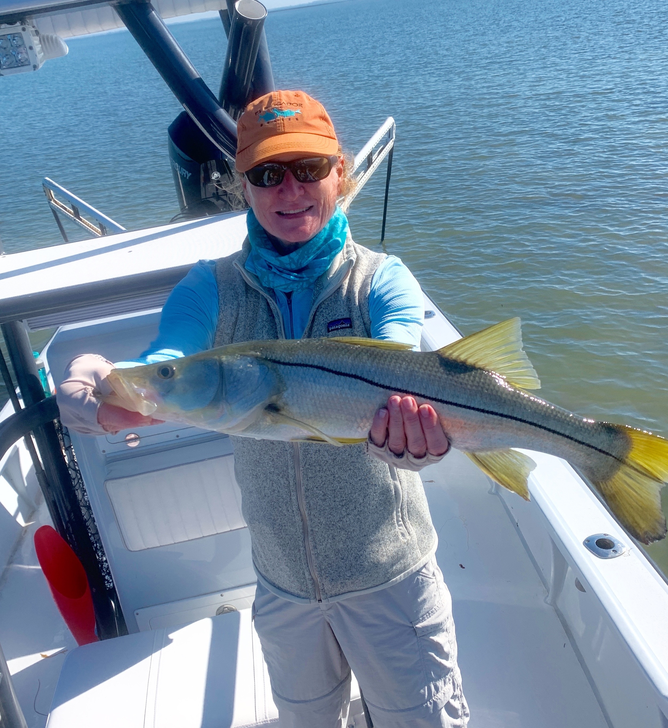

Pic: Melissa got a big snook while oyster bar fishing with Capt Matt Mitchell this week

Tarpon time has arrived.

This week was like someone had flipped the switch as our much awaited tarpon appeared. Seeing pods of rolling fish along with groups of boats anchored up in all the usual places is a sure sign that they are here. Although this favorite fishery has not quite kicked into high gear yet it will only get better by the day as huge pods of migrating tarpon pour into our waters.

On a few charters this week when my clients were game we gave the tarpon a try for the first hour of the trip. We did have one bite up at Fosters point on North Captiva but after one jump it was over before the battle began. Bending the rods catching sharks and watching rolling and free jumping tarpon is a great way to get your people fired up early.

Depending on the wind we tarpon fished in a few places throughout the sound over the past week and saw them at every spot. Soaking cut baits for these early season fish is hard to beat though fishing threadfins and pinfish under floats in the spread is never a bad idea either. Having a few rigged tarpon rods onboard is a must even if you don’t plan on tarpon fishing as you may just come across them in your travels.

Slow moving morning tides made Snook fishing a little tougher than it has been over the past few weeks. Finding any kind of tide movement was the key. Even sitting in the passes we had periods of zero tide which makes for a slow bite. Once the tide got up by mid day the snook bite fired off. Oyster bars on both sides of the sound came alive once the incoming tide was high enough to cover them.

Flats from Chino to Regla where a good choice for popping cork fishing with live shrimp. This fishing seems to bend rods during times of no tide and is a great way to catch a few ladyfish and mackerel for cut bait tarpon fishing. Let the boat drift in 3-5ft over the grass and sand bottom area’s until you start getting bites. Once you start catching fish anchor up and enjoy.

