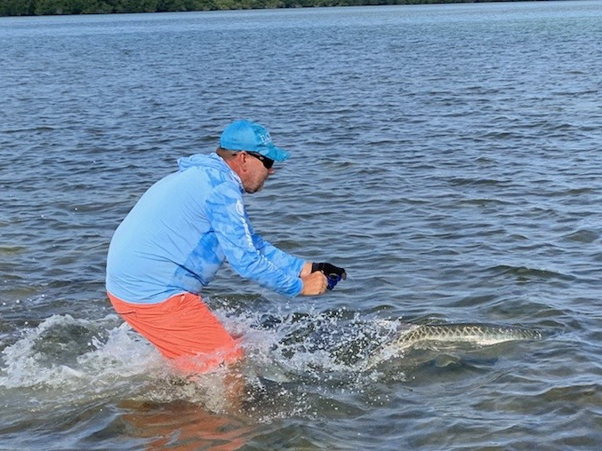

Tarpon tales

Pic: Tarpon wrangling.

COVID-19 has had the majority of our of April clients cancel there trips. With now only a few trips a week scheduled all with my local clients I’m gonna make the most of it and still get out to enjoy some of the best early Spring fishing we have experienced in years.

Tarpon have showed up all through our area. Most of the clients I had scheduled to fish with this week did not take much persuading to give these fish a go. All the usual places in the sound had these Spring time giants. Switching gears and chasing the silver king was a much needed break from all the craziness on land.

Sitting in rolling tarpon some days it did not take long to hook up. Having a rod double down and see a 6ft long tarpon jump for the sky is as good as it gets. Marking off a bucket list fish for a client is always a good feeling. Most of my anglers usually head head back up north before they can get a shot at our spring time push of tarpon. These early season fish are great for everyone me included.

No matter how well you explain to a client how strong a tarpon is until they are doing battle it simply has to be experienced to be believed. Early this week thirty minutes into one fight we had a big hammerhead pop up on a hooked tarpon. This wild fish took off with a new lease on life jumping and running after we thought we had it beat. After starting up the outboard and keeping the boat close to the hooked tarpon the shark gave up. Fifteen minutes later we brought this fish boat side and after grabbing the leader for a few pictures let it swim off.

During another tarpon fight this week after more than a 30 minute battle this fish decided to tow us up into super shallow water. In order to try to get the hook out I had to climb into ankle deep water and follow this fish. After wrangling it I was still not able to grab it for that perfect picture. While holding the leader and being within a few feet of the fish it surged one last time and broke off.

Every tarpon fight is different. Some are much more memorable than others. One thing they do all have in common though is full on thrills while feeling the amazing power of these fish.

